

Team Working Agreement

In this course, you will complete several assignments with the same team. To set your team up for success, you will create a working agreement that establishes roles, expectations, communication strategies, etc. By creating this agreement, the goal is to set yourself up for success and to reduce the occurrences of problems. This agreement is expected to be a living document that you can modify throughout the course whenever necessary.

# Team Name

| **Binary Brothers** |
| --- |

*Optional: Add a team logo or mascot.*

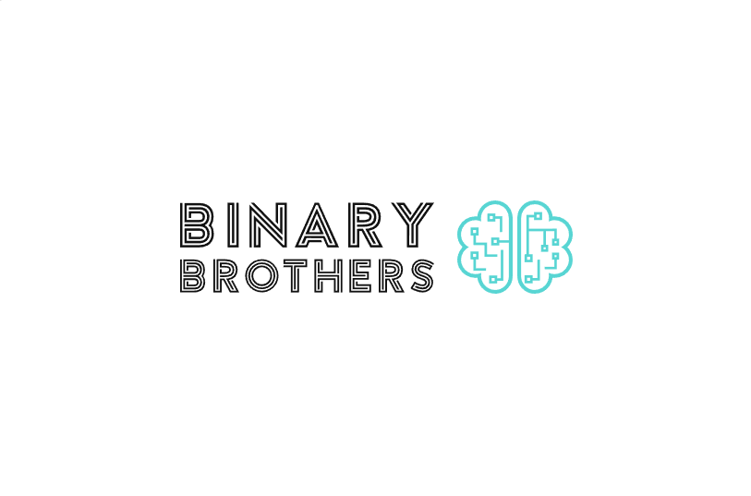

# Team Member Information and Roles

| **Team Member Name** | **Role \*** | **Contact Info (e-mail & phone)**  **Preferred Method of Communication** |
| --- | --- | --- |
| Grant Iodic |  | [giodic1@students.towson.edu](mailto:giodic1@students.towson.edu) (443)-286-0831 |
| Christopher Solano |  | [csolan2@students.towson.edu](mailto:csolan2@students.towson.edu) (443)-939-9732 |
| Luis Serna |  | [lserna1@students.towson.edu](mailto:lserna1@students.towson.edu) (240)-277-8409 |
| Habeebu Adenuga |  | [hadenu1@students.towson.edu](mailto:hadenu1@students.towson.edu) (347)-341-9029 |

* You can leave Role blank for your first revision of the agreement. Roles might include, but are not limited to, Team Manager, Technical Writer, Graphic Designer/Document Formatter, Content Developer, Tester, etc. You can change your role or take on multiple roles for any assignment. It is expected that you all will support each other in the development of assignments. In other words, each assignment has multiple parts, and everyone is expected to contribute part of this content.

# Team Communication and Material-Sharing Strategies

* Email and text group as needed.
* Within a day response for text, 2-3 days for email.
* Store materials on Google docs and Microsoft
* Deadlines for projects are due 2 days before the actual deadlines to prevent last minute workings.
* Quality assignment requirement:
  + Does it run?
  + Does it perform its function?
  + Will it crash?

# Team Values, Behaviors, and Expectations

* Consider and define (briefly) principles that will guide the team
* Expectations

Each team member shall

* + Follow the working agreement
  + Act respectful
  + Practice active listening
  + Consider all ideas
  + Support each other
  + Raise questions and concerns early – don’t wait
  + Be on-time to meetings
* Examples/Suggestions
  + Each teammate is expected to respond within x hours of receiving a message
  + Be on-time to meetings
  + Show respect – don’t attack, listen first, be honest and transparent
  + Make commitments and be responsible for meeting them
  + Trust – don’t be afraid to ask for help or say you don’t know
  + Bring problems to the group but also propose solutions, don’t just dump
  + Raise questions and concerns early – don’t wait
  + Pull your weight and expect others to pull theirs

# Methods for Handling Team Issues

* If an issue arises, what is the chain of command for addressing it?
* If issues arise,
  + First, we try and resolve it among ourselves
  + Second, we report to the professor.
* If a teammate fails to complete a task, how will this be handled?
  + Teammate should inform the team before any deadlines so it can be discussed and resolved
  + If reported the day before a deadline or on a deadline, the rest of the team reserves the right to report to the professor.

# Approvals

Each member sign and date below

*We, the undersigned, agree to abide by the above document.*

| **Name** | **Signature** | **Date** |
| --- | --- | --- |
| Luis Serna |  | 02/02/23 |
| Habeebu Adenuga |  | 02/02/23 |
| Grant Iodice |  | 2/6/23 |
| Christopher Solano |  | 2/6/23 |