**Problems:**

**A. Graph Coloring Problem**

Properly colors a graph with the smallest number of colors. Properly coloring a graph means coloring each node of the graph with a color such that all pairs of nodes joined by an edge do not have the same color. The colors will be represented by numbers starting at zero.

**Problem definition:**

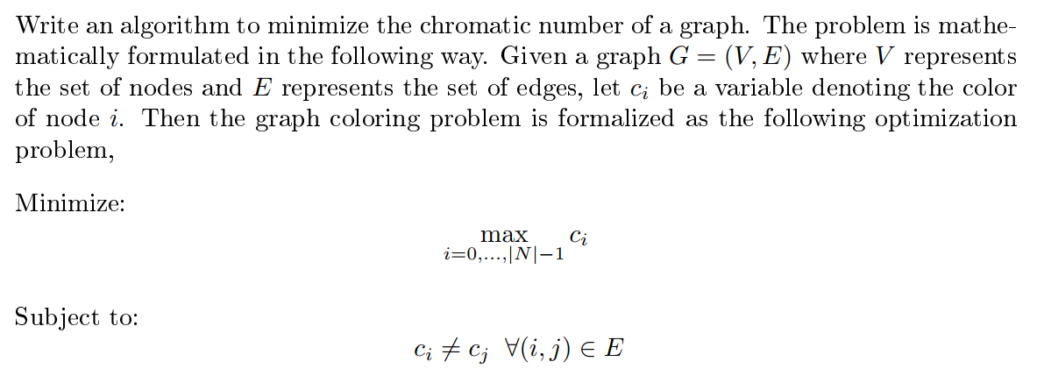

**Input and Output Data Format:**

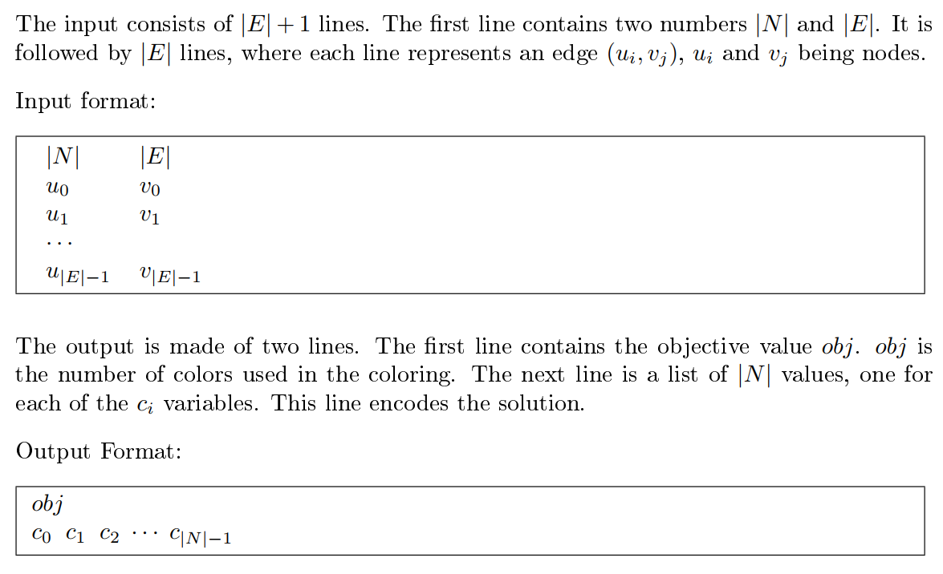

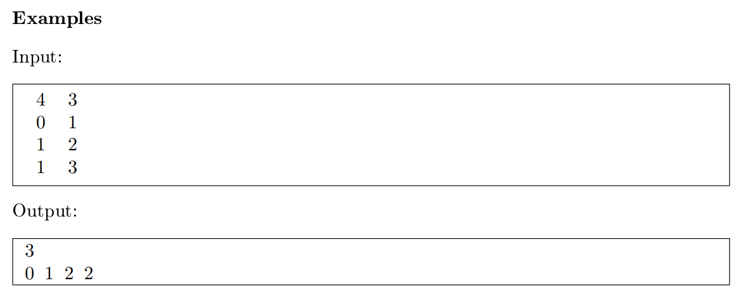

**B. Knapsack Problem**

In this assignment you will design an algorithm to solve the well-known Single Knapsack Problem. You are provided with a knapsack with limited space and a collection of items with dierent values and weights. Your task is to maximize the value of items packed into your knapsack without exceeding its total capacity.

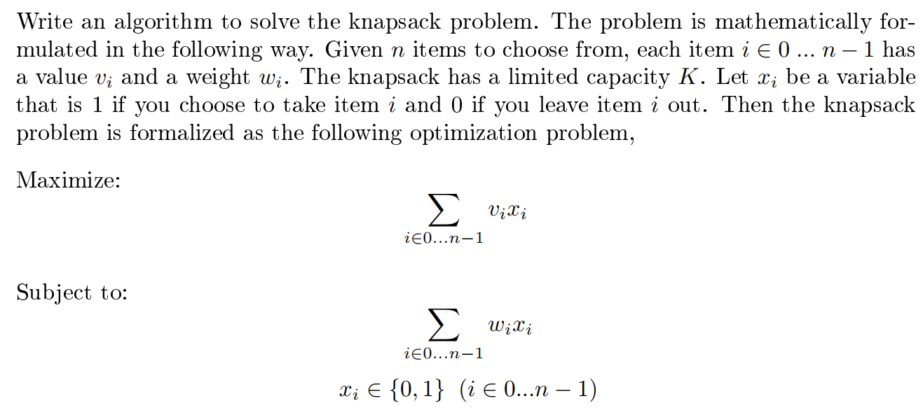

**Input and Output Data Format:**

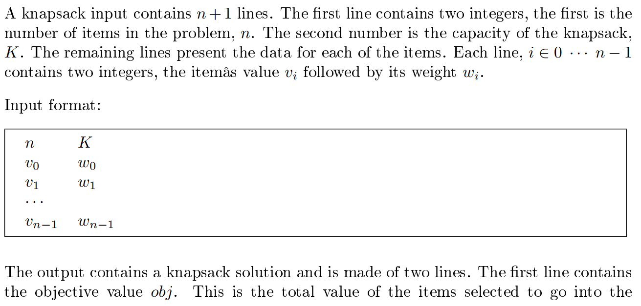

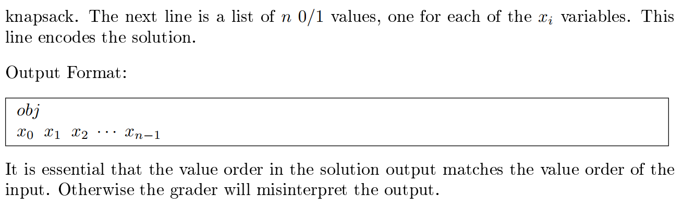

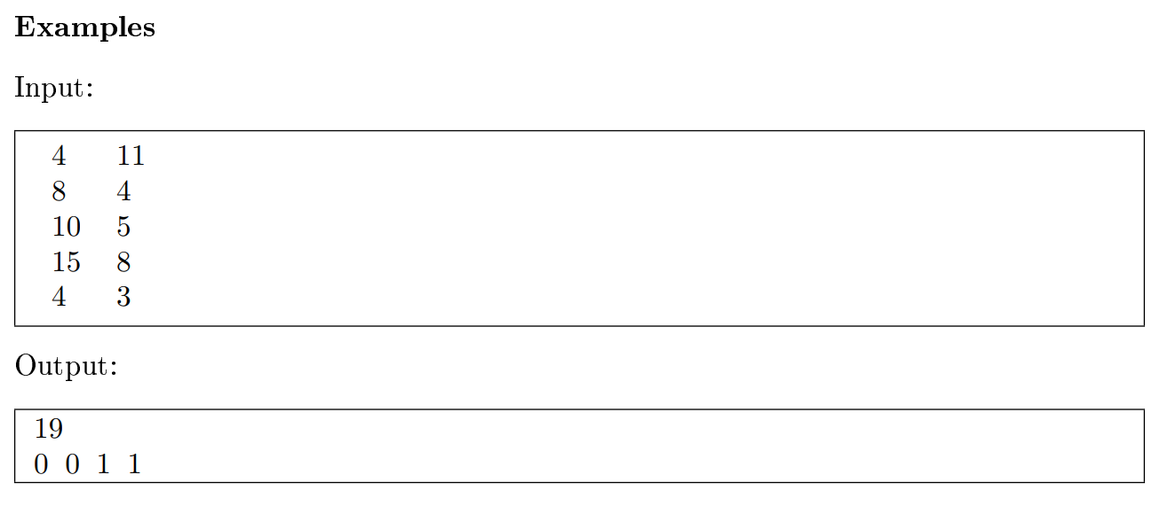

**C. Traveling Salesman Problem (TSP)**

**Problem Statement:**

The Traveling Salesman Problem (TSP):

All traveling sales- people start from their home, travel to several cities to sell their goods, and complete the day by returning home. To minimize their costs, traveling salespeople should visit all of the cities using the shortest total travel distance. This amounts to finding an order of all of the cities that minimizes the sum of the distances traveled when moving from one city to another. The following figure illustrates a small TSP and a feasible solution to that problem. The cities are labeled from 0 to 4.

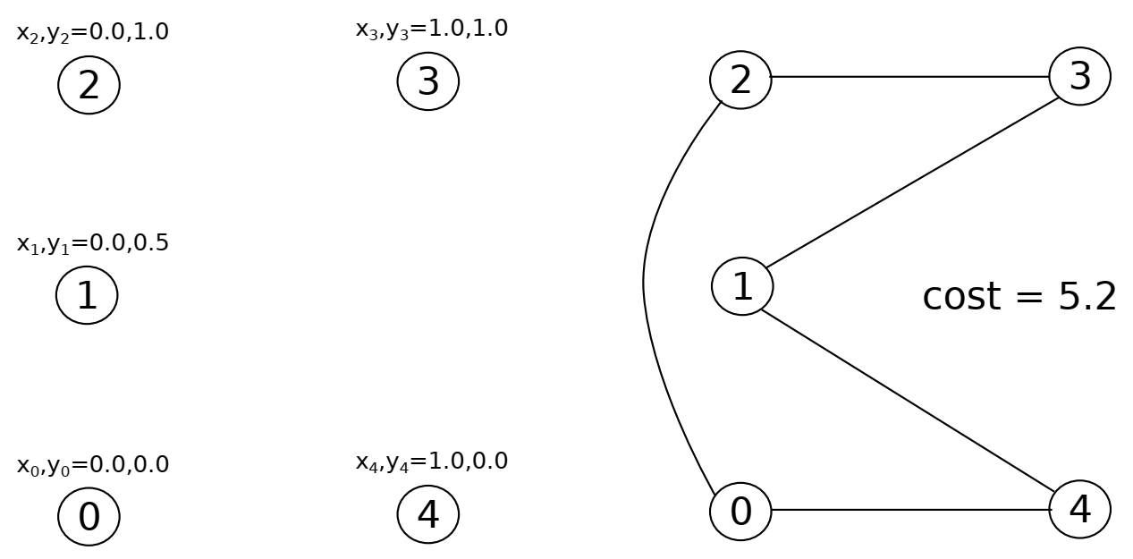

**Problem Formulation:**   
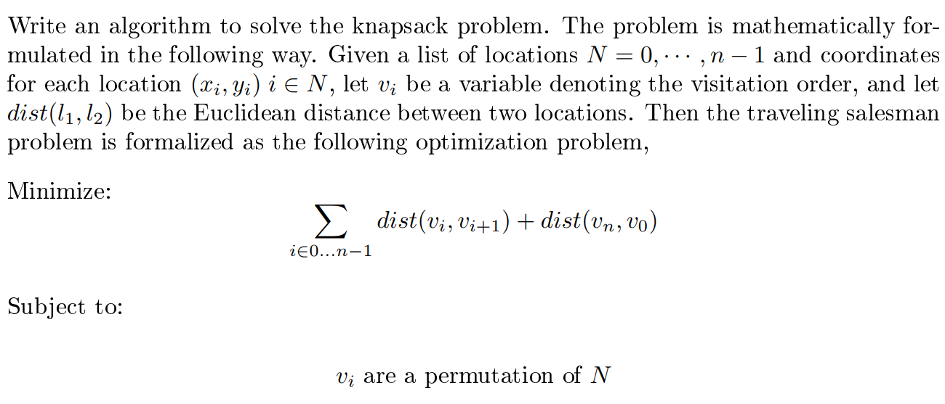

**Input and Output Data Format:**

