Project Report– Robotics and Automation
Obstacle- Aware Mobile Robot Using Sonar and Camera in Gazebo
Submitted for partial fulfillment of award of

BACHELOR OF ENGINEERING
Degree In
Computer Systems Engineering

Group Members:
Nimerta Wadhwani(!33-22-0009) Rabia Soomro(133-22-0025) Habeeban Memon(133-22-0033) Ayesha Siddiqua(133-22-0005)

Guided by:
Dr: Ghulam Abbas Lashari


Department of Computer Systems Engineering Sukkur IBA University
November 2025

Table of Contents
- Abstract ................................................................................................................... 3
- Introduction ............................................................................................................. 3
- System Design .......................................................................................................... 3
3.1 Robot Model (URDF) ..................................................................................... 3
3.2 Sensor Integration ........................................................................................... 4
3.3 Motion Control Plugin .................................................................................... 5
- Software and Launch Configuration .................................................................... 5
4.1 Workspace and Package Layout ..................................................................... 5
4.2 Step-by-Step Implementation ......................................................................... 8
4.3 Launch File .................................................................................................... 18
4.4 Manual Control Commands ........................................................................... 19
4.5 Sonar Avoidance Node .................................................................................. 19
- Experiments and Results ....................................................................................... 21
5.1 Sonar Validation ............................................................................................. 21
5.2 Camera Validation .......................................................................................... 21
5.3 Robot Motion Tests ........................................................................................ 21
- Discussion ................................................................................................................ 22
- Conclusion and Future Work ................................................................................ 22
- Appendix A – Complete URDF Code ................................................................... 23
- Appendix B – Gazebo Launch File ....................................................................... 31
- Appendix C – Sonar Avoidance Python Node ...........................................…...…34

Abstract
This project presents the design and simulation of an obstacle-aware mobile robot using ROS2 Humble and the Gazebo physics simulator. The robot is equipped with a forward-looking camera and a sonar sensor, both aligned in a common reference frame on the robot’s base so they observe the same forward region. The robot is modeled using the Unified Robot Description Format (URDF), containing a base, a revolute arm link, and fixed mounts for both sensors, along with appropriate inertial and collision properties to ensure physically stable simulation. The camera data can be visualized through standard ROS tools, while the sonar is implemented as a ray-based distance sensor publishing forward range measurements. Robot motion is commanded via the standard cmd_vel topic, enabling manual teleoperation and basic obstacle-aware behavior using sonar distance thresholds. Simulation results show correct robot movement and consistent sonar readings as obstacles are placed in front of the robot, demonstrating successful integration of sensing and actuation.

2. Introduction
Mobile robots rely on onboard sensors to detect obstacles and understand their surroundings. Cameras provide rich visual information but require heavy processing, while range sensors such as sonar offer simple, direct distance measurements suitable for basic obstacle avoidance. Combining both sensor types on a single platform highlights the advantages and limitations of different sensing modalities. This project focuses on building a multi-sensor mobile robot model that includes both a camera and a sonar sensor. The robot can be manually controlled using ROS velocity commands and can additionally use sonar data for basic reactive behaviors. The robot model, sensor integration, and control mechanisms are implemented entirely within ROS2 and Gazebo.

The main objectives of the project are:

- To design a URDF model of a mobile robot with a base, an arm link, a camera, and a sonar sensor.
- To integrate both sensors into Gazebo using ROS2-compatible plugins and verify proper topic publication.
- To control the robot using the cmd_vel topic and demonstrate that sonar measurements accurately correspond to obstacles placed in front of the robot.

System Design
3.1 Robot Model (URDF)

The robot is modeled in URDF as a hierarchy of rigid links connected by joints. The base of the robot is represented by a rectangular box link called base_link, which serves as the mobile platform. A cylindrical link named link_1 is connected to the base by a revolute joint, joint_1, that allows rotation around the vertical axis. This link provides an additional articulated component of the robot’s body.

Two further links represent the sensors. The camera_link is a small box positioned in front of and above the base, attached using a fixed joint so that its optical axis points along the positive X direction. The sonar_link is another small box mounted at the front of the base at mid height, also using a fixed joint and oriented along the positive X direction. Both sensors are rigidly attached to the base so their frames are aligned and point toward the same field of view.

Each link includes visual, collision, and inertial descriptions. The visual elements define how the robot appears in Gazebo. The collision elements provide geometry for the physics engine to calculate contact responses. The inertial elements specify each link’s mass and inertia tensor. Including inertial and collision tags is essential for stable simulation; without them, Gazebo cannot correctly compute gravity, collisions, and dynamics, which may result in unstable or unrealistic robot behavior.

Robot Model with Camera (Blue) and Sonar (Silver)
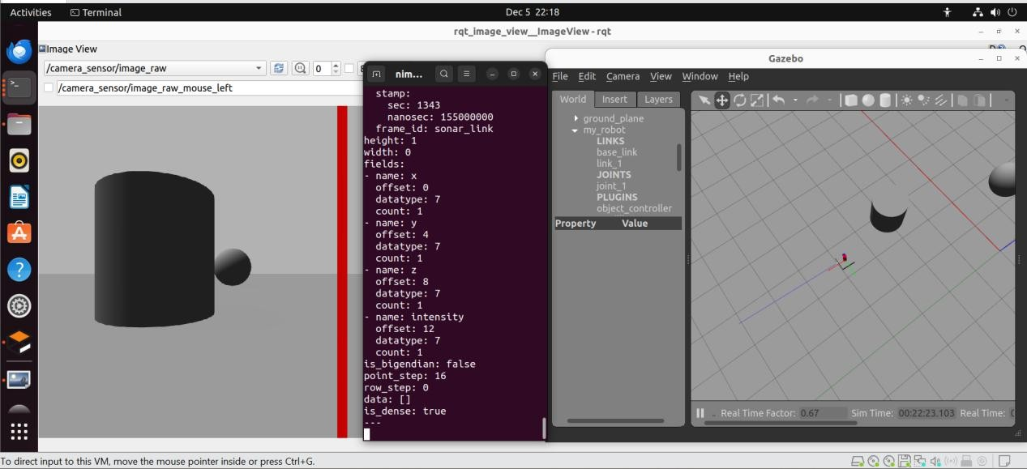

“The full URDF file is provided in Appendix A.”

3.2 Sensor Integration

The camera is implemented using a Gazebo camera sensor defined under a <gazebo reference="camera_link"> element. The sensor is configured with parameters such as update rate, field of view, image resolution, and clipping distances. A ROS2 camera plugin (libgazebo_ros_camera.so) is attached to this sensor to convert Gazebo’s rendered images into ROS image messages published on topics such as my_robot/camera1/image_raw, along with camera calibration data published on a camera_info topic. The camera output can be viewed in real time using rqt_image_view to confirm correct functioning.

The sonar is implemented as a ray sensor attached to sonar_link under a <gazebo reference="sonar_link"> element. It is configured with a single ray sample in both horizontal and vertical dimensions, effectively producing a one-dimensional distance measurement directly in front of the robot. Its minimum and maximum range values and resolution define the measurable distance

interval and precision. A ROS2 ray sensor plugin such as libgazebo_ros_ray_sensor.so publishes the output on a topic named /my_robot/sonar in the form of sensor_msgs/Range messages.

To ensure both sensors observe the same region, the camera and sonar are mounted with zero roll, pitch, and yaw relative to the base, oriented along the positive X direction. An obstacle placed on the robot’s forward axis therefore appears within the camera’s field of view and simultaneously lies along the sonar’s distance ray. This alignment simplifies sensor interpretation and validation.

3.3 Motion Control Plugin

The robot’s movement is controlled with a Gazebo motion plugin rather than by modeling individual wheels. A global <gazebo> tag loads the planar move plugin (libgazebo_ros_planar_move.so), which directly applies horizontal plane velocities to base_link. The plugin subscribes to the cmd_vel topic, interpreting linear velocity along the X axis as forward motion and angular velocity around the Z axis as rotational motion. It also publishes odometry information on the odom topic, providing estimates of the robot’s position and velocity.

The coordinate frame follows standard ROS conventions: the X axis points forward, Y points to the left, and Z points upward. Positive linear X values move the robot forward, and positive angular Z values rotate it counterclockwise. This consistency facilitates teleoperation and simplifies the creation of control nodes that rely on standard twist messages.

4. Software and Launch Configuration
  - Workspace and Package Layout

The project files are organized in a ROS2 workspace named ws_humble_urdf. Within the src directory, a package named my_gazebo_robot contains the robot’s URDF files in the urdf/ folder and launch files in the launch/ folder. Additional packages may be included for control nodes, such as a dedicated package for a sonar-based controller. This organization follows common ROS2 practices and ensures the workspace can be built and sourced reliably.

The workspace is compiled using colcon build, and the install/setup.bash script is sourced before running any launch files or nodes so that ROS2 can locate the robot description, launch files, and executables.

Step by Step Implementation:
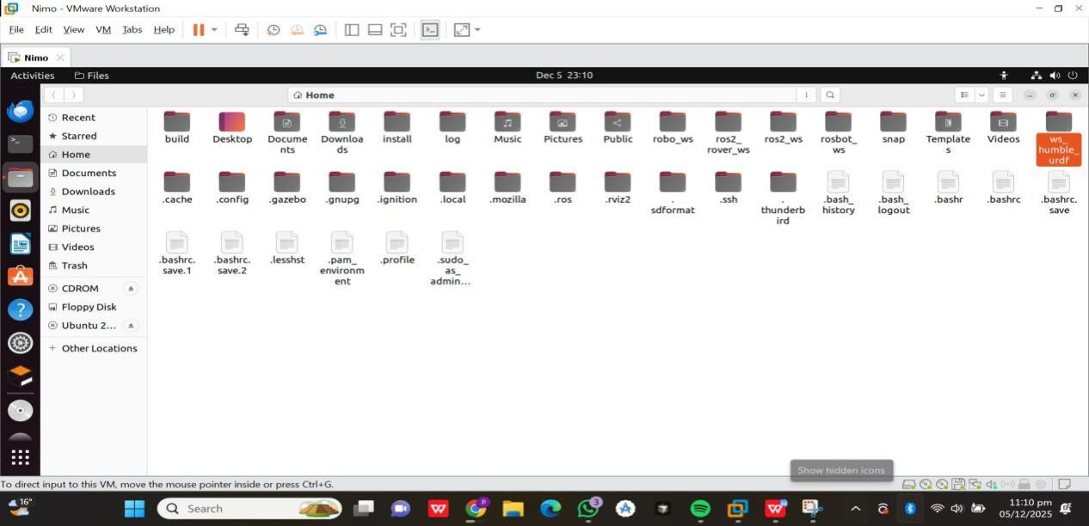
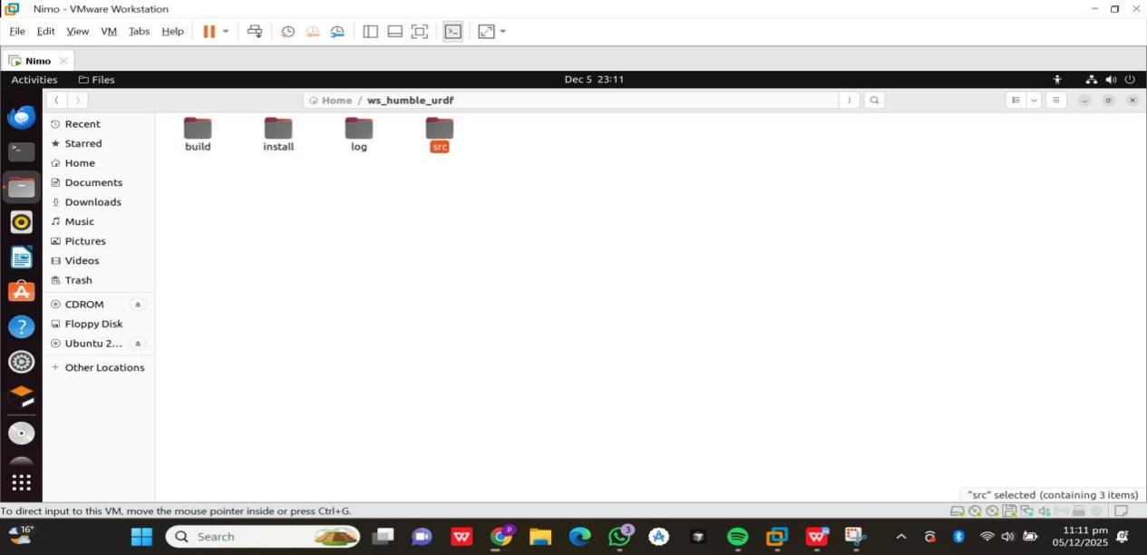

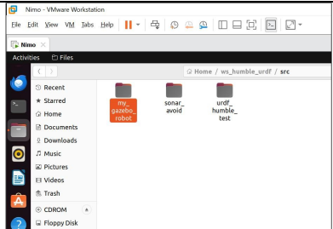

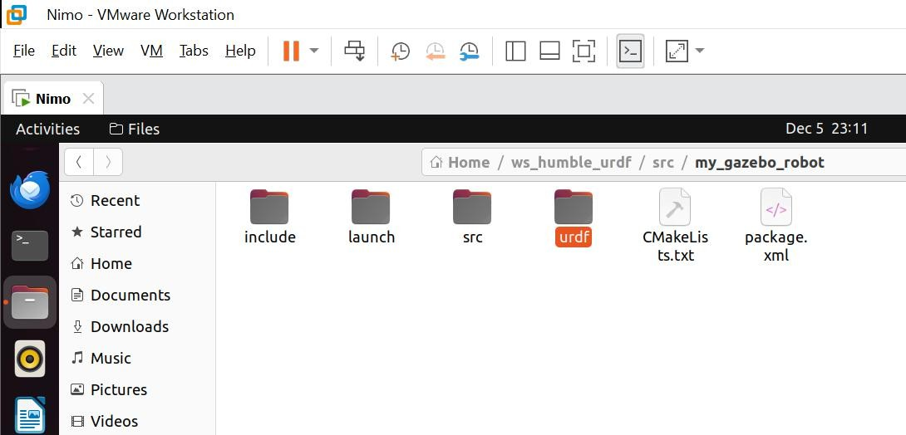

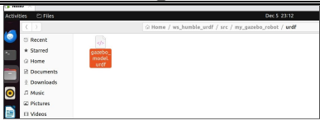

Figure: Workspace folder structure showing urdf/, launch/, and Python script directories.

  - Step-by-Step Implementation (Commands, Codes, and Explanations)
This section describes the complete procedural implementation of the mobile robot system, including environment setup, workspace preparation, URDF development, Gazebo–ROS integration, launch configuration, obstacle-avoidance logic, and final runtime execution. Each command and code segment is followed by a clear explanation of its purpose and functionality.

System Setup and Installation:
The development environment was configured by installing the required ROS 2 Humble packages and Gazebo integration libraries. These components are essential for simulating sensors and enabling ROS–Gazebo communication.
sudo apt updatesudo apt install ros-humble-gazebo-ros-pkgs ros-humble-ros-gz-sim ros-humble-xacro -ysource /opt/ros/humble/setup.bash
These commands update the operating system, install sensor and simulation plugins for Gazebo, and load the ROS environment into the terminal. Without this configuration, Gazebo would not be able to interpret ROS topics, and sensor plugins (camera, sonar) would fail to load.

Workspace Creation and Package Setup:
A ROS 2 workspace titled ws_humble_urdf was used for the project. Within its src directory, a CMake-based package was created to hold the robot model and launch files.
cd ~/ws_humble_urdf/src
ros2 pkg create --build-type ament_cmake my_gazebo_robot
This command generates the package structure, enabling the addition of URDF files, launch descriptions, and resources needed to spawn the robot in Gazebo.
Required directories were then created:
mkdir -p ~/ws_humble_urdf/src/my_gazebo_robot/urdfmkdir -p ~/ws_humble_urdf/src/my_gazebo_robot/launch
The urdf/ folder stores the robot model, while the launch/ folder hosts the Gazebo launch script.

Robot Modeling in URDF:
The robot model was implemented by creating a URDF file and inserting the complete robot description.
gedit ~/ws_humble_urdf/src/my_gazebo_robot/urdf/gazebo_model.urdf
The following URDF code defines the robot’s structure, visual properties, physical characteristics, sensors, and motion plugin:

URDF Code:
<?xml version="1.0"?><robot name="gazebo_robot">

<link name="base_link">
<visual>
<geometry>
<box size="0.4 0.4 0.1"/>
</geometry>
<material name="gray">
<color rgba="0.5 0.5 0.5 1"/>
</material>
</visual>
<collision>
<geometry>
<box size="0.4 0.4 0.1"/>
</geometry>
</collision>
<inertial>
<mass value="10.0"/>
<inertia ixx="0.1" ixy="0" ixz="0" iyy="0.1" iyz="0" izz="0.1"/>
</inertial>
</link>

<link name="link_1">
<visual>
<geometry>
<cylinder radius="0.05" length="0.3"/>
</geometry>
<origin xyz="0 0 0.15" rpy="0 0 0"/>
<material name="red">
<color rgba="1 0 0 1"/>
</material>
</visual>
<collision>
<geometry>
<cylinder radius="0.05" length="0.3"/>
</geometry>
<origin xyz="0 0 0.15" rpy="0 0 0"/>
</collision>
<inertial>
<mass value="1.0"/>
<inertia ixx="0.01" ixy="0" ixz="0" iyy="0.01" iyz="0" izz="0.01"/>
</inertial>
</link>

<joint name="joint_1" type="revolute">
<parent link="base_link"/>
<child link="link_1"/>
<origin xyz="0 0 0.05" rpy="0 0 0"/>
<axis xyz="0 0 1"/>
<limit lower="-3.14" upper="3.14" effort="50" velocity="1.0"/>
</joint>

<link name="camera_link">
<visual>
<geometry>
<box size="0.05 0.05 0.05"/>
</geometry>
<material name="blue">
<color rgba="0 0 1 1"/>
</material>
</visual>
<collision>
<geometry>
<box size="0.05 0.05 0.05"/>
</geometry>
</collision>
<inertial>
<mass value="0.1"/>
<inertia ixx="0.001" ixy="0" ixz="0" iyy="0.001" iyz="0.001" izz="0.001"/>
</inertial>
</link>

<joint name="camera_joint" type="fixed">
<parent link="base_link"/>
<child link="camera_link"/>
<origin xyz="0.25 0 0.25" rpy="0 0 0"/>
</joint>

<link name="sonar_link">
<visual>
<geometry>
<box size="0.03 0.03 0.03"/>
</geometry>
<material name="yellow">
<color rgba="1 1 0 1"/>
</material>
</visual>
<collision>
<geometry>
<box size="0.03 0.03 0.03"/>
</geometry>
</collision>
<inertial>
<mass value="0.05"/>
<inertia ixx="0.0001" ixy="0" ixz="0" iyy="0.0001" iyz="0" izz="0.0001"/>
</inertial>
</link>

<joint name="sonar_joint" type="fixed">
<parent link="base_link"/>
<child link="sonar_link"/>
<origin xyz="0.25 0 0.15" rpy="0 0 0"/>
</joint>

<gazebo reference="camera_link">
<sensor type="camera" name="camera_sensor">
<update_rate>30.0</update_rate>
<camera name="head">
<horizontal_fov>1.3962634</horizontal_fov>
<image>
<width>800</width>
<height>800</height>
<format>R8G8B8</format>
</image>
<clip>
<near>0.02</near>
<far>300</far>
</clip>
</camera>
<plugin name="camera_controller" filename="libgazebo_ros_camera.so">
<alwaysOn>true</alwaysOn>
<updateRate>0.0</updateRate>
<cameraName>my_robot/camera1</cameraName>
<imageTopicName>image_raw</imageTopicName>
<cameraInfoTopicName>camera_info</cameraInfoTopicName>
<frameName>camera_link</frameName>
</plugin>
</sensor>
</gazebo>

<gazebo reference="sonar_link">
<sensor type="ray" name="sonar_sensor">
<always_on>true</always_on>
<update_rate>20.0</update_rate>
<visualize>true</visualize>
<ray>
<scan>
<horizontal>
<samples>1</samples>
<resolution>1</resolution>
<min_angle>0.0</min_angle>
<max_angle>0.0</max_angle>
</horizontal>
<vertical>
<samples>1</samples>
<resolution>1</resolution>
<min_angle>0.0</min_angle>
<max_angle>0.0</max_angle>
</vertical>
</scan>
<range>
<min>0.05</min>
<max>3.0</max>
<resolution>0.01</resolution>
</range>
</ray>
<plugin name="sonar_controller" filename="libgazebo_ros_ray_sensor.so">
<ros>
<namespace>/my_robot</namespace>
<remapping>~/out:=sonar</remapping>
</ros>
<frame_name>sonar_link</frame_name>
</plugin>
</sensor>
</gazebo>

<gazebo>
<plugin name="object_controller" filename="libgazebo_ros_planar_move.so">
<commandTopic>cmd_vel</commandTopic>
<odometryTopic>odom</odometryTopic>
<odometryFrame>odom</odometryFrame>
<odometryRate>20.0</odometryRate>
<robotBaseFrame>base_link</robotBaseFrame>
</plugin>
</gazebo>
</robot>
This comprehensive URDF defines the robot’s geometry, collision model, physical mass distribution, camera and sonar sensors, and includes the planar motion plugin that interprets velocity commands.

Gazebo Launch File Creation:
The launch file automates the loading of Gazebo, the publication of the URDF as robot_description, and the spawning of the robot into the simulation environment.

gedit ~/ws_humble_urdf/src/my_gazebo_robot/launch/gazebo_sim.launch.py
The complete launch script:
import os
from ament_index_python.packages import get_package_share_directoryfrom launch import LaunchDescriptionfrom launch.actions import DeclareLaunchArgument, ExecuteProcessfrom launch.substitutions import Command, LaunchConfiguration, PathJoinSubstitutionfrom launch_ros.actions import Nodefrom launch_ros.substitutions import FindPackageSharefrom launch_ros.parameter_descriptions import ParameterValue
def generate_launch_description():
model_arg = DeclareLaunchArgument(
'model',
default_value='gazebo_model.urdf',
description='Name of the URDF file to load from the urdf folder'
)

urdf_path = PathJoinSubstitution([
FindPackageShare('my_gazebo_robot'),
'urdf',
LaunchConfiguration('model')
])

robot_desc = Command(['cat ', urdf_path])

gazebo = ExecuteProcess(
cmd=['gazebo', '--verbose', '-s', 'libgazebo_ros_factory.so'],
output='screen'
)

spawn_entity = Node(
package='gazebo_ros',
executable='spawn_entity.py',
arguments=['-entity', 'my_robot', '-topic', 'robot_description'],
output='screen'
)

robot_state_publisher = Node(
package='robot_state_publisher',
executable='robot_state_publisher',
name='robot_state_publisher',
output='screen',
parameters=[{
'robot_description': ParameterValue(robot_desc, value_type=str)
}]
)

return LaunchDescription([
model_arg,
gazebo,
spawn_entity,
robot_state_publisher
])
This file loads Gazebo, publishes the URDF to ROS, and spawns the robot. The robot_state_publisher broadcasts TF frames so the robot structure is understood by ROS tools.

Sonar-Based Obstacle Avoidance Package:
To enable autonomous navigation, a dedicated Python-based ROS 2 package was developed. This package subscribes to the sonar sensor readings and publishes velocity commands for obstacle avoidance. The package was implemented using ament_python so that Python scripts can be executed directly through ROS 2 tools.
A new package named sonar_avoid was created using the following command:
cd ~/ws_humble_urdf/src
ros2 pkg create --build-type ament_python sonar_avoid --dependencies rclpy sensor_msgs geometry_msgs
This command automatically generates the essential Python package structure, including setup.py, package.xml, and a module folder named sonar_avoid/.
After creation, the node file was added inside:
~/ws_humble_urdf/src/sonar_avoid/sonar_avoid/sonar_avoid_node.py
This file contains the control logic.

Sonar Avoidance Node Code:
import rclpyfrom rclpy.node import Nodefrom sensor_msgs.msg import Rangefrom geometry_msgs.msg import Twist
class SonarAvoidNode(Node):
def __init__(self):
super().__init__('sonar_avoid_node')

self.safe_distance = 0.6
self.forward_speed = 0.2
self.turn_speed = 0.4

# Subscribe to sonar readings
self.create_subscription(
Range,
'/my_robot/sonar',
self.sonar_callback,
10
)

# Publish Twist commands to cmd_vel
self.cmd_pub = self.create_publisher(Twist, 'cmd_vel', 10)

self.get_logger().info('Sonar obstacle avoidance node started.')

def sonar_callback(self, msg: Range):
dist = msg.range
cmd = Twist()

if dist > 0.0 and dist < self.safe_distance:
# Obstacle detected
cmd.linear.x = 0.0
cmd.angular.z = self.turn_speed
else:
# Move forward safely
cmd.linear.x = self.forward_speed
cmd.angular.z = 0.0

self.cmd_pub.publish(cmd)
def main(args=None):
rclpy.init(args=args)
node = SonarAvoidNode()
rclpy.spin(node)
node.destroy_node()
rclpy.shutdown()
if __name__ == '__main__':
main()

Explanation of the Sonar Avoidance Logic:
This script implements a reactive navigation strategy. The node inherits from rclpy.node.Node, allowing it to communicate within the ROS 2 ecosystem. The node subscribes to /my_robot/sonar to read distance values issued by the Gazebo sonar plugin.
Three parameters govern the robot’s behavior:
- safe_distance: threshold at which the robot must stop and turn
- forward_speed: linear velocity used when no obstacle is detected
- turn_speed: angular velocity applied when the robot must rotate
When the callback detects that the distance is below 0.6 meters, the robot halts and rotates in place to avoid collision. If the path is clear, the robot proceeds forward. The resulting decisions are sent to the motion plugin through the cmd_vel topic as geometry_msgs/Twist messages.
This node represents a fundamental "sense → decide → act" loop and demonstrates a practical implementation of reactive robotics.

Configuring Setup Script for Executable Node:
The setup.py file was modified so the sonar node can be executed using ros2 run:
gedit ~/ws_humble_urdf/src/sonar_avoid/setup.py
Full setup configuration:
from setuptools import find_packages, setup

package_name = 'sonar_avoid'

setup(
name=package_name,
version='0.0.0',
packages=find_packages(exclude=['test']),
data_files=[
('share/ament_index/resource_index/packages',
['resource/' + package_name]),
('share/' + package_name, ['package.xml']),
],
install_requires=['setuptools'],
zip_safe=True,
maintainer='nimo',
maintainer_email='nimo@todo.todo',
description='Sonar-based obstacle avoidance node for Gazebo robot',
license='Apache License 2.0',
extras_require={
'test': [
'pytest',
],
},
entry_points={
'console_scripts': [
'sonar_avoid_node = sonar_avoid.sonar_avoid_node:main',
],
},
)
The entry_points section exposes the node as an executable. This enables the command:
ros2 run sonar_avoid sonar_avoid_node
to launch the Python node directly, which is essential for autonomous robot behavior.

Building the Workspace:
After completing all files, the entire workspace was built using colcon:
cd ~/ws_humble_urdf
colcon buildsource install/setup.bash
The first command compiles all packages in the workspace, the second loads the built packages so they become available for execution.
Sourcing the environment is mandatory after every successful build; otherwise ROS 2 will not detect newly-installed executables.

Running the Complete System:
A multi-terminal setup was used to run and test all components of the simulated robot. Each terminal plays a unique role in the system’s operation.

Launching Gazebo with the Robot:
Terminal 1:
cd ~/ws_humble_urdf
colcon build --packages-select my_gazebo_robotsource install/setup.bash
ros2 launch my_gazebo_robot gazebo_sim.launch.py
This command sequence builds the robot package, loads the environment, launches Gazebo, and spawns the robot model into the simulation world.

Monitoring Sonar Output:
Terminal 2:
source /opt/ros/humble/setup.bashsource ~/ws_humble_urdf/install/setup.bash

ros2 topic list
ros2 topic echo /my_robot/sonar
This terminal confirms that the sonar plugin is publishing data and that the range values change as objects move closer or farther.

Viewing Camera Feed:
Terminal 3:
source /opt/ros/humble/setup.bashsource ~/ws_humble_urdf/install/setup.bash
ros2 run rqt_image_view rqt_image_view
The camera feed appears in rqt_image_view, validating that the camera sensor is functioning correctly and aligned to observe the robot’s forward path.

Manual Robot Control Using Velocity Commands:
Terminal 4:
source /opt/ros/humble/setup.bashsource ~/ws_humble_urdf/install/setup.bash

ros2 topic pub /cmd_vel geometry_msgs/msg/Twist \
"{linear: {x: 0.2, y: 0.0, z: 0.0}, angular: {x: 0.0, y: 0.0, z: 0.1}}"
Sending velocity commands verifies that the planar motion plugin correctly interprets movement requests and drives the robot.
  - Launch File

The main launch file, gazebo_sim.launch.py, initializes the simulation and required ROS2 nodes. It accepts the URDF file name as a launch argument, locates the URDF file within the package, and loads its contents as a string. Gazebo is started with the factory plugin to allow dynamic insertion of robot models. A node is launched to publish the robot_description parameter containing the URDF text, and the entity spawning script is executed to create an instance of the robot named my_robot in the simulation. A robot_state_publisher node broadcasts TF transforms for all links and joints so tools such as RViz can interpret the robot’s structure.

This launch setup enables the robot to be spawned cleanly into Gazebo and allows the simulation to use ROS tools without further configuration changes.
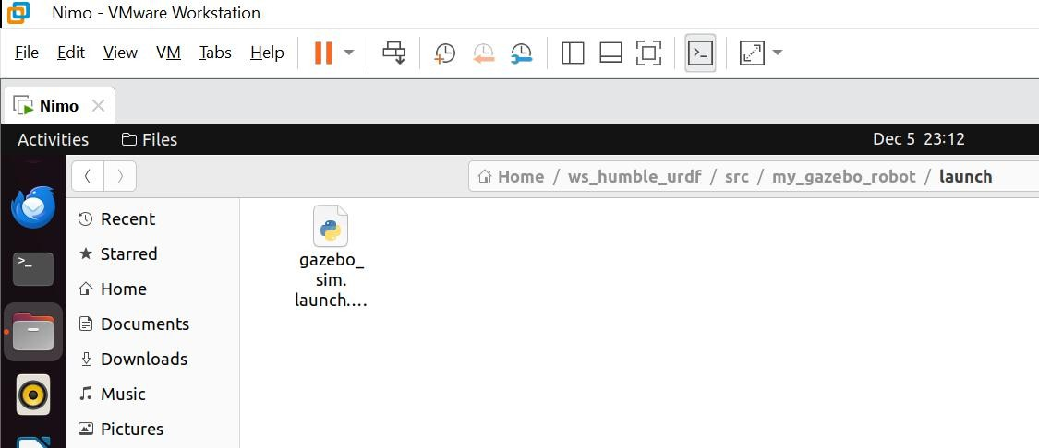

“The complete launch file used to spawn the robot in Gazebo is included in Appendix B.”

  - Manual Control Commands

The robot can be teleoperated by publishing velocity commands to the cmd_vel topic from the terminal. A constant twist message specifying forward linear velocity and angular velocity produces forward motion combined with rotation. Adjusting these values enables straight motion, in-place rotation, or curved trajectories. This method provides a simple means of verifying that the planar move plugin interprets twist messages correctly and that the robot responds as expected.

The linear X component represents forward speed in meters per second, and the angular Z component represents rotational speed in radians per second. Positive angular Z produces counterclockwise rotation, while negative values rotate clockwise. Understanding these conventions is important when designing automatic controllers that generate cmd_vel messages from sensor data.

  - Sonar Avoidance Node

An optional Python node, sonar_avoid_node, may be implemented in a separate ROS2 package. This node subscribes to the /my_robot/sonar topic to receive range measurements. Each callback compares the measured distance to a predefined safety threshold. When the distance is greater than the threshold, the node publishes a twist message with positive linear X and zero angular Z, causing forward movement. When the distance drops below the threshold, indicating an obstacle nearby, the node sets linear X to zero and applies a positive angular Z to rotate the robot until the path ahead is clear.

This creates a feedback loop in which Gazebo’s environment influences sonar readings, the controller interprets the readings, and the planar move plugin converts the resulting cmd_vel commands into motion, which in turn changes future sonar readings. This represents a complete sense–decide–act cycle typical of basic robotic navigation.
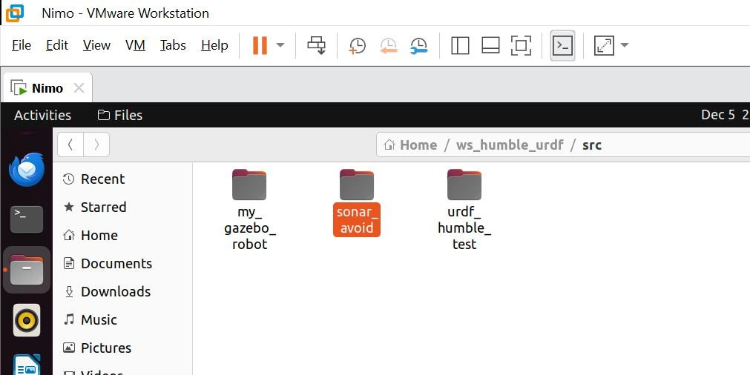

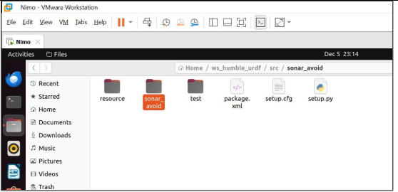

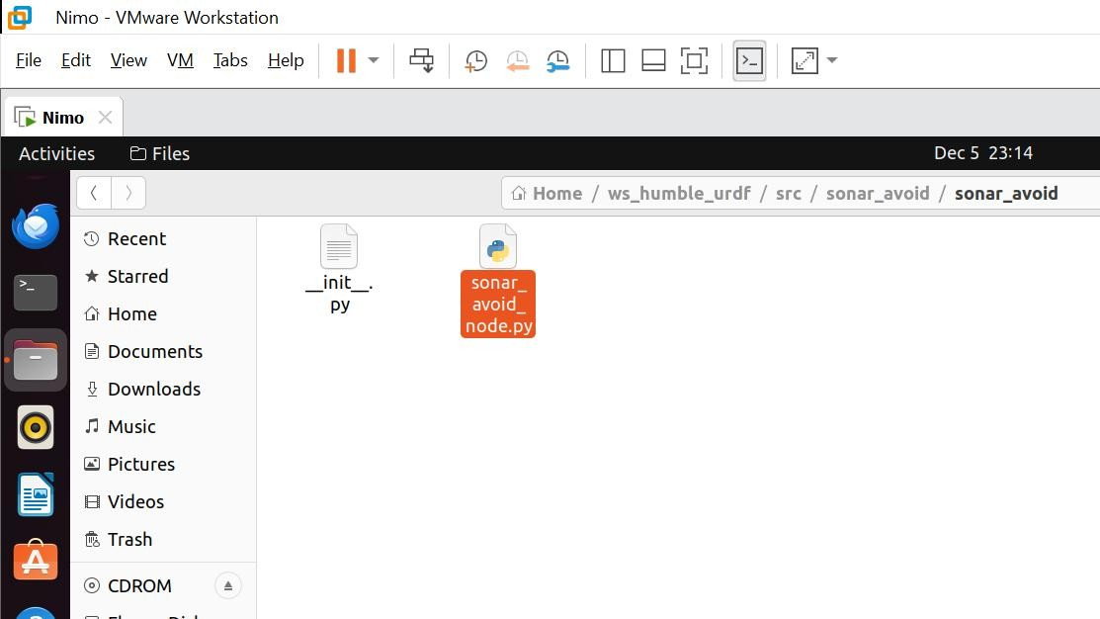
“The full implementation of the sonar-based obstacle avoidance node is included in Appendix C.”

Experiments and Results
  - Sonar Validation

A cube is inserted into the Gazebo environment and positioned at various known distances along the robot’s forward axis. The sonar topic is monitored, and the measured range values are recorded. The readings closely match the actual distances within the sensor’s configured resolution, confirming that the ray-based sonar model and its ROS2 plugin are functioning correctly and that the sonar frame is aligned with the robot’s base frame.Tabulating or plotting the relationship between true distances and measured ranges shows an approximately linear trend across the sensor’s operating limits, further confirming correct configuration.

  - Camera Validation

To verify the alignment of the camera and sonar, the cube is placed in front of the robot at a moderate distance. The camera feed is viewed using rqt_image_view, and the cube appears near the center of the image, confirming that the camera is pointed straight ahead. Simultaneously, the sonar reports a distance value corresponding to the cube’s position. Moving the cube closer or farther causes predictable changes in both the camera image and sonar readings. This consistency confirms that both sensors observe the same portion of the environment.

  - Robot Motion Tests

Robot motion is tested under manual and optional automatic control. Manual cmd_vel commands successfully produce forward movement and rotation, demonstrating correct interpretation by the planar move plugin. The observed trajectory matches the commanded twist values.

When the sonar avoidance node is used, the robot autonomously reacts to nearby obstacles. Beginning from a position facing an obstacle, the robot moves forward while the sonar reading exceeds the threshold. Once the obstacle enters the unsafe distance range, the node instructs the robot to stop forward motion and rotate. The robot turns until the sonar no longer detects the obstacle, after which forward movement resumes. These experiments demonstrate that the integrated system can react to environmental conditions through a basic obstacle-avoidance strategy.

  - Results Link
https://drive.google.com/file/d/1W7fGy21J4XWISEKIS5lyvc-kYwVokWD2/view?usp=sharing

Discussion
The experiments highlight the complementary roles of the camera and sonar sensors. The sonar provides straightforward, low-dimensional distance measurements ideal for simple reactive behaviors, though it does not convey information about object appearance or lateral placement. The camera supplies rich visual information capable of supporting more complex perception tasks but requires significant processing to extract useful geometric data.

Sensor placement and frame alignment significantly affect how easily sensor data can be interpreted. By mounting both sensors on the base and aligning them along the same axis, the sensors consistently observe obstacles directly ahead, simplifying system validation. More advanced designs could intentionally place sensors at different orientations to support navigation behaviors such as wall- following or environmental mapping.

The system has several limitations. The sonar model is idealized and lacks realistic noise or beam- spreading effects. The planar move plugin simplifies locomotion by not modeling wheel dynamics. The optional sonar controller is reactive and does not incorporate mapping or global planning. Nevertheless, these simplifications are appropriate for demonstrating fundamental integration of sensing, motion, and ROS2 software.

Conclusion and Future Work
This project develops a multi-sensor mobile robot simulation in ROS2 and Gazebo, incorporating a base, a revolute link, and dedicated links for camera and sonar sensors, all modeled with appropriate visual, collision, and inertial properties. The camera and sonar are integrated through ROS2 plugins, and the planar move plugin enables motion control using standard cmd_vel commands. Experiments confirm that sonar readings correspond to obstacle positions, that the camera observes the same region as the sonar, and that the robot responds correctly to motion commands, with optional reactive behavior based on sonar measurements.

Future work may involve extending the sonar controller to implement more sophisticated avoidance behaviors, such as wall following or maze navigation; incorporating computer vision processing to detect colored objects or features using the camera; or adapting the simulated system to a real-world robot platform where sensor noise, calibration, and hardware constraints introducce additional challenges.

Appendix A - Complete Code
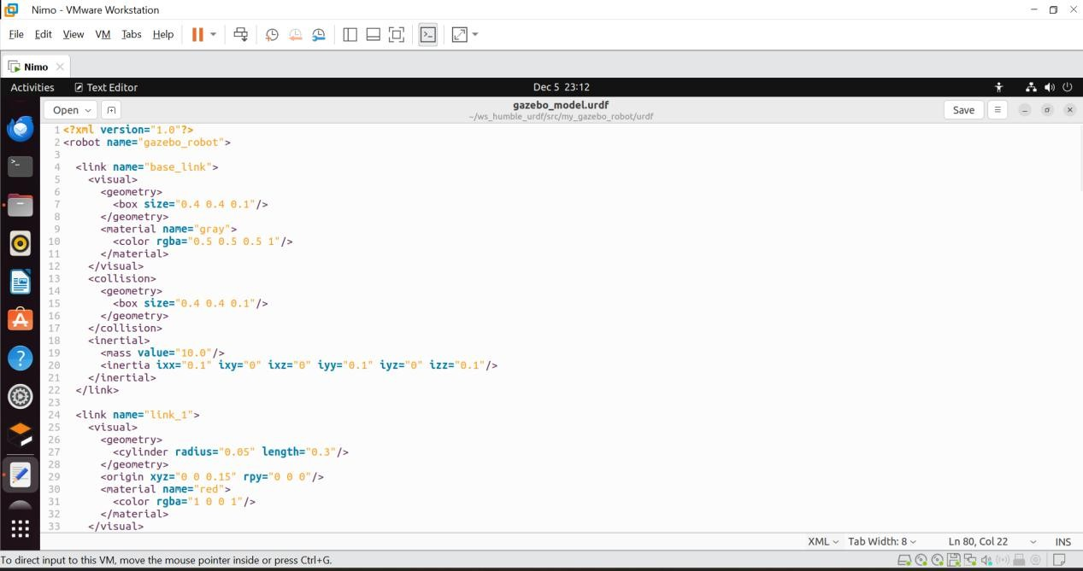

CODE:
<?xml version="1.0"?>
<robot name="gazebo_robot">

<link name="base_link">
<visual>
<geometry>
<box size="0.4 0.4 0.1"/>
</geometry>
<material name="gray">
<color rgba="0.5 0.5 0.5 1"/>
</material>
</visual>
<collision>
<geometry>

<box size="0.4 0.4 0.1"/>
</geometry>
</collision>
<inertial>
<mass value="10.0"/>
<inertia ixx="0.1" ixy="0" ixz="0" iyy="0.1" iyz="0" izz="0.1"/>
</inertial>
</link>

<link name="link_1">
<visual>
<geometry>
<cylinder radius="0.05" length="0.3"/>
</geometry>
<origin xyz="0 0 0.15" rpy="0 0 0"/>
<material name="red">
<color rgba="1 0 0 1"/>
</material>
</visual>
<collision>
<geometry>
<cylinder radius="0.05" length="0.3"/>
</geometry>
<origin xyz="0 0 0.15" rpy="0 0 0"/>
</collision>
<inertial>

<mass value="1.0"/>
<inertia ixx="0.01" ixy="0" ixz="0" iyy="0.01" iyz="0" izz="0.01"/>
</inertial>
</link>

<joint name="joint_1" type="revolute">
<parent link="base_link"/>
<child link="link_1"/>
<origin xyz="0 0 0.05" rpy="0 0 0"/>
<axis xyz="0 0 1"/>
<limit lower="-3.14" upper="3.14" effort="50" velocity="1.0"/>
</joint>

<link name="camera_link">
<visual>
<geometry>
<box size="0.05 0.05 0.05"/>
</geometry>
<material name="blue">
<color rgba="0 0 1 1"/>
</material>
</visual>
<collision>
<geometry>
<box size="0.05 0.05 0.05"/>
</geometry>

</collision>
<inertial>
<mass value="0.1"/>
<inertia ixx="0.001" ixy="0" ixz="0" iyy="0.001" iyz="0.001" izz="0.001"/>
</inertial>
</link>

<joint name="camera_joint" type="fixed">
<parent link="base_link"/>
<child link="camera_link"/>
<origin xyz="0.25 0 0.25" rpy="0 0 0"/>
</joint>

<!-- Sonar link -->
<link name="sonar_link">
<visual>
<geometry>
<box size="0.03 0.03 0.03"/>
</geometry>
<material name="yellow">
<color rgba="1 1 0 1"/>
</material>
</visual>
<collision>
<geometry>
<box size="0.03 0.03 0.03"/>

</geometry>
</collision>
<inertial>
<mass value="0.05"/>
<inertia ixx="0.0001" ixy="0" ixz="0" iyy="0.0001" iyz="0" izz="0.0001"/>
</inertial>
</link>

<joint name="sonar_joint" type="fixed">
<parent link="base_link"/>
<child link="sonar_link"/>
<origin xyz="0.25 0 0.15" rpy="0 0 0"/>
</joint>

<gazebo reference="base_link">
<material>Gazebo/Gray</material>
</gazebo>
<gazebo reference="link_1">
<material>Gazebo/Red</material>
</gazebo>
<gazebo reference="camera_link">
<material>Gazebo/Blue</material>
</gazebo>

<gazebo reference="camera_link">
<sensor type="camera" name="camera_sensor">

<update_rate>30.0</update_rate>
<camera name="head">
<horizontal_fov>1.3962634</horizontal_fov>
<image>
<width>800</width>
<height>800</height>
<format>R8G8B8</format>
</image>
<clip>
<near>0.02</near>
<far>300</far>
</clip>
</camera>
<plugin name="camera_controller" filename="libgazebo_ros_camera.so">
<alwaysOn>true</alwaysOn>
<updateRate>0.0</updateRate>
<cameraName>my_robot/camera1</cameraName>
<imageTopicName>image_raw</imageTopicName>
<cameraInfoTopicName>camera_info</cameraInfoTopicName>
<frameName>camera_link</frameName>
</plugin>
</sensor>
</gazebo>

<!-- Sonar sensor -->
<gazebo reference="sonar_link">

<sensor type="ray" name="sonar_sensor">
<always_on>true</always_on>
<update_rate>20.0</update_rate>
<visualize>true</visualize>

<ray>
<scan>
<horizontal>
<samples>1</samples>
<resolution>1</resolution>
<min_angle>0.0</min_angle>
<max_angle>0.0</max_angle>
</horizontal>
<vertical>
<samples>1</samples>
<resolution>1</resolution>
<min_angle>0.0</min_angle>
<max_angle>0.0</max_angle>
</vertical>
</scan>
<range>
<min>0.05</min>
<max>3.0</max>
<resolution>0.01</resolution>
</range>
</ray>

<plugin name="sonar_controller" filename="libgazebo_ros_ray_sensor.so">
<ros>
<namespace>/my_robot</namespace>
<remapping>~/out:=sonar</remapping>
</ros>
<frame_name>sonar_link</frame_name>
</plugin>
</sensor>
</gazebo>

<gazebo>
<plugin name="object_controller" filename="libgazebo_ros_planar_move.so">
<commandTopic>cmd_vel</commandTopic>
<odometryTopic>odom</odometryTopic>
<odometryFrame>odom</odometryFrame>
<odometryRate>20.0</odometryRate>
<robotBaseFrame>base_link</robotBaseFrame>
</plugin>
</gazebo>

</robot>

Appendix B
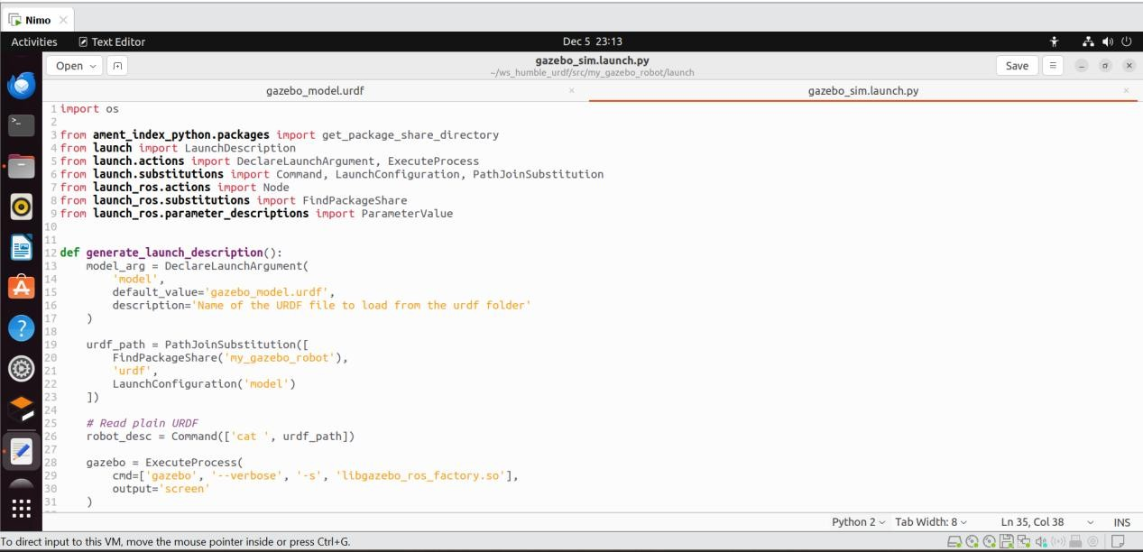

CODE:

import os

from ament_index_python.packages import get_package_share_directory from launch import LaunchDescription
from launch.actions import DeclareLaunchArgument, ExecuteProcess
from launch.substitutions import Command, LaunchConfiguration, PathJoinSubstitution from launch_ros.actions import Node
from launch_ros.substitutions import FindPackageShare
from launch_ros.parameter_descriptions import ParameterValue

def generate_launch_description(): model_arg = DeclareLaunchArgument(
'model',

default_value='gazebo_model.urdf',
description='Name of the URDF file to load from the urdf folder'
)

urdf_path = PathJoinSubstitution([ FindPackageShare('my_gazebo_robot'), 'urdf',
LaunchConfiguration('model')
])

# Read plain URDF
robot_desc = Command(['cat ', urdf_path])

gazebo = ExecuteProcess(
cmd=['gazebo', '--verbose', '-s', 'libgazebo_ros_factory.so'], output='screen'
)

spawn_entity = Node( package='gazebo_ros', executable='spawn_entity.py',
arguments=['-entity', 'my_robot', '-topic', 'robot_description'], output='screen'
)

robot_state_publisher = Node(

package='robot_state_publisher', executable='robot_state_publisher', name='robot_state_publisher', output='screen',
parameters=[{
'robot_description': ParameterValue(robot_desc, value_type=str)
}]
)

return LaunchDescription([ model_arg,
gazebo, spawn_entity,
robot_state_publisher
])

Appendix C:
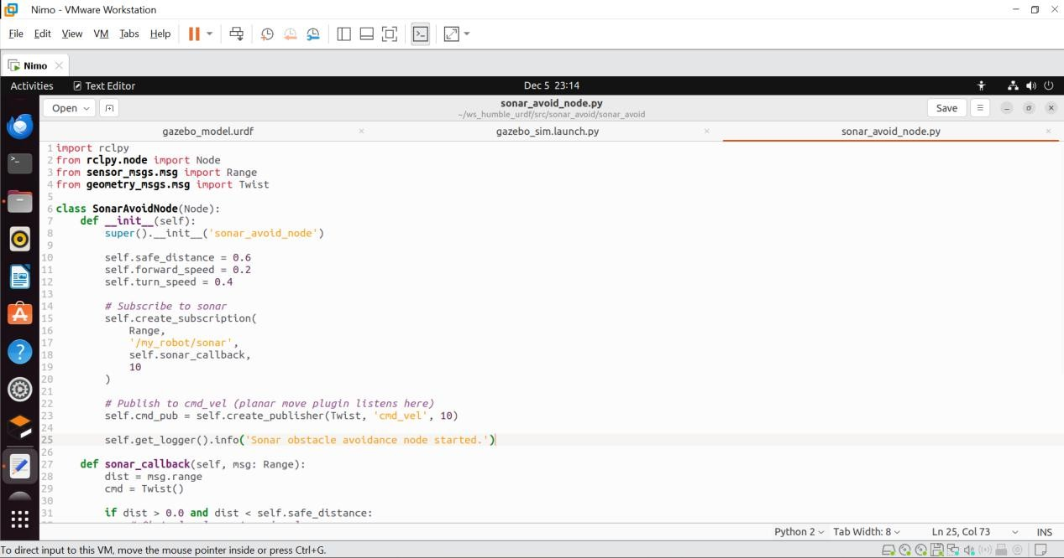

CODE:
import rclpy
from rclpy.node import Node
from sensor_msgs.msg import Range from geometry_msgs.msg import Twist

class SonarAvoidNode(Node): def init (self):
super(). init ('sonar_avoid_node')

self.safe_distance = 0.6
self.forward_speed = 0.2
self.turn_speed = 0.4

# Subscribe to sonar self.create_subscription(
Range, '/my_robot/sonar', self.sonar_callback, 10
)

# Publish to cmd_vel (planar move plugin listens here) self.cmd_pub = self.create_publisher(Twist, 'cmd_vel', 10)

self.get_logger().info('Sonar obstacle avoidance node started.')

def sonar_callback(self, msg: Range): dist = msg.range
cmd = Twist()

if dist > 0.0 and dist < self.safe_distance: # Obstacle close: turn in place cmd.linear.x = 0.0
cmd.angular.z = self.turn_speed
else:
# Path clear: go straight cmd.linear.x = self.forward_speed cmd.angular.z = 0.0

self.cmd_pub.publish(cmd)

def main(args=None): rclpy.init(args=args)
node = SonarAvoidNode() rclpy.spin(node) node.destroy_node() rclpy.shutdown()

if name == ' main ': main()

References:
- Quigley, M., Gerkey, B., & Smart, W. D. (2015). Programming Robots with ROS: A Practical Introduction to the Robot Operating System. O’Reilly Media.
- Inigo-Blasco, P., Díaz-del-Río, F., Cagigas-Muñiz, D., & Vicente-Díaz, S. (2012). A survey of mobile robots: Developments and trends. Journal of Industrial Informatics, 8(4), 581–593.
- Open Robotics (2023). ROS 2 Documentation – Humble Hawksbill. Retrieved from https://docs.ros.org/en/humble/
- Open Robotics (2023). URDF – Unified Robot Description Format. Retrieved from https://wiki.ros.org/urdf
- Open Robotics (2023). robot_state_publisher Package Documentation. Retrieved from https://docs.ros.org/en/humble/p/r/state_publisher
- Open Robotics (2023). Gazebo Simulation Documentation. Retrieved from https://gazebosim.org/docs

Gazebo ROS Integration – gazebo_ros_pkgs (2023).
Retrieved from https://gazebosim.org/api/ros
- Kuc, R., & Li, H. (1985). Experimental study of sonar systems for mobile robots. IEEE Transactions on Robotics and Automation, 1(1), 31–41.
- Szeliski, R. (2010). Computer Vision: Algorithms and Applications. Springer.
- Bradski, G., & Kaehler, A. (2008). Learning OpenCV: Computer Vision with the OpenCV Library.
O’Reilly.

gazebo_ros_camera Plugin Documentation (2023).
Retrieved from https://gazebosim.org/api/ros/camera

gazebo_ros_ray_sensor Plugin Documentation (2023).
Retrieved from https://gazebosim.org/api/ros/ray

gazebo_ros_planar_move Plugin Documentation (2023).
Retrieved from https://gazebosim.org/api/ros/planar_move
- MacMartin, M. (2023). Writing ROS2 Python Nodes (rclpy).
Retrieved from https://docs.ros.org/en/humble/Tutorials/Intermediate/ROS2PythonNodes.html
- Siegwart, R., Nourbakhsh, I. R., & Scaramuzza, D. (2011). Introduction to Autonomous Mobile Robots (2nd ed.). MIT Press.

