# Creative Processes Representation

A conceptual model extending CIDOC CRM and FRBR for the description of creative processes

**Authors:**

Guillem Anaïs, Bruseker George

**Context:**

ETH/SARI collaboration, need of integration of heterogeneous architectural data. This work has been carried out in collaboration with the research team at ETH Zurich working on Heinz Isler archives.

**Dependencies CIDOC CRM and extensions:**

Creative Processes Representation (CPR) ontology is built on:

CIDOC CRM 6.2.1

FRBRoo 2.4

CRMSoc 0.9

**Scope:**

Creative Processes Representation, is an ontological model harmonizing to the CIDOC CRM family of models that aims to facilitate the representation and integration of information related to creative processes and the materialization of ideas into reality. It has a particular focus on architectural creative processes and will open its scope to deal with artistic creative processes as well.

The presently proposed model and its related classes and properties have been modelled to cover architectural practice, art, archives and design activities.

**Examples used:**

Examples come directly from the collaboration and close discussion with the Isler project team. Other examples come from D. Libeskind architectural production or from Le Corbusier designs.

**OntoME**::

[http://ontologies.dataforhistory.org/namespace/72#classe](http://ontologies.dataforhistory.org/namespace/72#classes)

In OntoME:

CC1: superclasses F2 and E29 to be deleted

CC4: superclasses socE2 and F2 to be deleted

CC5: superclass CC9 to be deleted

CC6: superclass socE2 to be deleted

**Creative Processes Representation** **1**

**Classes definition** **5**

**CC1 Architectural Model** **5**

**CC2 Construction** **7**

**CC3 Execution Concept** **8**

**CC4 Construction Plan** **9**

**CC5 Architectural Formulation** **10**

CC6 Architectural Program 12

**CC7 Maîtrise d'Ouvrage (MOa)** **13**

**CC8 Maîtrise d'Oeuvre (MOe)** **15**

**CC9 Oeuvre** **16**

**CC10 Mission** **18**

**CC11 Object Trigger Template** **19**

**CC12 Event Trigger Template** **21**

CC13 Design Concept 23

**CC14 Programmation** **24**

**CC15 Design Conception** **26**

**CC16 Construction Planning** **27**

**CC17 Projective Requirements** **28**

**CC18 Architectural Activity Plan** **29**

**CC19 Assessment** **30**

Properties list 32

**Properties definitions** **32**

cp1 had client team (was client team of) 32

cp2 had executing team (was executing team of) 32

cp3 was undertaken by (undertook) 33

cp4 projects (was projected by) 33

cp5 stipulates type of object outcome (is type of object outcome stipulated by) 34

cp6 stipulates event type (is type of event stipulated by) 34

cp7 stipulates actor type (is actor type stipulated by) 34

cp8 stipulates place (is place stipulated by) 35

cp9 stipulates time-span (is time-span stipulated by) 35

cp10 stipulates actor (is actor stipulated by) 35

cp11 stipulates equipment (is equipment stipulated by) 35

cp12 stipulates particular method (is particular method stipulated by) 36

cp13 stipulates budget (is budget stipulated by) 36

cp14 stipulates object outcome (is object outcome stipulated by) 36

cp15 stipulates sub-event (is sub-event stipulated by) 37

cp16 stipulates material (is material stipulated by) 37

cp17 stipulates site (is site stipulated by) 38

cp18 stipulates dimension (is dimension stipulated by) 38

cp19 stipulates function (is function stipulated by) 38

cp20 stipulates reference (is reference stipulated by) 38

cp21 stipulates part (is part stipulated by) 39

cp22 assessed (was assessed by) 39

cp23 assigned (was assigned by) 39

cp24 produced revision (was revision produced by) 40

cp25 concerns extant object (is object of concern of) 40

## Classes definition

### CC1 Architectural Model

**Subclass of**:

CC5 Architectural Formulation

**Scope note**:

This class comprises the immaterial content of objects created during architectural design in order to express and represent architectural concepts. The propositional content contained in an architectural model provides information regarding an overall architectural concept and can be used to understand the architect’s intent. Instances of this class are information objects produced as a result of architectural design processes (instances of F28) undertaken in relation to the goals of an instance of CC15 Design Conception to comply with the specifications of an instance of CC6 Architectural Program. An instance of Architectural Model realises, in whole or in part, the propositional content of the instance of CC3 Design Concept it especially functions to provide representations of the relations of space and materiality of the design proposal, such that these representations can be used as guides for the eventual realization of these models in some built work.

**Examples**:

Le Corbusier’s sketch (CC1) for the Palais de Soviets competition.

<https://thecharnelhouse.org/2013/06/19/le-corbusiers-project-for-the-palace-of-the-soviets-1928-1931/#jp-carousel-2078>

Isler’s draped fabric physical models (CC1) for shape finding of structural efficiency in concrete shells.

<http://blog.buildllc.com/2009/04/heinz-isler-a-few-important-things/>

The design concept of the Edmonton Public Library

https://archpaper.com/2019/07/backlash-edmonton-public-library-construction/

Fujimoto’s Tower Gathering Towers (and other mini models)

George Howe and William Lescaze’s unrealized proposal for the original Moma

Plan Voisin (1925), Le Corbusier https://theculturetrip.com/europe/articles/8-spectacular-unrealized-architectural-projects/

Utzon’s winning design for the Sydney Opera House

The original design work on the Gran Teatre del Liceu by Miquel Garriga i Roca c.1840 (https://en.wikipedia.org/wiki/Liceu)

In First Order Logic:

CC1(x) ⊃ F2(x)

CC1(x) ⊃ E29(x)

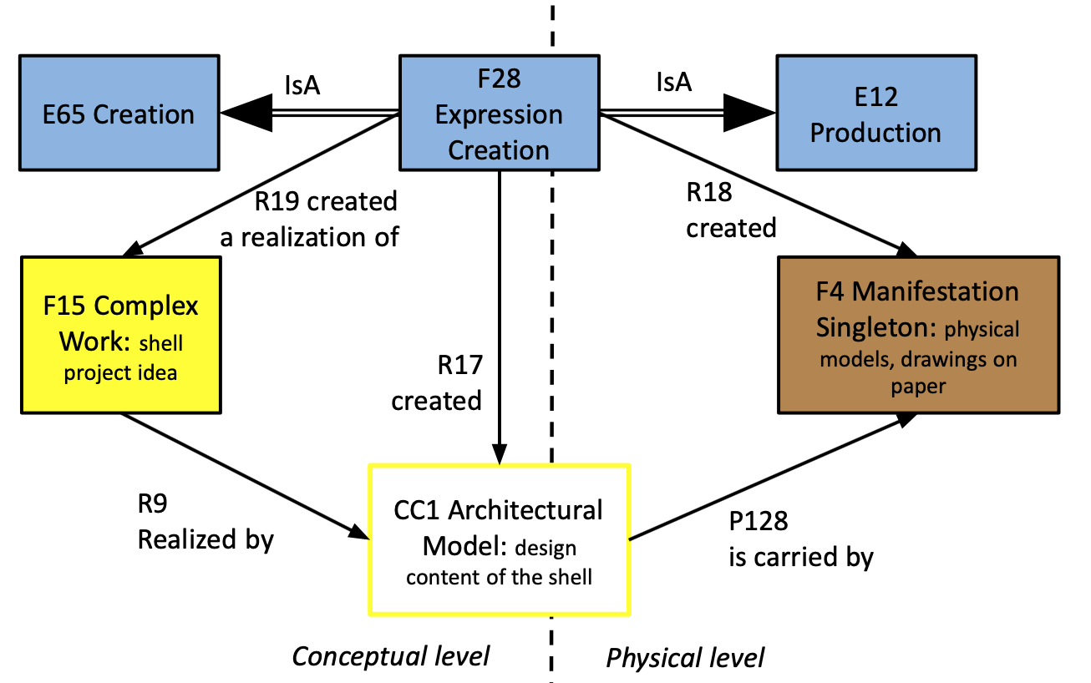

Fig: CC1 Architectural Model and its relation to FRBRoo classes

### CC2 Construction

Subclass: E12 Production

Scope note:

This class comprises the events of the construction in an Oeuvre.

Property:

ar1->ar4:executed

Examples:

In First Order Logic:

The construction event of the Edmonton Public Library

https://archpaper.com/2019/07/backlash-edmonton-public-library-construction/

Building stage one of the Sydney Opera House at Bennelong Point from 1959 until 1963, two years behind schedule

https://www.sydneyoperahouse.com/our-story/sydney-opera-house-history/construction-begins.html

### CC3 Execution Concept

Subclass of: F1 Work

Scope note:

This class comprises combinations of concepts such as are found in construction planning documents, such as BIM, details, drawings, sketches, diagrams, plans, descriptions, 3D representations etc. The instance of Execution Concept is a complex set of ideas that is proposed as the intellectual response to a certain, projected architectural concept, expressed in an instance of Design Concept, interpreting the latter as particular construction proposal. The Execution Concept is typically elaborated by a Maitrise d’Oeuvre (MOe) through different construction planning documents - instances of Construction Plan - that represent aspects of the overall plan. The substance of Execution Concept is ideas; with regards to construction the ideas proposed typically deal with the planning of the execution and realization of an architectural model into a physical object taking into account various real-world constraints regarding the organization of the events necessary to bring this end about. An instance of Execution Concept is complex by nature as it interacts with the set of constraints expressed in an instance, or more, of Architectural Model that detail the conceptual and physical aspects of the spatial projection selected as expressing the Design Concept. The Expression Concept is articulated through various documents expressing different collective proposals that will go through processes of selection and filtering. In the normal case, one of these proposals will be selected as satisfying the Design Concept expressed in an Architectural Model and serve as the instance of Construction Plan that expresses the proposed Execution Concept.

-~The specific functionality of this class is to indicate the sets of concepts generated in order to plan the execution of a construction activity.

Examples:

-The execution concept (CC3) proposed by Skidmore, Owings & Merrill (E74) based on the Architectural Model (CC1) of Libeskind for the One World Freedom Tower.

<https://en.wikiarquitectura.com/building/one-world-trade-center-freedom-tower/>

-““… I really wanted our design was based on something that was very real, not just in sculptural sketches.’ve Explored the infrastructure problems because the proper solution would have to be convincing, not only beautiful. Designing has no great sculptural implications, understand deeply, the symbolic importance of the tower, but also have to be a highly efficient building.’s speech on Freedom Tower has often been limited to the symbolic, formal and aesthetic but recognize that if this building does not work well, if people do not want to work and visit, then we have failed as architects… ”

<https://en.wikiarquitectura.com/building/one-world-trade-center-freedom-tower/>

In First Order Logic:

### CC4 Construction Plan

Subclass of:

CC5 Architectural Formulation

This class comprises the immaterial content of objects created during construction planning in order to express and represent aspects of the construction activity and its outcome. The propositional content contained in a construction plan provides information regarding an overall execution concept for a construction activity and can be used to understand the construction planner’s intent. Instances of this class are information objects produced as the result of construction planning processes (instances of F28) undertaken in relation to the goals of an instance of CC16 Construction Planning to comply with the specifications of an instance of CC1 Architectural Model. An instance of Construction Plan realises, in whole or in part, the propositional content of the instance of CC3 Execution Concept.

Examples:

In First Order Logic:

### CC5 Architectural Formulation

Subclass of:

CC18 Architectural Activity Plan

F2 Expression

Superclass of:

CC1 Architectural Model

CC6 Architectural Program

CC4 Construction Plan

Scope Note:

This class comprises the immaterial content of objects created during architectural conception activities. The propositional content contained in an architectural formulation provides information which represents particular architectural concepts proposed for a certain project and which may provide information on how to realize these concepts into concrete objects. Instances of this class are information objects produced during an activity of expression creation undertaken in relation to the goals of an instance of F27 Work Conception to realize an architectural idea. An instance of architectural formulation realises, in whole or in part, the propositional content of the instance of F1 Work.

Examples:

The programming activities (CC5) undertaken by Port Authority of New York and New Jersey and Larry Silverstein (CC7) in order to specify the user requirements (CC17) for the design of the One World Trade Centre (E22) in New York.

In First Order Logic:

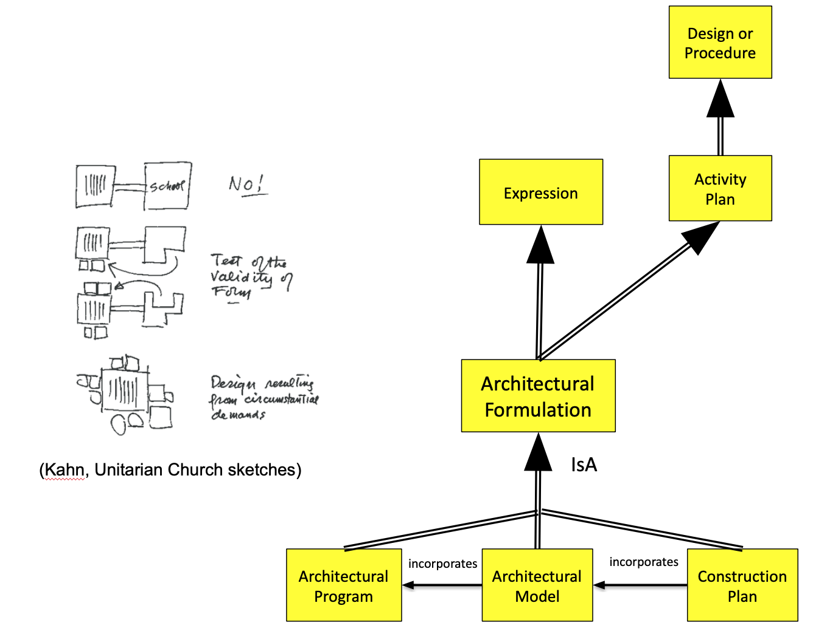

Fig: Overview of the class CC5 Architectural Formulation and super- and subclasses

### 

### **CC6 Architectural Program**

Subclass of:

CC5 Architectural Formulation

Scope note:

This class comprises instances of information object expressing projective requirements, wishes and needs, for an architectural work, in a formalized manner. A finalized, accepted architectural program provides an expression of the users requirements that will be employed as a constraint and guide to a design project/proposal (A13 Design Concept). An instance of CC6 Architectural Program comes into existence from an activity of expression creation that aims to express the projective requirements sought by an instance of CC5 Programmation activity.

Examples:

The content of the 1920s era specification for the competition to design the future ‘Palais des Nations’, headquarters of the League of Nations. (CC6)

<https://en.wikipedia.org/wiki/Palace_of_Nations>

In First Order Logic:

CC6(x) ⊃ socE2(x)

CC6(x) ⊃ F2(x)

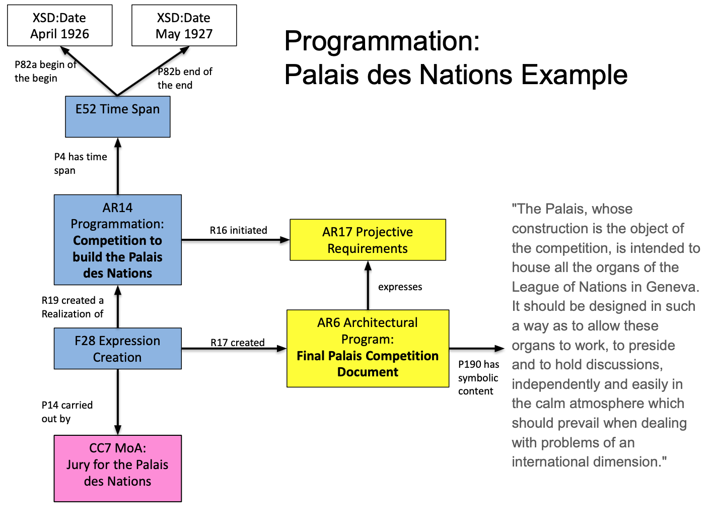

Fig.: Illustration of CC6 Architectural Program with the example of the Palais des Nations.

### CC7 Maîtrise d'Ouvrage (MOa)

Subclass of: E74 Group

Scope note:

This class comprises the group of actors, either individuals or collectives, that form together a team that represents the client for whom an instance of Oeuvre is undertaken. The CC7 either is or represents the client for whom an architectural project is designed. Thus the CC7 can be a group containing only one member, the client him/herself. This class, therefore, covers the groups or individuals that are commonly indicated as 'client', 'owner', or ‘user’. The Maîtrise d’Ouvrage MOa consists of all designated members of the client’s representation and can be decomposed into subgroups, usually along main roles or functions within this representation. An instance of MOa comes into being together with the agreement to commission an CC9 Oeuvre with a counterparty MOe, that undertakes to execute it. The MOa remains in existence until the agreed upon outcome, commonly a design or a construction, is realized and accepted, or the goal is abandoned.

Examples:

This residence was designed for Dr. Frederick O.Lien (CC7), by Schwartz and Ryland (Fresno) and built by J.E. Fritz.

The Port Authority of New York and New Jersey and Larry Silverstein (CC7) accepted the project for the Freedom Tower, proposed by Daniel Libeskind.

In First Order Logic:

CC7(x) ⊃ E74(x)

Incoming properties:

CC9 Oeuvre → cp1 had client team-> CC7 Maîtrise d’ouvrage

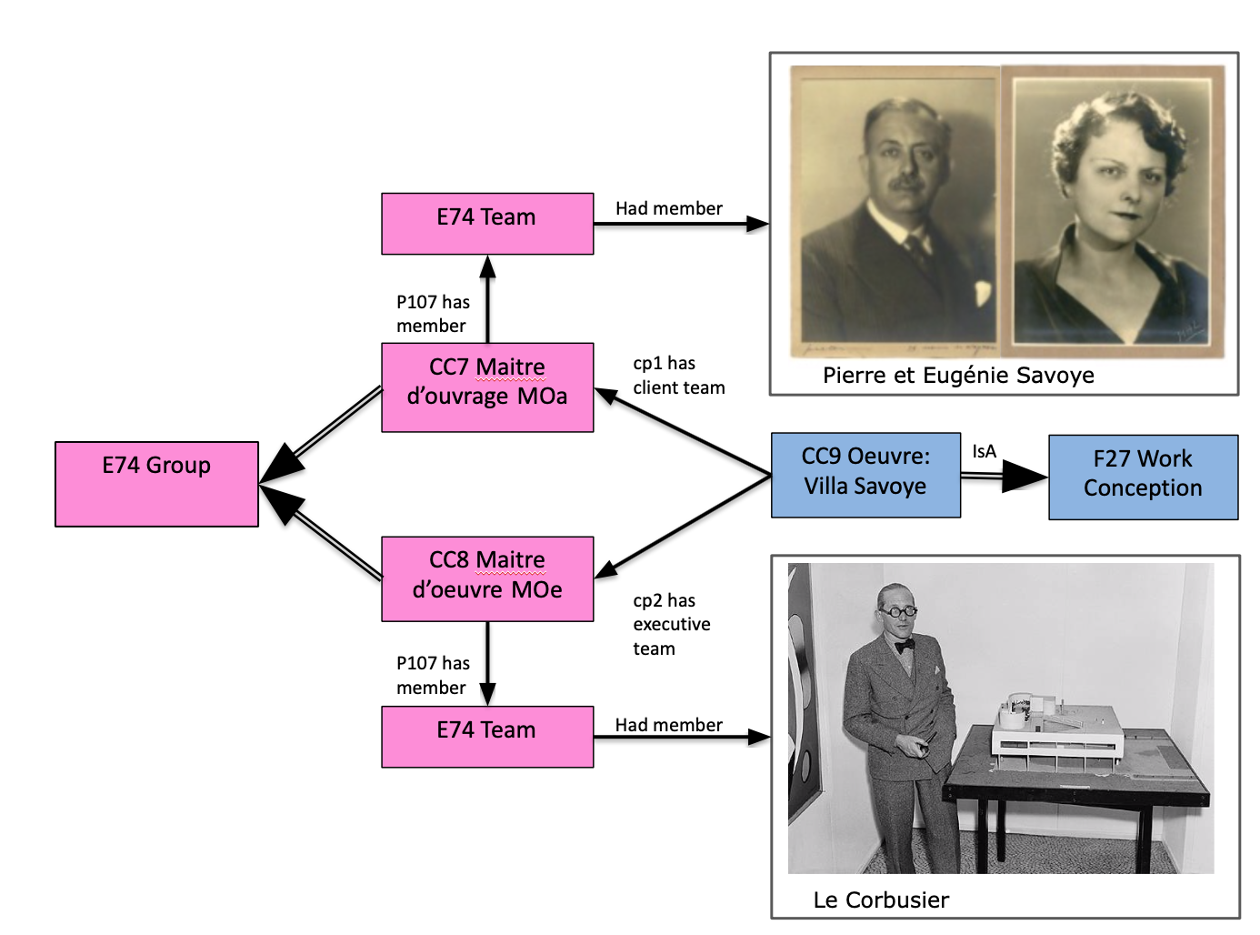

Fig: overview of class CC7 Maitre d’ouvrage (client team) with the example of Le Corbusier and the project of Villa Savoye.

### CC8 Maîtrise d'Oeuvre (MOe)

Subclass of: E74 Group

Scope note:

This class comprises groups of actors, either individuals or collectives, that form together a team that represents the team which undertakes to execute an CC9 Oeuvre for a client (CC7). The CC8 either is or represents the executing party by which an architectural project is carried out. Thus the CC8 can be a group containing only one member, the executing agent him/herself. This class, therefore, covers the groups or individuals that are commonly indicated as 'designer', 'architect', or ‘builder’. The MOe consists of all designated members of the executing team and can be decomposed into subgroups, usually along main roles or functions within this team. An instance of MOe comes into being together with the agreement to execute an CC9 Oeuvre with a counterparty MOa, that commissions it. The MOe remains in existence until the agreed upon outcome, commonly a design or a construction, is realized and accepted, or the goal is abandoned.

Examples:

-This residence was designed for Dr. Frederick O.Lien, by **Schwartz and Ryland** (Fresno) and built by **J.E. Fritz** (CC8).

-The executing team of the One World Trade Centre (CC8), with original lead architect Daniel Libeskind, undertook the design of the tower from 2002-2005.

In First Order Logic:

CC8(x) ⊃ E74(x)

Incoming properties:

CC9 Oeuvre → cp2 had executing team -> CC8

### CC9 Oeuvre

Subclass of: F27 Work Conception

Scope Note:

This class comprises the beginning of the evolution of a set of activities that aim towards the common intent to realize an architectural work in a broad sense, by a client team (CC7-MOa) and an executing team (CC8-MOe). An instance of CC9-Oeuvre marks the initiation of an instance of F17-Aggregation Work which gathers together the various works that are conceived and realized towards this common goal. An instance of this class comes into being alongside the constitution of an instance of CC7-MOa (client) and CC8-MOe (architect) which jointly agree to the funding and realization of an architectural work in the broad sense. The instance of CC9-Oeuvre is considered to be on-going and to encompass the sub-activities undertaken towards the realization of the main goal as long as the two parties, the MOa and MOe jointly continue to pursue this aim.

Examples:

The activities initiated by the granting of the 'Freedom Tower' project (CC9) to the team led by Daniel Libeskind (CC8) by Lower Manhattan Development (CC7) which began in 2002.

The commissioning of the Villa Jeanneret by Le Corbusier's brother, Albert Jeanneret, and his fiancée Lotti Raaf (<https://en.wikipedia.org/wiki/Villa_Jeanneret>)

The commissioning of Swiss architects Le Corbusier and his cousin, Pierre Jeanneret to build a country retreat for the Savoye family (Villa Savoye)

(<https://en.wikipedia.org/wiki/Villa_Savoye>)

The commission of Frank Gehry to design the new Jazz Bakery building at 9814 Washington Blvd. next to the Kirk Douglas Theatre in the downtown arts district (on hold) (<https://en.wikipedia.org/wiki/Jazz_Bakery>)

The agreement between the Societat del Gran Teatre del Liceu (Great Liceu Theatre Society) and Miquel Garriga i Roca to design the Liceo Filarmónico Dramático c.1840 (https://en.wikipedia.org/wiki/Liceu)

The organization of the Fundació del Gran Teatre del Liceu (Liceu Great Theater Foundation) with the architects Ignasi de Solà-Morales and Xavier Fabré i Lluís Dilmé to rebuild the Liceo Filarmónico Dramático in 1994

properties:

cp1 has client team → CC7 Maîtrise d'Ouvrage MOa

cp2 had executing team → CC8 Maîtrise d'Oeuvre MOe

First order logic:

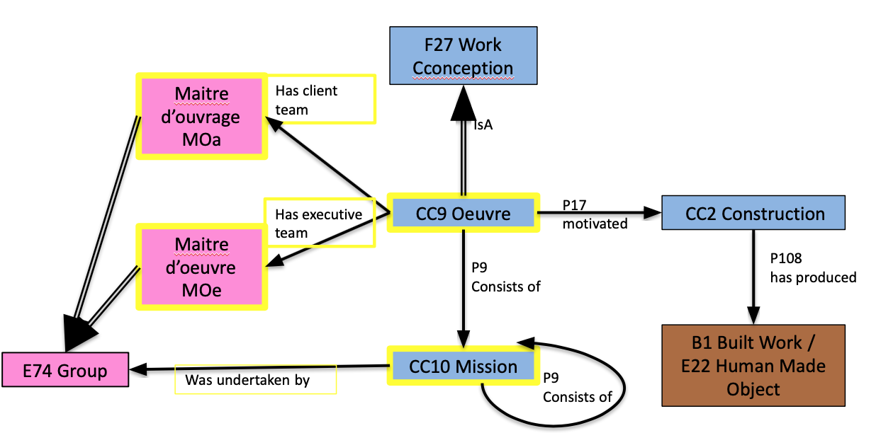

Fig: Overview of the class CC9 Oeuvre

### CC10 Mission

Subclass of:

E7_Activity

Scope Note:

This class comprises assigned and accepted commitments by teams of actors to carry out a kind of activity within the context of an overall architectural project (Oeuvre). An instance of mission is used in order to be able to document the details of the commitment undertaken by a team within a project. The substance of the mission is continued, accepted obligation over time. An instance of this class comes into being upon the assignment of the particular set of tasks to the particular group and its acceptance thereof. The instance of mission ceases to exist when the assigned tasks have been discharged, the overall oeuvre cancelled or the willingness of the assigned and accepting group ceases to hold. The existence of an instance of mission potentially implies moral and legal obligations on the part of the group accepting to undertake the assigned mission.

Examples:

In First Order Logic:

Property:

cp3 undertaken by [undertook] [CC10->E74]

### CC11 Object Trigger Template

Subclass of: E89 Propositional Object

Scope note:

This class comprises specifications of projected architectural objects that detail constraints, specified as desired or necessary, that a projected architectural object should comply with, according to a documented instance of CC6 Architectural Program. The function of CC11 Object Trigger Template is to allow the specification of qualities which the realized architectural object should have such as dimension, material, function etc. The qualities specified here should be used as constraints to an architectural design activity and can be used as a check of conformity between delivered design and construction activities and documented projective requirements. For the documentation of the details of the constraints on the projected creation activity of the architectural object, an associated instance of CC12 Architectural Event Trigger Template should be instantiated and connected through the property *cp14i is required object outcome*.

Formalized projective requirements come into existence upon the creation of an instance of CC6 Architectural Program and may be analytically documented in an instance of CC11 Object Trigger Template. An instance of CC11 Object Trigger Template is considered to stand as the valid constraint with regards to further design activities within the context of an on-going Oeuvre, unless a newer instance of CC6 Architectural Program is created to supercede it.

Examples:

“The single-stage competition will select an ‘iconic’ design for a landmark **51,000m2** (E54) National Central Library and National **Repository Library** (E55 ‘Function’) in **Xinying District** (E27) around 37km north of Tainan City. (Taiwan)” (CC11)

https://www.architectsjournal.co.uk/competitions/competition-national-central-library-southern-branch-taiwan/10033249.article

In First Order Logic:

CC11(x) ⊃ E89(x)

Ongoing properties:

cp16 stipulates material -> E57 Material

cp17 stipulates site -> E27 Site

cp18 stipulates dimension -> E54 Dimension

cp19 stipulates function -> E55 Type

cp20 stipulates reference -> E73 Information Object

cp21 stipulates part -> CC11 Object Trigger Template

Incoming properties:

CC11 Object Trigger Template → ar20 stipulates part

CC12 Architectural Event Trigger Template → ar15 requires object outcome

### CC12 Event Trigger Template

Subclass of:

E89_Propositional_Object

(socE4 Trigger Event Template)

Scope note:

This class comprises specifications of projected architectural activities towards the realization of an architectural work. It details constraints, ( specified as desired or necessary) that an architectural activity should comply with, according to the documented instance of CC6 Architectural Program. The specified constraints can be instantiated on the level of kinds of processes, items or qualities and quantities involved in the action. The qualities specified here should be used as constraints to an architectural design activity and can be used as a check of conformity between delivered design and construction activities and documented projective requirements. An instance of an expected kind of outcome in terms of object, e.g. design or building, is typically implied in most instances of CC12 Architectural Event Trigger Template and documented via an instance of CC11 Object Trigger Template. Formalized projective requirements come into existence upon the creation of an instance of CC6 Architectural Program and may be analytically documented in an instance of CC12 Architectural Event Trigger Template. An instance of CC12 Architectural Event Trigger Template is considered to stand as the valid constraint with regards to further design activities within the context of an on-going Oeuvre, unless a newer instance of CC6 Architectural Program is created to supercede it.

Examples:

The analytic description (CC12) of the content of the 1920s era specification for the competition to design the future ‘Palais des Nations’, headquarters of the League of Nations (CC6), as parsed into definite constraining properties.

In First Order Logic:

CC12(x) ⊃ socE4(x)

cp5 stipulates tipulates type of object outcome → E55 Type

cp6 stipulates event type → E55 Type

cp7 stipulates actor type E55 Type

cp8 stipulates place → E53 Place

cp9 stipulates time-span → E52 Time-Span

cp10 stipulates actor E39 Actor

cp11 stipulates equipment E18 Physical Thing

cp12 stipulates particular method → E29 Design or Procedure

cp13 stipulates budget E54 Dimension

cp14 stipulates object outcome → CC11 Object Trigger Template

cp15 stipulates sub-event CC12 Event Trigger Template

### 

### CC13 Design Concept

Subclass of:

F1_Work

Scope note:

This class comprises combinations of concepts found in architectural expressions, such as drawings, sketches, diagrams, plans, descriptions, 3D representations etc. The instance of Design Concept is a complex set of ideas that is proposed as the intellectual response to a certain, projected architectural aim, an instance of CC17 Projective Requirement, expressing the latter as particular architectural conceptual proposals. The Design Concept is typically elaborated by a Maitrise d’Oeuvre (MOe) through different architectural documents - instances of CC1 Architectural Model - that represent aspects of the overall idea. The substance of Design Concept is ideas; in the architectural profession the ideas proposed often deal with the organization and transformation of space relative to the needs and aims of human beings, individual or collective, and at different scales. An instance of Design Concept is complex by nature as it interacts with the set of requirements expressed in the instance of Programme detailing the requirements set out by an instance of Projective Requirements. It is articulated through various documents expressing different collective proposals that will go through processes of selection and filtering. In the normal case, one of these proposals will be selected as satisfying the Project Requirements expressed in a Programme and serve as the instance of Architectural Model that expresses the proposed Design Concept.

Examples:

The design concept (ARx) proposed by Libeskind in the winning proposal (Architectural Model) for the competition to design the One World Trade Centre.

First order logic:

### CC14 Programmation

Subclass of:

F27 Work_Conception

Scope note:

This class comprises the beginning of the evolution of a set of activities that aim towards the formulation of user needs, wishes and requirements for a projected architectural work, be it design or construction. The substance of programming is intentional activity towards discovering projective requirements. The instance of programmation begins when the MOa starts the activities to formulate the user needs, with or without an external party participating, which may or may not include the MOe.

Examples:

The programming activities (CC5) undertaken by the Port Authority of New York and New Jersey and Larry Silverstein (CC7) in order to specify the projective requirements (AR??) for the design of the One World Trade Centre (E22) in New York.

Correspondence between Hearst and Julia Morgan to define parameters for Hearst Castle

The programming of the Villa Jeanneret including a salon, dining room, bedrooms, a study, a kitchen, a maid's room and a garage. The site faced north, and zoning restrictions prevented windows looking over the surrounding back gardens

(<https://en.wikipedia.org/wiki/Villa_Jeanneret>)

Competition to build the Palais des Nations (https://www.unog.ch/80256EE600581D0E/(httpPages)/306A6D6505098824C12579BC0041A4A7?OpenDocumen )

Declaration of the requirement to create a central capital ‘Brasilia’ (https://en.wikipedia.org/wiki/Bras%C3%ADlia)

The competition to design the new House of Parliament in the same location and in Gothic or Elizabethan style after the 1834 fire organized by the Royal Commission

The competition launched by the New South Wales Premier, The Hon. Joe Cahill, to design a dedicated performing arts centre in Sydney with “a fine concert hall for the orchestra, with perfect acoustics and seating accommodation for 3500 people, a home for an opera company and a smaller hall for chamber music”

The competition, launched by Charles de Gaulle in 1968, to build a public library and, a year later, a centre for the contemporary arts at Plateau Beaubourg (eventual Pompidou)

<https://beebreeders.com/3-famous-landmarks-designed-by-architecture-competitions>

In First Order Logic:

CC5(x) ⊃ CC9(x)

### CC15 Design Conception

Subclass of:

F27 Work Conception

Scope note:

This class comprises the beginning of the evolution of a set of activities that aim towards the formulation of an architectural design concept (CC13), realized in one or more instances of CC1 Architectural Model, that respond to an instance of CC6 Architectural Program formulated for a projected architectural work, be it design or construction. The substance of design conception is intentional activity towards the formalization of a proposal detailing a (series of) architectural model(s) aiming to satisfy the MOa requirements expressed in the architectural program. The instance of design conception begins when the MOe starts the activities to formulate a design proposal, with or without an external party participating, which may or may not include the MOa.

Examples:

The design activities begun by Le Corbusier to respond to the competition for the projected ‘Palace of the Soviets’ (CC13) advertised by the projected 1933 CIAM meeting in Moscow.

The design activities (CC13) originally undertaken by Libeskind in 2002 to answer the competition by Lower Manhattan Development for the ‘Freedom Tower’ building.

The design activities (CC13) undertaken by the architect Daniel Libeskind (CC8) in relation to the specified projective requirements of the Port Authority of New York and New Jersey and Larry Silverstein (ARx) for the design of the One World Trade Centre (E22) in New York.

In First Order Logic:

CC13(x) ⊃ CC9(x)

### CC16 Construction Planning

Subclass of:

F27_Work_Conception

Scope note:

This class comprises the beginning of the evolution of a set of activities that aim towards the articulation of an execution concept (CC3) in a series of construction plans (CC4) that aim to correctly incorporate a specific set of design documents (instance of CC1 Architectural Model) into a plan to realize a built work (E22). The instance of this event begins when the MOe starts the activities of formulating the construction plan, with or without an external party participating, which may or may not include the MOa.

Examples:

The construction planning (ARx) for the realization of the the One World Trade Centre (E22) in New York undertaken by Tishman Construction (E74) based on the final designs (CC1) of the architect Daniel Libeskind in relation to the specified projective requirements of the Port Authority of New York and New Jersey and Larry Silverstein.

### CC17 Projective Requirements

Subclass of:

F1_Work

Scope note:

This class comprises distinct concepts or combinations of concepts embodying the aim, will and/or desire of an actor with regards to a particular projected instance of architectural creation, which is typically expressed as a set of projective requirements. The instance of Projective Requirements is elicited from an actor either by him/herself or, more usually, with others in order to express it in some documented form which will be used to guide architectural design creation activities. The substance of an instance of projective requirements is ideas in the sense of articulated will, aim and desire with regards to a projected architectural creation. An instance of User Requirement is considered a complex work, dominated by an initial will, aim or desire, which is usually elaborated and reformulated over time in different iterations and derivations of the initial desire. One of these formulations is, typically, eventually chosen as representative and to be adopted as guide by the architectural design activities, as an instance of ARx Programme.

Examples:

The collective projective requirements (ARx) of the Port Authority of New York and New Jersey and Larry Silverstein for the realization of the the One World Trade Centre (E22) in New York as expressed in the competition brief (AR Programme) announced to the public.

### CC18 Architectural Activity Plan

(Equivalent class: SocE2-Activity Plan)

Subclass of:

E29_Design_Procedure

Superclass of:

E5_Architectural_Formulation

Scope Note:

This class comprises plans foreseeing specific predefined activities or kinds of architectural activities taking place. Instances of this class consist of descriptions of specific constraints, patterns or types of activities that could be realized. In architectural work, the projection of planned activities to realize particular object outcomes is a key element in the creative process. This class enables the documentation of such projective constraints either within a document as a whole or broken down into analytic detail through the instantiation of the on4 projects relation.

Ongoing properties:

cp4 projects [was projected by] [CC18->CC12]

### CC19 Assessment

Subclass of:

E17_Type_Assignment

E65_Creation

Scope note:

This class comprises acts of evaluation of an instance of E73 Information Object against an implicit or explicit standard by some actor. An instance of Assessment is undertaken in order to provide some form of feedback and evaluation on the assessed instance of E73 Information Object in the form of a categorical assessment, a reviewed information object or both. Typically such acts are triggered after the completion of an active of creative formulation (an instance of F28 Expression Creation) that has resulted in a new E73 Information Object. An act of assessment may result in the assignment of an evaluative categorical rank to the assessed conceptual pattern. Moreover, an act of assessment may result in a modified version of the assessed instance of E73 Information Object being produced by the assessor. The resultant assessed instance of E73 Information Object may include additions, deletions, modifications and commentaries relative to the original target of assessed. The resultant instance information object is, then, considered to incorporate elements of the original E73 Information Object. The edge cases of an act of assessment are the rejection or acceptance of the assessed information object. In the case of rejection, the assessed information object has been categorized as a failure by the assessing actor, potentially terminating a direction of creation. In the case of approval, the assessed information object is considered to have been categorized as accepted *in toto* qua information object by the assessor, relative to the standard of evaluation. Acts of assessment are considered to trigger and be triggered by instances of F28 Expression Creation in a cycle that typically aims towards achieving an acceptance evaluation. Within the context of a cycle of creative processes, an act of assessment resulting in an assignment of approval typically indicates that the assessor considers the main idea and all relevant additional parameters of judgement with regards to the formulation of the object to be satisfactory and to express the instance of F1 Work which it was formulated to materialize.

Typical examples of this would be the submission of a paper to a reviewer, or a draft of a report to a manager.

Ongoing properties:

cp22 assessed E73 Information Object

cp23 assigned E55 Type

cp24 produced revision E73 Information Object

## 

## Properties list

## Properties definitions

### cp1 had client team (was client team of)

**Name:** had client team (was client team of)

**Domain:** CC9 Oeuvre

**Range:** CC7 MOa

**Superproperty of:**

**Subproperty of:** p14 is carried out by

**Scope Note:**

This property describes the commitment of a group formed to represent a client in the context of an architectural project. The property serves, therefore to connect an instance of CC7 Maîtrise d’Ouvrage (MOa) to an instance of CC9 Oeuvre. It is used to indicate the desire on the part of the client side, via its representation, (CC7) to achieve a specific architectural work through their participation in the project (CC9 Oeuvre). The relation is valid so long as the instance of MOa continues to be so constituted as to support and will the on-going Oeuvre.

**Example:**

### cp2 had executing team (was executing team of)

**Name:**  had executing team (was executing team of)

Domain: CC9 Oeuvre

Range: CC8 Maîtrise d’Oeuvre (MOe)

Superproperty of:

Subproperty of: p14 is carried out by

Scope Note:

This property describes the commitment of a group formed to undertake the execution of architectural project for a client. The property serves, therefore, to connect an instance of CC8 Maîtrise d’Oeuvre (MOe) to an instance of CC9 Oeuvre. It is used to indicate the participation on the part of the design-conception-construction team (designers, architects, engineers etc) (CC7) to achieve a specific architectural work through their participation in the project (CC9 Oeuvre). The relation is valid so long as the instance of MOe continues to be so constituted as to will and eventually be able to carry out of the realization of the on-going Oeuvre.

Example:

### cp3 was undertaken by (undertook)

**Name:**  was undertaken by (undertook)

Domain: CC10 Mission

Range: E74 Group

Superproperty of:

Subproperty of: p14 is carried out by

Scope Note:

This property describes the relationship of a group to carry out a particular set of activities within the context of an architectural project. It allows therefore the documentation of the relationship of responsibility that exists towards an instance of mission (CC10) - conceived as a specified set of responsibilities and objectives as related to an overall Oeuvre activity (CC9) - on the part of an instances of the group (E74) that is constituted or specified to take up and realize these responsibilities and objectives. It potentially implies moral, economic and/or legal responsibility.

Example: Isler team (E74) undertook the Mission...

### cp4 projects (was projected by)

**Name:**  projects (was projected by)

Domain: CC18 Architectural Activity Plan

Range: CC12 Event Trigger Template

Superproperty of:

Scope Note:

This property describes the relation between an Architectural Activity Plan (CC18) and a projected event it plans for. Instances of Architectural Activity Plan may contain detailed, analytic information regarding how the plan formulates an intended event, or set of events, to occur, documenting thus also how and under what conditions a specific event can be said to have taken place and achieved according to a set of agreed terms. By instantiating this property, an activity plan can be connected to the analytic information it details for the projected manner of execution of the event that it foresees.

Example:

### cp5 stipulates type of object outcome (is type of object outcome stipulated by)

**Name:** stipulates type of object outcome (is type of object outcome stipulated by)

Domain: CC12 Event Trigger Template

Range: E55 Type

Superproperty of:

Scope Note:

This property describes what type of object has been stipulated in an Event Trigger Template as expected to be brought into existence through the event it projects. The form of stipulation is categorical, specifying a kind of object to be produced but not its particular features.

Example: report, software, building

### cp6 stipulates event type (is type of event stipulated by)

**Name:** stipulates event type (is type of event stipulated by)

Domain: CC12 Event Trigger Template

Range: E55 Type

Superproperty of:

Scope Note:

This property describes what form of activity the projected event is expected to consist in, stipulating its basic nature such as: production, communication, design.

Example: The One World Freedom Tower Construction Plan stipulates event type ‘construction’

### cp7 stipulates actor type (is actor type stipulated by)

Domain: CC12 Event Trigger Template

Range: E55 Type

Superproperty of:

Scope Note: This property describes the kind(s) of actor that a projected activity is foreseen to involve. It thus allows the description of kinds of participants in the foreseen event at the categorical level. A plan may, thus, call for a certain type of professional to be involved, a certain category of individual etc.

Example:

### cp8 stipulates place (is place stipulated by)

Name: stipulates place (is place stipulated by)

Domain: CC12 Event Trigger Template

Range: E53 Place

Superproperty of:

Scope Note:

This property describes the expected, real-world place where the projected event is supposed to occur.

Example:

### cp9 stipulates time-span (is time-span stipulated by)

Name: stipulates time-span (is time-span stipulated by)

Domain: CC12 Event Trigger Template

Range: E52 Time-Span

Superproperty of:

Scope Note:

This property describes the expected time-span within which the projected event is supposed to occur.

Example:

### cp10 stipulates actor (is actor stipulated by)

Name: stipulates actor (is actor stipulated by)

Domain: CC12 Event Trigger Template

Range: E39 Actor

Superproperty of:

Scope Note:

This property describes instances of particular individuals persons or groups that are expected to participate within the projected event.

Example:

### cp11 stipulates equipment (is equipment stipulated by)

Name: stipulates equipment (is equipment stipulated by)

Domain: CC12 Event Trigger Template

Range: E18 Physical Thing

Superproperty of:

Scope Note:

This property describes instances of equipment (E18) that are stipulated as expected to be used in the carrying out of the projected event.

Example:

### cp12 stipulates particular method (is particular method stipulated by)

Name: stipulates particular method (is particular method stipulated by)

Domain: CC12 Event Trigger Template

Range: E29 Design or Procedure

Superproperty of:

Scope Note:

This property describes instances of design or procedures that are stipulated to be followed in the carrying out of the projected event.

Example: in the activity plan of the meeting, the design procedure would be the rules of the meeting organization ie. notes taking, agenda setup etc.

### cp13 stipulates budget (is budget stipulated by)

Name: stipulates budget (is budget stipulated by)

Domain: CC12 Event Trigger Template

Range: E54 Dimension

Superproperty of:

Scope Note:

This property describes the budget that is stipulated as a constraint to the carrying out of the projected event.

Example: Completing the One World Trade Center will cost $3.8 billion, [*The Wall Street Journal* reports](http://online.wsj.com/article/SB10001424052970203920204577191371172049652.html), making it “by far” the most expensive building in the world.

### cp14 stipulates object outcome (is object outcome stipulated by)

Name: stipulates object outcome (is object outcome stipulated by)

Domain: CC12 Event Trigger Template

Range: CC11 Object Trigger Template

Superproperty of:

Scope Note:

This property allows the specification of an expected object outcome of a projected event. It thus enables the linking of the Event Trigger Template instance with an instance of Object Trigger Template. The latter becomes a specification for an intended object outcome of the projected event.

This property should be used instead of cp5 just in case the foreseen object outcome from the projected event has particular documented features at a categorical or particular level. In contrast to the latter property, this property enables the documentation of a projected object outcome with regards to its particular features.

Example:

### cp15 stipulates sub-event (is sub-event stipulated by)

Name: stipulates sub-event (is sub-event stipulated by)

Domain: CC12 Event Trigger Template

Range: CC12 Event Trigger Template

Superproperty of:

Scope Note:

This property enables the documentation of planned sub-events stipulated as part of an overall event projected by the Activity Plan. It is used to link an instance of Event Trigger Template to another instance of this class which would be an element of its own execution. The intention of this property is to enable the modelling of the projection of a complex event with sub-elements.

Example: Meeting (main event), presentation, discussion etc as sub-events

### cp16 stipulates material (is material stipulated by)

Name: stipulates material (is material stipulated by)

Domain: CC11 Object Trigger Template

Range: E57 Material

Superproperty of:

Scope Note:

This property describes the material of which the projected object is expected to be comprised.

Example: specific kind of marble to be used in the projective new bathroom that I am renovating.

### cp17 stipulates site (is site stipulated by)

Name: stipulates site (is site stipulated by)

Domain: CC11 - Object Trigger Template

Range: E27 Site

Superproperty of:

Scope Note:

This property describes a particular real world site at which the projected object is expected to be installed or placed.

Example: the project is projected to be built in the parcel number 131-013 in the city of xx.

### cp18 stipulates dimension (is dimension stipulated by)

Name: stipulates dimension (is dimension stipulated by)

Domain: CC11 - Object Trigger Template

Range: E54 Dimension

Superproperty of:

Scope Note: This property describes the expected dimensions of the projected object.

Example:

### cp19 stipulates function (is function stipulated by)

Name: stipulates function (is function stipulated by)

Domain: CC11 - Object Trigger Template

Range: E55 Type

Superproperty of:

Scope Note:

This property describes the expected function of the projected object.

Example:

### cp20 stipulates reference (is reference stipulated by)

Name: stipulates reference (is reference stipulated by)

Domain: CC11 - Object Trigger Template

Range: E73 Information Object

Superproperty of:

Scope Note:

This property describes the relationship between the projected object and some reference document indicating essential features desired to hold in the projective object.

Example: going to the architect and pointing at few pictures in magazines to discuss about the project I want to realize.

### cp21 stipulates part (is part stipulated by)

Name: stipulates part (is part stipulated by)

Domain: CC11 - Object Trigger Template

Range: CC11 - Object Trigger Template

Superproperty of:

Scope Note:

This property enables the documentation of expected parts of a planned object and the particular features of those parts.

Example:

### cp22 assessed (was assessed by)

Name: assessed (was assessed by)

Domain: CC19 Assessment

Range: E73 Information Object

Superproperty of:

Scope Note: This property indicates that an assessment activity was carried out on an instance of information object.

Example:

### cp23 assigned (was assigned by)

Name: assigned (was assigned by)

Domain: CC19 Assessment

Range: E55 Type

Superproperty of:

Scope Note: This property indicates a categorical assessment that was assigned to an assessed information object by an assessment activity.

Example:

### cp24 produced revision (was revision produced by)

Name: had output (was output of)

Domain: CC19 Assessment

Range: E73 Information Object

Superproperty of:

Scope Note: This property indicates that a new information object was created out of an assessment activity. The generated instance of information object will incorporate the assessed information object but may have added, removed, or modified its content as part of the assessment activity.

Example:

### cp25 concerns extant object (is object of concern of)

**Name:** concerns extant object (is object of concern of)

Domain: CC11 - Object Trigger Template

Range: E18 Physical Thing

Superproperty of:

Scope Note:

This property describes instances of things that are the main object concerned in the realization of the projected new configuration of an extant object. The execution of the object template may result in modification or transformation of the object indicated by this property.

Example: House xx (building) to be specified in the renovation plan