# CSE 421

Lab 2: Introduction to Packet Analysis and Network Simulation

ID: 22241042

**Task 2: Using NS-3**

**Home task**

Now vary the packet size and observe the metrics. Take packet size [128,256,512,1024,2048] bytes and collect the throughputs for each of them. Plot the packet size vs Throughput in this case and explain the graph.  
  
**Ans: →** Here is the screenshot of all different data packets and its throughputs

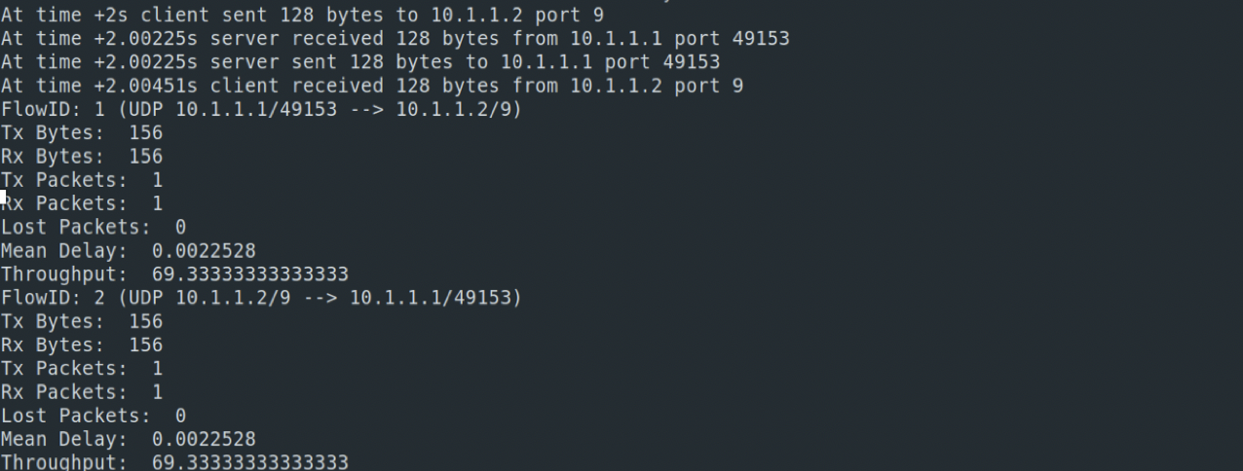

**Fig: packet size 128**

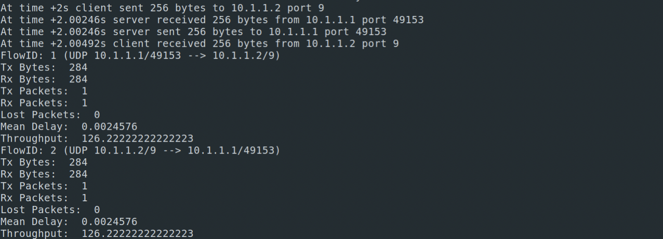

**Fig: packet size 256**

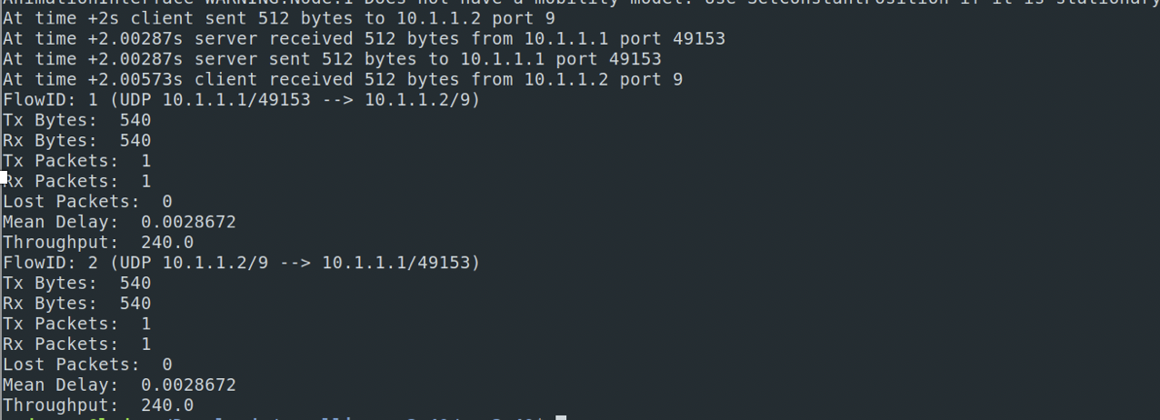

**Fig: packet size 512**

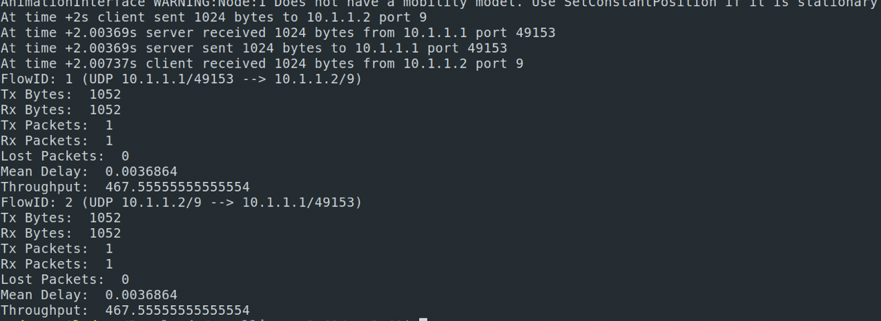

**Fig: packet size 1024**

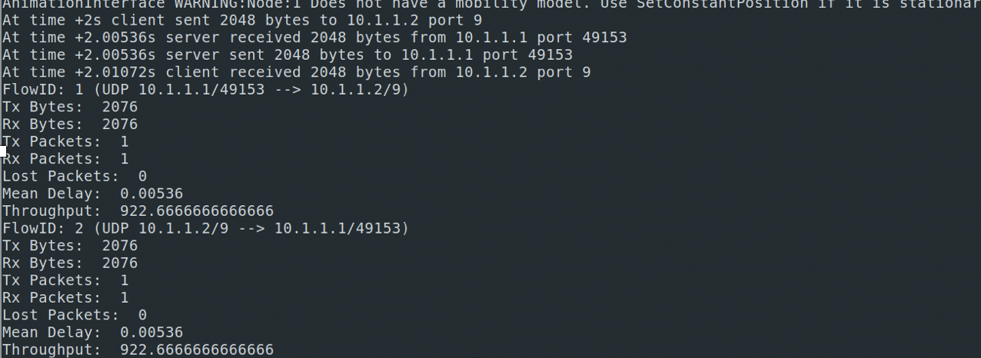

**Fig: packet size 2048**

Here, the X axis will be packet, and the Y axis will be throughput. So the coordinates will be (128, 69.33), (256, 126.22), (512, 240), (1024, 467.56), and (2048, 922.67).  
  
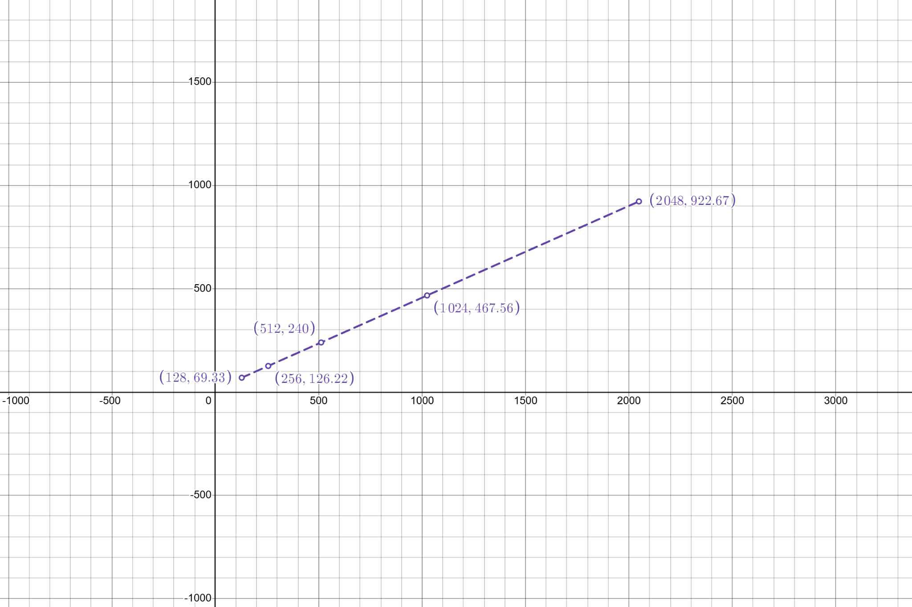

This graph represents the relationship between data size (x-axis) and throughput (y-axis).A dashed purple line connects the points, indicating a roughly linear increase in throughput as data size grows. This suggests that throughput scales proportionally with the data size in this scenario.