**RPS Game Test**

Habib Ullah

V0.1

**Overview**

This PRS Game application allows two players to play Rock, Paper or Scissors game

**Proposed Solution Design**

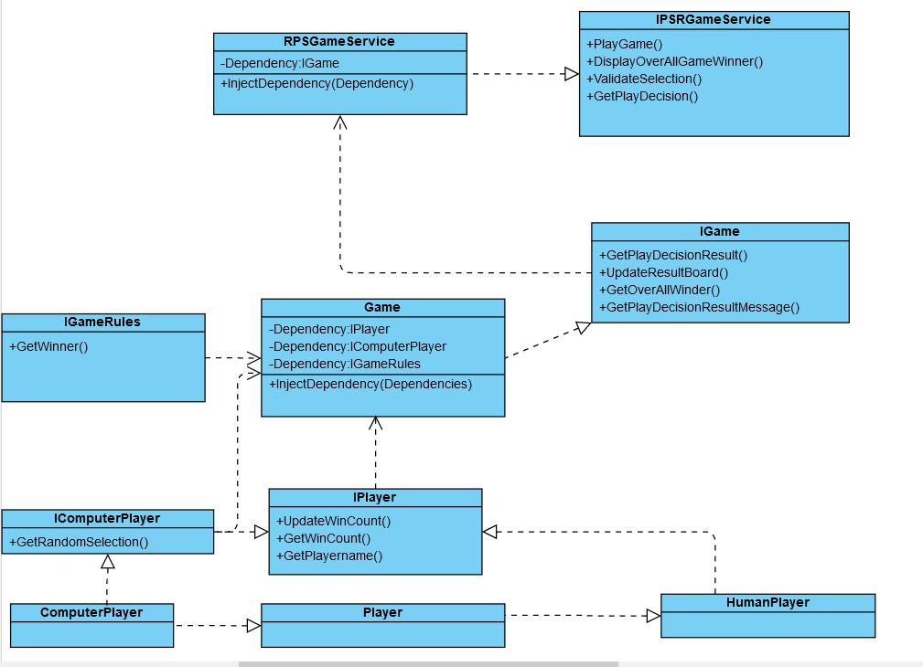

**Implementation**

This application is developed as int .net core 3.1

**Project Structure in Visual Studio**

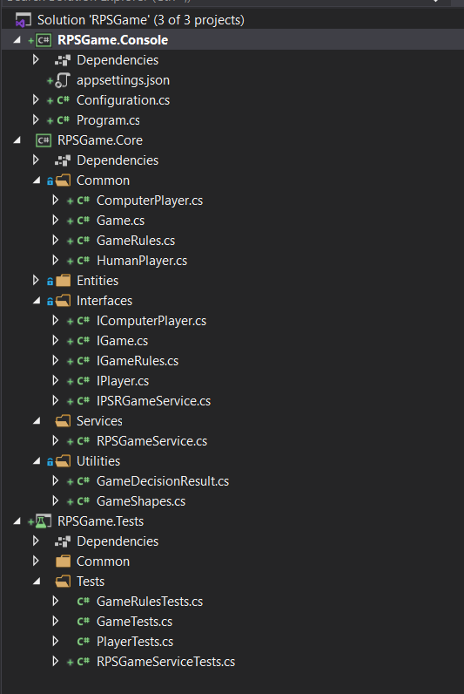

**Application Settings**

All of the application settings are available within appsettings.json file

