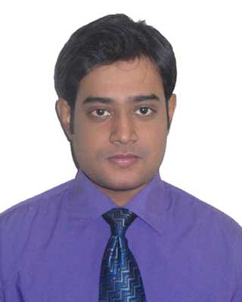
A S M ARSHED ALI
Building # 21 Flat # 703, Japan Garden City, Mohammadpur, Dhaka-1207
arshedali96@gmail.com
Mobile: 01677408159
-------------------------------------------------------------------------------------------------------------------------------

Career Statement:
To pursue a challenging role in a fast-paced working environment, where contributed strategic initiatives can create branding activities, utilizing thoughtful leadership and communication skills.

Why Do Feel Fit?
Creative, Active listener and learner, Youth, dynamism, energetic mind, problem solving ability, well communication skill and thirst for learning will be helpful to perform the assign duties successfully.

Educational Qualifications:

Degree Name of Institution Board Grade Year Major
MBA American International University–Bangladesh 3.75 2014 Marketing
BBA American International University–Bangladesh 3.77 2013 Marketing
HSC Dhaka Commerce College Dhaka 4.20 2009 B.Studies
SSC Dhanmondi Govt. Boys’ High School Dhaka 4.25 2007 B.Studies

Computer skills:
- Microsoft Office Package (Ms Word, Ms Excel, and Ms Power point)
- Photoshop cs5,Windows XP/vista,7,8, and Internet & e-mail Browsing
Languages known:
 | Speaking | Reading | Writing
English | Excellent | Excellent | Excellent
Bangla | Excellent | Excellent | Excellent

Employment History:
- HB Consultants ltd.
Management Trainee (September 25, 2014 - Continuing)
Department: Busines Development

- Biman Bangladesh Airlines
Internship ( January 01, 2014 - April 01, 2014)
Department: Market Research

Project Experience:

- Recently made marketing strategy report on “DUSAI” resort.
- Did internship at Biman Bangladesh Airlines and made Affiliation report based on marketing practices and policies.

Personal Details:

Father’s Name : A K M Imtiaz Ali
Mother’s Name : Afsana Begum
Permanent Address : House # 358, Road # 3, Dhap Jail Road, Kallahband
Thana: Kotwali, Dist: Rangpur
Date of Birth : 29th December 1992
Marital Status : Single
Sex : Male
Blood Group : B (+) ve
Current Location : Dhaka.

Therefore, I declare that according to my knowledge above information is true.

Signature

------------------
A S M Arshed Ali

