Curriculum Vitae

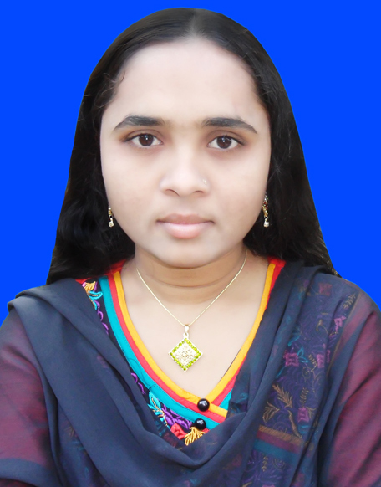
MOSA. SANOWARA PERVIN
Contact Information:
Cell : +8801738738357;
+8801918077961;
E-mail: sanowara.ab@gmail.com
Zamirdia, Valuka, Mymensingh.

OBJECTIVE | To work in an organization where discipline and high tech environment will ensure fast career development and the congenial atmosphere will enable to develop managerial qualities i.e., vision, positive attitude, interpersonal relationship, communication skill, attitude to take challenges and commitment to achieve results.

EDUCATION | Name of the examination | Department/ Group | Passing Year | Result | University/ Board
EDUCATION | - M.B.S | Department of Management | 2011 | 2nd Class | National University
EDUCATION | - B.B.S | Department of Management | 2010 | 2nd Class | National University
EDUCATION | - H.S.C | Humanities | 2006 | 3.80 on scale of 5 | Rajshahi Board
EDUCATION | - S.S.C | Science | 2004 | 2.88 on scale of 5 | Rajshahi Board

COMPUTER SKILLS | - Operating System : Microsoft Windows 2000/XP, Windows 7 & Vista  - Application : MS Word (high speed typing), Excel, Power Point.  - Internet and others : Internet Browsing and Information Download.

LANGUAGE  SKILL | - Spoken and written skills in both English and Bengali.  - Have communication ability in Hindi.

HOBBIES | Watching drama; Stage Shows; Photography; Reading books, magazines, newspapers, and periodicals novels and other literary works as well as writing poems, articles, etc.

PERSONAL INFORMATION | Name | : Mosa. Sanowara Pervin
PERSONAL INFORMATION | Father’s Name | : Md. Saidur Rahman
PERSONAL INFORMATION | Mother’s Name | : Mosa. Khadija Begum
PERSONAL INFORMATION | Date of Birth | : 25 December, 1987
PERSONAL INFORMATION | Nationality | : Bangladeshi by Birth
PERSONAL INFORMATION | National I.D No.  Religion | : 6916387151749  : Islam
PERSONAL INFORMATION | Marital Status | : Married
PERSONAL INFORMATION | Blood Group | : O (+)
PERSONAL INFORMATION | Permanent Address: | Vill: Patul, P.O: Patul, P.S: Naldanga ,Dist: Natore

REFERENCES | Md. Zohurul Islam Shamol  Assistant Professor, Dept. of Management  N.S. Govt. College, Natore.  Cell: +8801716298922  MD. Nazmul Haque  Sr. Merchandiser  WOO REE INT. Ltd.  Cell: +8801716011647

Declaration:

I do here by declare that the above-mentioned information is true and correct.


Date: 09.06.2015 Mosa. Sanowara Pervin

