ALAMGIR HOSSAIN
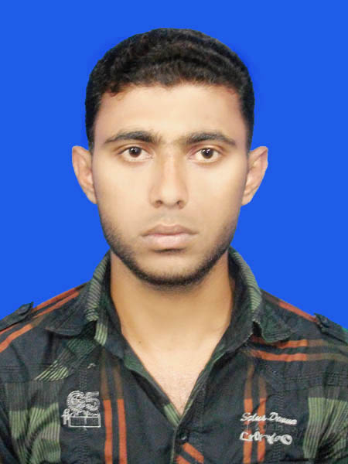
Email: a.h.tanvir194@gmail.com
Mobile: 01739660940
Nationality: Bangladeshi

OBJECTIVE:
To be pert a prestigious institution and contribute to the development works that patronizes nation building by utilizing my experience ,skill, knowledge and creative innovations. To ensure a challenging job in the management and administration for contributing to achieve the organization goal and objectives.

PERSONAL DETAILS:

01. Name : Alamgir Hossain.
02. Father’s Name : Md. Shafiqul Islam.
03. Mother’s Name : Arifa Sultana.
04. Sex : male
04. Present Address : Village: Kalikapur, Post: Kalikapur,
Upazilla: Durgapur, Dist: Netrakona.
05. Permanent Address : Village: Kalikapur, Post: Kalikapur,
Upazilla: Durgapur, Dist: Netrakona.
06. Date of birth : 26.12.1991.
07. Home District : Netrakona.
08. Religion : Islam.
09. Marital status : Unmarried.
10. Nationality : Bangladeshi (by birth).
11. Mobile No : 01739660940.
12. National ID No : 19917211851000075.
13. Educational Qualification :
Name of Exam | Passing | Group | GPA | Board/University
S.S.C | 2007 | Science | 3.88 | Dhaka
H.S.C | 2009 | Business Studies | 3.40 | Dhaka
Degree (Pass) | 2013 | B.Com | Appealed | National University

Computer Skill

Course outline:
1.Introduction to PC & Operating Systems, 2.MS WORD, 3. MS EXCEL , 4. FoxPro/MS EXCCESS,
5.PC Maintenance & Troubleshooting,
6.Internet 7.Networking.

Skill:

- Good communication skill (spoken and written) both in English and bangle .
- Good command in (a) operating system windows (b)windows 7 (c) internet and web.
- on cricket, badminton and all kind of sports.

KEY EXPERTISE

- 1.Commitment
- 2.Result oriented
- 3.Interpersonal Skill
- 4.Working ability under pressure .
AREA OF INTEREST

- 1.Develop effective plans, policy guidelines/operatiounal stratagies .
- 2.operate Management and administrative.
- 3.Supervision, monitoring and evaluation.

Signature


________________
(Alamgir Hossain)
Date : 26/07/2015

