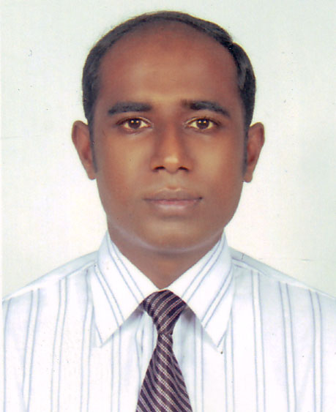
Resume

MD SERAJUS SALEKIN.
C/O MD. Mustafizur Rahman.
Kanugazi mosque road.
Napiter pul.
Maijdee court.
Contact Number: 01716-566768
E-mail: salekin70@gmail.com

Career objective:
I am seeking to serve as an amiable employee in an organization with growth opportunity to utilize the skills and abilities I have gained my formal education. I am looking for a challenging position that offers professional growth and which provides an environment for being resourceful, innovative and flexible in an established organization. I would like to through my performance & hard working. I will be able to implement my knowledge, skills and abilities efficiency and effectively.

Educational Qualifications:

- Completed M.B.A Degree major in Marketing 2004 from Asian University of Bangladesh, securing 3.175 CGPA.
- Completed B.com. (Pass) degree in Commerce 1999 from National University of Bangladesh securing Second Class.
- Passed Higher Secondary Certificate (HSC) Science Group from Noakhali University College under Comilla Board securing first division in 1997.
- Passed Secondary School Certificate (SSC) in Science Group from Noakhali Zilla School, under Comilla Board securing first division in 1995.

Working Experience:

- Present Job: At present I m working as a Sr. commercial officer in SM Group Of Companies with a responsibility to communicate with the supplier, Processing of L/C, checking L/C, amendment execution, Prepare different type of statement, shipment follow up & check documents, co-operation with the shipping line for good position, coordinate with principal for shipment schedule, Prepare Local Export Documents, Submission of original documents, BTMA for GSP & cash incentive from 10-03-2014 to till date.
- Worked as a Commercial Officer with a responsibility to communicate with the supplier, Processing of L/C, checking L/C, amendment execution, Prepare different type of statement, maintain register & shipment follow up & check documents, co-operation with the shipping line for good position , coordinate with principal for shipment schedule from 15-02-2011 to 01.03.2014.
- Worked as a commercial officer in the AHB Cotton Ltd with a responsibility to communicate with the supplier, make deal for product, amendment execution & shipment follow up from 01-06-2009 to 02-01-2011
- Worked as a T.S.O (Trainee sales Officer) in the City Bank Limited last 01-01-09 to 01-05-09.
- Worked as a ”Distribution Manager” of a distribution House of Grameen Phone Ltd with a responsibility to develop market, make outstanding relationship with channel partners communicate with sellers through sales channel having good market intelligence supervise marketing activities from last 01-01-2008 to 05-12-2008.

- Worked as a Marketing Officer of Globe soft drinks Ltd with a responsibility to develop market& meet up sales target by implanting policies prepare report& submit it to area office as well.
- Worked as a research assistant of World Bank project under Development policy Group(DPG) from last 01-02-2007 to 11-02-2007.

Computer literacy:
  - Operating system : : Windows 98, Windows 2000, Windows XP
  - Word processor : MS Word
  - Spread sheet analysis : MS Excel, MS Access
  - Internet : Internet explorer,

Personal Details:

Name : MD. Sersjus Salekin
Father’s Name : MD. Mustafizur Rahman.
Mothers Name : Momtaz Begum,
Permanent Address : Vill: Maijdee, Post:Maijdee Bazar, Thana: Sudharam
District: Noakhali

Present address : Serajus Salekin(Mahbub) House no 79,3 rd Floor,

Middle pirerbag,,Shewrapara,Mirpur ,Dhaka.
Date of Birth : 01-09-1979
Marital Status : Married.
Nationality : Bangladeshi,
Religion : Islam,
Cellular : 01716-566768.

References:

1.Major Shamsuddin.  Jessore Cantonment  Jessore,Bangladesh  PH-01731-627156 | 2. Md.Munirul Hoque.  Sales Team Manager.  The City Bank LTD.  PH-01713-310477

MD. SERAJUS SALEKIN.

