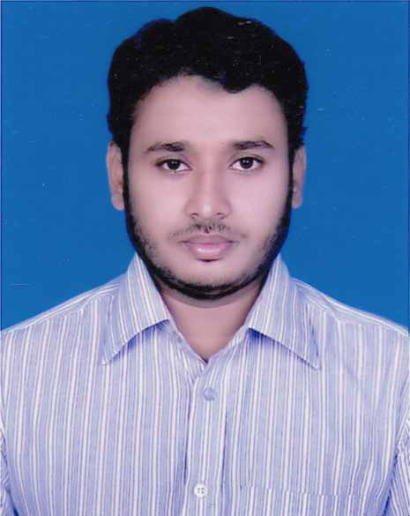
CURRICULUM VITAE
OF
Md.Raisul Islam Aman.

CONTACT ADDRESS :
175, Shanti Niketan,
Tejgaon, Dhaka- 1208.
E-mail:- raisul35@yahoo.com raisul35@gmail.com
Contact Number: +88-01721813948
+88-01948602702

CAREER OBJECTIVE:

To build up a career in an organization at mid-level management as a merchandiser with a great sense of responsibility and honesty, meet the challenges of new situation and expect to make a positive contribution in the position and work up to top level management.

EDUCATIONAL QUALIFICATION

Bachelor of Textile Engineering:
Institution: Southeast University (SEU), Dhaka.
Program: B.Sc. in Textile Engineering.
Major Subject: Fabric Manufacturing Technology.
Year of Passing: 2014

Higher Secondary Certificate (H.S.C):
Institution: Khoksha College,Khoksha, Kushtia.
Education Board: Jessore.
Group: Science.
Year of Passing: 2009

Secondary School Certificate (S.S.C):
Institution: Kumarkhali M.N. Pilot High School.
Education Board: Jessore.
Group: Science.
Year of Passing: 2007

Extra Curricular Activities:
Member of “Student Welfare Association Dhaka”.
Member of “The Scholars Foundation Kushtia”.

Industrial Training: Zaber & Zubair Fabrics Limited,
Tongi, Dhaka.

Experience:
I have been working in a buying house since February 2015 as trainee merchandiser.

LANGUAGE PROFICIENCY:

Language | Reading | Writing | Speaking
Bengali | High | High | High
English | High | High | Medium
Urdu & Hindi | Low | Low | Medium

COMPUTER LITERACY:
- Proficiency in Microsoft word, MS Excel, Power point.
- Internet Browsing.
- Email writing.

MY STRENGHTS:
- Good communication skills.
- Good speaker.
- Capable of adopting any type of environment.
- A very good team player.
- Good Organizing capabilities.

PERSONAL INFORMATION:
Name: Md.Raisul Islam Aman.
Father’s Name: M.A Quddus.
Mother’s Name: Sayeeda Begum.
Nationality : Bangladeshi.
Religion : Islam.
Marital status: Unmarried.
Date of Birth : 24 February , 1992.

Permanent Address:
Vill:- Charpaturia,
Post:-Mrigi Bazar,
Upazila:-Kalukhali,
Dist.- Rajbari.

ANNOUNCEMENT:

I do hereby declare that the particulars provided here are true and no
mis-information is given.

( Md.Raisul Islam Aman)

