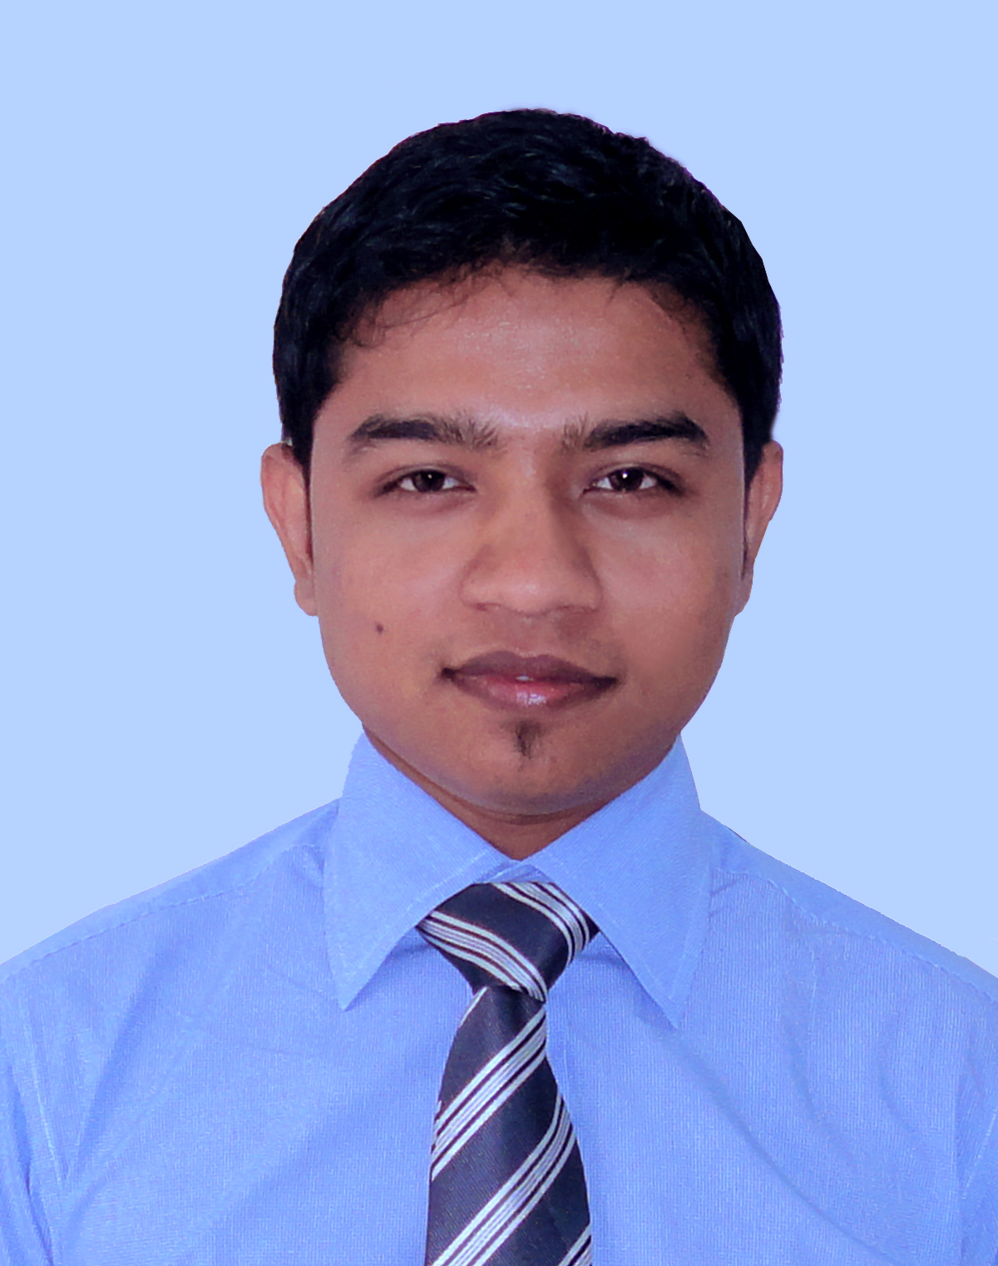
Professional Resume
Of
MD. BILLAL HOSSEN

Mailing Address: Pa-2/2, (6th Floor),
South Badda, Gulshan, Dhaka -1212.
Contact Mobile: 01923-575787, 01966-620202
E-mail: billaltob@yahoo.com, billaltob@gmail.com
OBJECT:

Intend to work in a challenging and competitive institutional environment that requires positive attitude, creativity, and innovative thinking providing excellence in professional services.

WORK EXPERIENCE:

1. Name of Organization : Bangas Tallu Group
Address : South Avenue Tower (6th Floor), H# 50,R# 3,
Gulshan-1, Dhaka.
Position : Executive (H.R, MIS)
Appointment Date : January, 2014 to till now

2. Name of Organization : Bangas Tallu Group
Address : South Avenue Tower (6th Floor), H# 50,R# 3,
Gulshan-1, Dhaka.
Position : Information Officer (Sales & Marketing)
Appointment Date : May, 2011 to December, 2013

3. Name of Organization : Signet Ltd.
Address : Baridhara, Dhaka
Position : H.R Officer
Appointment Date : August, 2010 to April, 2011
LANGUAGR PROFICIENCY:

Language competence in English and Bengali (Both in spoken & written)
COMPUTER SKILL:

- Hardware Maintenance
- Software Installation
- Operating System 2000, XP, Windows 7, Windows 8 & vista
- Microsoft Office Program
- Adobe Photoshop, Adobe Illustrator
- Audio Editing, Video Editing
Page 1 of 2
- Multimedia, Internet Service & E-mail.
Professional Resume Of Md. Billal Hossen

EDUCATIONAL AND OTHER QUALIFICATION:

B.S.S (Hon’s)
Institution : Govt. Titumir College
Passing Year : 2013
Obtained : CGP 2.84
Under : National University

H.S.C (Humanities Group)
Institution : Benapole Degree College
Passing Year : 2009
Obtained : GPA 2.30
Under : Jessore Board

S.S.C (Humanities Group)
Institution : Benapole secondary School
Passing Year : 2007
Obtained : GPA 4.50
Under : Jessore Board

Training Summary:

Training Title : General Banking
Topic : Credit Risk Management
Organization : BRAC Bank Ltd
Location : Gulshan, Dhaka
Year : 2014
Duration : 3 Months

Page 2 of 3

Professional Resume Of Md. Billal Hossen

PERSONAL PROFILE:

Name : Md. Billal Hossen
Father’s Name : Md. Abdul Wadud
Mother’s Name : Taslima Begum.
Present Address : Pa-2/2, (6th Floor),
South Badda, Gulshan, Dhaka -1212.
Permanent Address : Villa: Gazipur, P.O:Benapole,
P.S: Benapole, Dist: Jessore.
Contact No : 01923-575787, 01966-620202
E-mail : billaltob@yahoo.com, billaltob@gmail.com
Sex : Male.
Marital status : Married.
Date of birth : 10-December-1991.
Place of birth : Jessore
Nationality : Bangladeshi by birth.
Religion : Islam
Blood group : B+
REFERENCES:

1. Md. Nurul Amin (Repon)
General Manager
Bangas Ltd.
South Avenue Tower (6th Floor),
H # 50, R # 03, Gulshan-1, Dhaka
Mobile: 01713-069063
E-mail: namin_bangas@ymail.com

Signature
Date: .....................

MD. BILLAL HOSSEN

