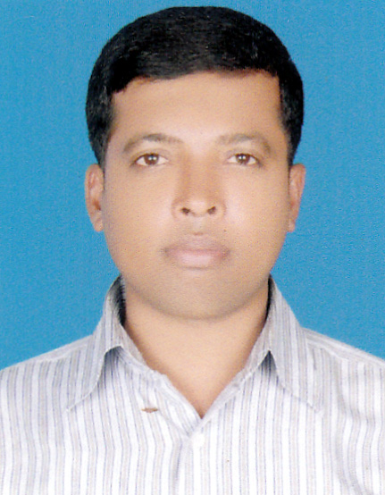 RESUME
OF
MOHAMMAD HOSSAIN

Sonapur taltola, Sharif pur, Begumgonj, Noakhali, Bangladesh
Mobile: 01829567915, 01745245105.
OBJECTIVE:

I like to build up my carrier. I believe my academic degrees and other qualifications and experience will provide me necessary supports that will help me to flourish my carrier.

Educational Qualification:
Name of the Institute :Darul Ihsan University Ashulia Dhaka.
Name of the Degree : M A.
Name of the Department :Islamic Studies
Passing Year : 2012
Medium of Study : Bangla,English
CGPA : 3.46 out of 4
Name of the Institute : Islamic University Kushtia
Name of the Degree : Fazil/ B A
Group : Arts
Passing Year : 2009
Medium of Study : Bangla, English
G.P.A : 2.17
Name of the Eduacation Board : Madrasha
Name of the Degree : H. S. C ( ALIM )
Group :Arts
Passing Year : 2006
G.P.A : 2.42
Name of the Eduacation Boar : Madrasha
Name of the Degree : S..S.C (Dhakhil)
Group : Arts
Passing Year : 200
G.P.A : 3.83

COMPUTER APPLICATION:
MS Word, MS Excel.Power point. Etc.

Page- WORKING EXPERIENCE:
Job Description :-
1.Candy Depositor Machine Oparating & Machine Mantance
:2. Production planning & Quality Control execution.
3..Research & develop different kinds of Food and Beverage products as per requirement by marketing.
4 .Sourcing local and international suppliers.
5. Implementation of Quality Systems at manufacturing premises as per Company requirement
6.Monitor and Operator,Sr:Operator production at co-pack.
Implementing, monitoring & reviewing different standards & GMP requirement at co-manufacturing unit.
7. Analyze batch problems, determine Corrective Action.
Ensure cost effective formulation and compliance with GMP during all development projects.
8. Prepare packaging material, raw material and finished goods specification.
9. Improving existing product formulations, packaging and optimize the costing.
10. Monitor the shelf life for new and existing products and interpret results for quality improvement.
11.Interfaces with Marketing, Quality Control, Operations, Purchasing and other departments regarding R & D product development and support.
Develop & improve test methods of PM/RM/FG and SOP.
12.Good knowledge in food safty Hygiene
13. Strong Leadership skill.
14.Manage all aspect of production and Quality from Reciving of Raw materials to packing to Ensure that Targets are met in a particular shift.
15. Ensure Maximum utilization of time & Labour.
16. Liaison with Government & Regulatory bodies for successfully production & Marketing proceed.
17. Management of Quality Assurance Dept, Administrative Dept, Store Dept, Production dept, Procurement dept, Accounts Dept & Distribution dept.
** DANISH FOOD’S LTD. ** (A ‘SISTERS OF PARTEX STAR GROUP )
Employment History / EXPERIENCE: -
Total Year of Experience : 10.6 Year(s)

1. | Production Supervisor(Parmanent Supervisor) ( September 1, 2008 - Continuing)
Danish Foods Ltd ( Candy Plant )
Department: Candy Plant ( Process ,Packing & Finish Goods )
2. | Assist: Supervisor(Casual )  ( August 1, 2006 - August 30, 2008)
 | Department: Chanachur Plant
3. | Packing Oparator ( Casual )  ( January 2, 2006 - August 1, 2006)
 | Department: Biscuit Plant

Traninig Summary:-

Training Title | Topic | Institute | Country | Location | Year | Duration
Industrial Traning | All type of HACCP | Bangladesh Agro-Processors`Association ( BAPA) | Bangladesh | Navana ( 6th floor ) Sobhanbagh, Dhanmondi | 2016 | 6 Six ( Month )
Industrial Traning | Improve Productivity through 5s & Kaizen | National Productivity Organization (NPO) | Bangladesh | Ministry of Industries 91, Motijheel C/A, 1000 | 2015 | TWO ( 02 ) Days
Industrial Traning | E R P ( Institute of Food & Radiation Research Establishmen) | Oracle Applications - HORIZON PSG | Bangladesh | PARTEX STAR GROUP- CX- 02 | 2015 | 6 Six ( Month

Personal Information :-
Personal Information: Father’s Name : Monwar Hossain : Md: Monwar Hossain.
Mother’s Name : Tajnaher Begum
Date of Birth : 10.10.1988
Nationality : Bangladeshi by birth
Religion : Islam
Marital Status : Unmarried
Mailing Address : Mohammad Hossain
Village : Sonapur, Taltola.
P/O : Hassan Hat,
P S : Begumgonj.
Dist : Noakhali.
Language : and Written Oral communication ability in Bangla & English

Signature:

Date:

Reference:
Md: Nurul Afsar
G,M Co- ordination.Danish Foods Ltd.
Partex Star Group
Mob-01713093570

Page-3

