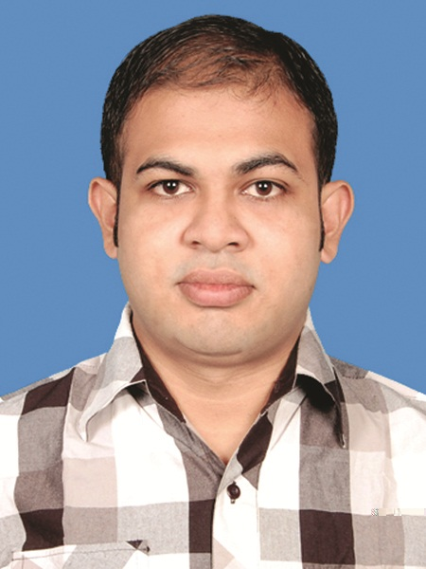
CURRICULUM VITAE

MD. ZAMIRUL HAQUE CHOWDHURY
34,Haji Meher Ali Road,Ekbal Nagor,Khulna.
CELL PHONE: +8801917183212

+880155631169

EMAIL : zamirulhaque@gmail.com , zamirulhaque@yahoo.com

CARRIER OBJECTIVE  JOB EXPERIENCE  JOB  RESPONSIBILITIES  EDUCATIONAL BACKGROUND |  | Objective : To obtain a suitable position in a reputed organization where I will have the opportunity to utilize my analysis, adaptability, potentiality, creativity, academic achievement and ability to do something innovative for the organization and where I will be able to enrich my knowledge.  I've been working as an IE Officer under “IE and Planning Department” at “ABANTI COLOUR TEX” sister concern of "CRONY GROUP" at Shashongaon, Fatullah,Narayangonj,Dhaka. since 7th September 2013.(3 year and 5 month)  Responsible for Doing the Following Tasks Individually or Group Wise Assigned by the Top Management:  - Style Wise Lay out prepare,SMV Calculation, SMV Databank, CM Value Calculation, Process Wise SAM Calculation, FOB Calculation, Performance Rating.  - Line Wise Efficient Target Setup, Follow Up, Bottleneck Identification & Solution, Lost Time & NPT Calculation.  - Plan follow up and execute, finding problems and way to solve.  - Style Wise Operation Bulletin/Line Layout, Line Feeding, Time Study, Capacity Study, Line Balancing, Pitch Diagram, Observation/Follow up  - Efficiency Calculation (Sewing & Finishing) for Incentive Bonus  - Manpower(Workers) Requisition & Requirement, OT Hours Allocation  - Skill Test, Salary Fixation, Re-Skill(Yearly), Skill Matrix for Worker’s Performances, O/P Rating  - Daily Forecast Report (Sewing, Finishing) for Efficiency & Plan Vs Achieve Calculation  - Daily color wise production report update on 'Fast React' software (Sewing & Finishing).  - Daily Man Power & M/C Study Report for the Best Utilization of Man Hours & M/C  - Daily WIP Report (Input & Output)  - Daily Updated Production Status(Overall), Hourly Production Report.  - DPR Report(Size & Color Wise), Especially for H&M, Tom-Tailor Buyer  - Weekly Closing Report.  - Monthly or Yearly Key Performing Indicator (KPI)  - Maintain Liaison with Other Department For Productivity Improvement, Reduction of Wastes/NPT  - Analysis & Application of Different Tools & Technique of “Lean Manufacturing & Industrial Engineering”  - Training Program for Worker Motivation & Implementation of 5S  - Maintain SMV calculation of every style for CM calculation, Daily efficiency report and also ensure proper line balancing & Target calculation.  - Analyze the product and prepare operation bulletin for optimum production and maximum utilization of man machine & material.  - Worker assessment & salary fixation for new worker & annual increment according to worker skill inventory.  - Analyze production data, identify root cause of problem for continuous improvement.  Program : Textile Engineering (2014-2015)  University : Bangladesh University of Textile.  Course : M.Sc in Textile Engineering.  Status : Completion in the year of 2016.  Major : Textile Management and Business Studies.  CGPA : 3.06 out of 4.  Program : Textile Engineering (2007-2008)  Institution : Textile Engineering College, Begumgonj, Noakhali.  Course : B.Sc in Textile Engineering.  Status : Completion in the year of 2013  Major : Wet Processing(Dying)  CGPA : 3.26 out of 4.00  Program : Higher Secondary Certificate(2005-2006)  Institution : Govt. M.M. City College, Khulna.  Status : Completed in the year of 2007  Major : Science  GPA : 4.30 out of 5  Program : Secondary School Certificate (2003-2004)  Institution : St. Joseph’s High School, Khulna  Status : Completed in the year 2005  Major : Science  GPA : 4.88 out of 5
COMPUTER  SKILLS  LANGUAGE  &  OTHER QUALIFICATION |  | Capable to make the best usages of any types of software to assist my tasks, as well as grab the latest facilities of Internet.  Operating environment : Windows 8,Windows 7, XP  Application program : Microsoft Office Tools  Programming language : C++  Other : Internet Literacy  English: Good in Reading, Writing and Speaking  Bangla: Excellent in Reading, Writing and Speaking  Good managerial ability, Leadership ability in teamwork, hardworking, energetic, Enthusiastic in challenging working field, Strong interpersonal communication skill, Quick learning ability, Adaptive to any environment. technically sound with good academic background.
PERSONAL INFORMATION |  | Name : Md. Zamirul Haque Chowdhury  Father’s Name : Md. Ziaul Haque Chowdhury(Late)  Mother’s Name : Tasnim Ara  Date of Birth : 24th February 1989  Present Address : 34, Hazi Maharali Road ,Iqbalnagor, Khulna.  Permanent Address : Nur Box Chowdhury bari,  Village:Nursonapur,Thana & P.O:Kabirhat,  District:Noakhali.  Nationality : Bangladeshi  Marital Status : Single  Sex : Male  National ID No : 4795124436460  Contract No. : 01917183212 ; 01556311691  E-MAIL ID : zamirulhaque@gmail.com  Blood Group : O⁺
REFERENCES |  | Engr Md Abdul Sattar  Senior Manager & HOD  IE & Planning Department  Delta Group  Kashimpur,Gazipur  Mobile : 01770790566 | Md.Abdul Hannan  Professor,Dyeing Department,  DUET.  Mobile No: 01913354913

I, hereby, declare that the information stated are correct to the best of my concern.
Sincerely yours.


________________________
(MD.ZAMIRUL HAQUE CHOWDHURY)

