March 02, 2017

The Head of HRM

REEDISHA FOODS LIMITED

36, Shahid Tajuddin Sarani, Tejgaon Industrial Area, Dhaka-1208, Bangladesh

Subject: Application for the post of Executive – Supply Chain Management.

Dear Sir,

I learned from media that REEDISHA GROUP launched new company REEDISHA FOODS LTD. In this company I wish to join as Executive - SCM. In this regard I am presenting all of my necessary particulars along with a detailed resume for your kind consideration.

May I hope that you would be kind enough to give me a chance to prove my efficiency for the aforementioned post.

Yours sincerely

M Shahidul Islam

Enclosed: Detailed resume.

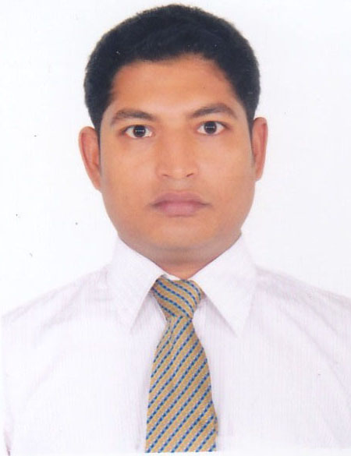
Résumé of
M Shahidul Islam

+8801823 418790

shahidslm3@gmail.com

Objective:

My objective is to learn and work in a challenging environment with ample prospects for growth in well reputed organization and to advance career by utilizing my skills, abilities and background.

Educational Qualification:

Level | Name of Examination | Group/Subject | Result | Board/University | Year of Passing
Post Graduation | MBA | Finance | CGPA 3.66 out of 4 | Asian University of Bangladesh | 2016
Graduation | BSS | Social Science | CGPA 3.11 out of 4 | Bangladesh Open University | 2012
HSC | HSC | Science | GPA 2.60 out of 5 | Dhaka | 2005
SSC | SSC | Science | GPA 3.63 out of 5 | Jessore | 2003

Professional Qualification:

Post Graduation Diploma in Supply Chain Management ( PGDSCM) continuing in Bangladesh Institute of Management Studies ( BIMS ).

Job Experience:

Present Company: Fabricares Ltd.

Present Position: Executive

Department: Supply Chain Management

I am working;

- Negotiating with foreign & Local suppliers

- Follow-up international forwarder and C&F agent.

- Banking

- Documentation

Period: From January 1, 2015 to till date.

Business visit: Chittagong , Sylhet and other places where required.

Personal Profile:

Name : M Shahidul Islam
Father’s name : Md. Hasan Mia
Mother’s name : Mrs. Sufia Hasan
Permanent address : Boijhaki, Kahalpur, Mollahat, Bagerhat.
Present address : 403, Kaskura, Uttarkhan, Dhaka-1230
Date of birth : October 12, 1987
Nationality : Bangladeshi
Religion : Islam
Marital status : Married
Blood group : A (+ve)
NID no. : 6710443814883

Computer Literacy: MS Office Program

Language: Bengali & English can read, write & speak.

Hobby: Reading books/ journals and passing time with family and friends.

Reference:

Md. Tuhin Mridha
Manager SCM & Business Development
Hatim Group
01922000355

Md. Faruqur Rahman
Commercial Manager
Magpie Group
01731 512176

Thank you for your kind attention.

M Shahidul Islam
March 02, 2017

