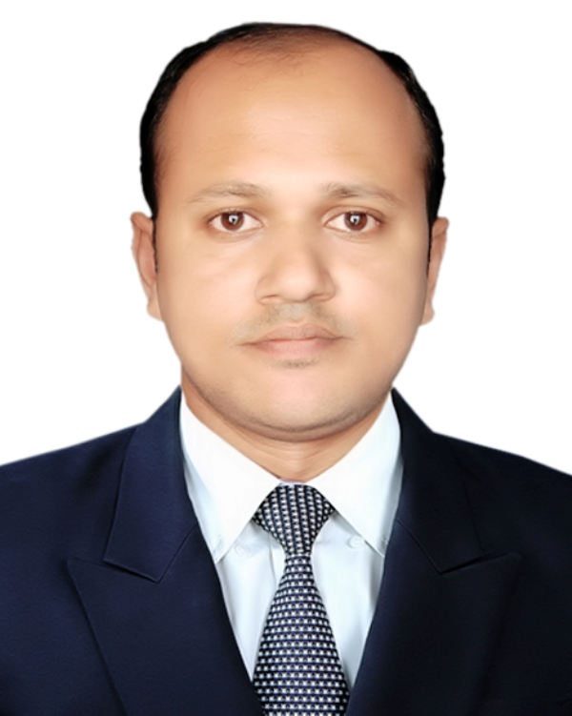
Resume
Shahin Ahmed
Sylhet-3100, Bangladesh
Cell: +8801716-826080, e-mail: shahin.mktg06@gmail.com

Career Objectives:

To build up my career at a reputed business organization where I will have sufficient scope to prove my worth, creativity as well as encounter challenges at every event work in.
Work History:
Present status:
Regional Manager
(FMCG-Sales)
Meghna Group of Industries
Sylhet Region
5th December-2015 to till date

Previous work Experience:
Assistant Manager (Marketing),
Sylhet Division
October 2009 to till December-2015
M. Ahmed Tea and Lands Co Ltd. Dorgamahalla, Sylhet
Nature Work: Sales and Marketing

Marketing Executive,
August 19, 2006 to 2009
M. Ahmed Tea and Lands Co Ltd,
Dorgamahalla, Sylhet-3100, Bangladesh

Major Duties Performed:

- Supervised a number of Sales Representatives, Sales Supervisors & Sales Executives working entire Sylhet Division.
- Assisted large sales team effectively to achieve sales target.
- Set annual sales target indicating monthly, district wise, territory wise based on sales volume.
- Developed Market oriented Channel of distribution to reach effectively & economically to our target consumers.
- Assessed conflict across the channel, analyzing competitor’s distribution Channel strategy & providing solution.
- Achieved Sales & Outlet coverage target of entire Sylhet Division.
- Searched for new distributor/commission agent in vacant territories and appoint them on priority basis.

Educational background:

Exam/Degree | Institution/Board | Passing Year | Group/ Major Subject | Result
M.B.A | Leading University | 2008 | Marketing | 3.68 ( Scale:4.00)
B.B.A | Sylhet International University | 2006 | Marketing | 3.52 (Scale:4.00)
H.S.C | Sylhet | 2001 | Science | 2nd Division
S.S.C | Comilla | 1999 | Science | 1st Division

Skills and competences:

- Good proficiency on English Language
- Excellent command on Computer Literacy
- Ability to work on under pressure
- Strong interpersonal skills.
- Ability to guide team members
- Ability to formulate better communication (both internal & external)

English Language Skills:
Strong ability on English language both verbal & written.
Computer Skills/ Knowledge
MS Word, MS Excel, MS Power Point, Internet Browsing, Data Entry, Data mining, Web Research, etc.
Permanent Address:

Vill: Chanpur, P.O: Jalalabad,
P.S: Jalalabad, Upozila: Sadar,
Sylhet-3100
Father’s Name: Ajmol Ali
Mothers Name: Gulesta Begum
Date of Birth: December 30, 1983
Religion: Islam, Nationality: Bangladeshi
Marital Status: Married

Reference 2:

Yousuf Wajed
Manager Marketing
The Merchants Limited
House # 38, Road #13
Sector#3, Uttora Dhaka
Cell: 01670-847999

Reference1:
Enam Ahmed Chowdhury Emon
Head of Branch
IDLC Finance Limited
Sylhet Branch.
Cell: 01712-109485, 01729-228998

Signature & Date

Shahin Ahmed

