MOHAMMAD SHOWKET HOSSAN
MOB: 01851-307300 . Gmail - showkethossan7300@gmail.com.
Objective | A Challenging and stimulating job in an entity where diligence honesty and intelligence are the criteria of achieving the highest position.
Biography | Father Name: Habib ullah  Mother Name: Sahina begum  Sex: Male  Date of birth: 23 November 1993  Religion: Islam  Marital status: Unmarried
Permanent address | C/o : Habib ullah  Vill: Banderjullah(boro bari)  P.o: Alkara  P.s: Chouddagram  Dist: Cumilla
Educational Qualifications
Examination | Institution | Board/university | Group/Sub: | Passing year | GPA/ CGPA
S.s.c | Bakgram kazi ahammed ali high school | Cumilla | Humanities | 2009 | 3.38
H.s.c | Kulgong City Corporation School & college. CTG | Chittagong | Humanities | 20011 | 3.70
B.A(hon’s) | Feni govt college | National university | Bangla | 2016 | 2.88
Master’s | Feni govt college | National university | Bangla | 2017 | appeared

Personal | Keep confidentialness listen carefully, enthusiastic, enjoy working.
Capabilities | To meet the challenge.
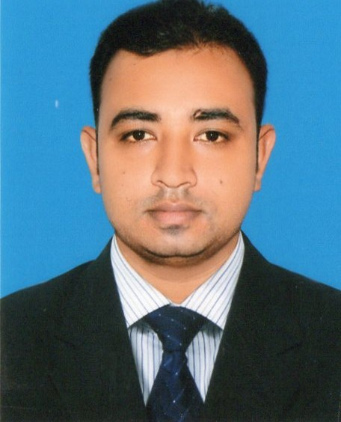
Curriculam vitae
Computer  Proficiency | Computer maintains, windows ,ms office, powerpoint , excel.
Languages | Bengali: mother tongue  English :fluent spoken and written
Interests | Reading, drawing, thinking, traveling.
Practical  Experience | 1. From 14.01.18 to till now as a Territory Head (T.H) at S.A Group of Industries.
Contact  Address | C/o : HABIB ULLAH  VILL: Banderjulla  P.o: alkara  P.s: chouddagram  Dist: COMILLA  MOBIlE: 01856224445
Reference | 1. Md. Shakawat Shahin Sir  Additional SP  Narayangonj Zone  Mobile: 01713500916
Signature | 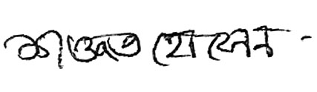  …………………………………...…….  MOHAMMAD SHOWKET HOSSAN

