RESUME  Of  NAWAZ SHARIF  Present Address:  Sattar Tower, 9, West Kafrul, Taltola,Dhaka-1207.  Email: nawazsharif7046@gmail.com  Cell : +8801749-857046  CellCell : +8801749-857046 | 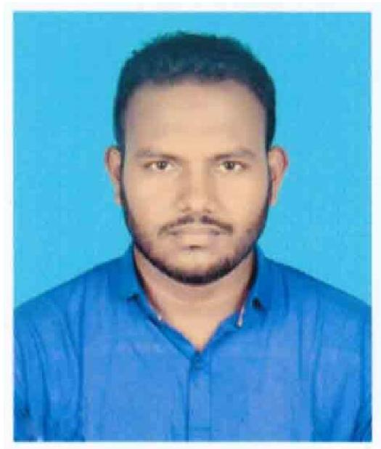

CAREER OBJECTIVE:
To develop a dynamic career and to obtain a responsible, challenging and growth-oriented position in a field where I can exploit my accumulated know-how and self motivated potentials optimally to augment performance.
Academic Qualification:
- Master’s of Business Administration (MBA)
University : National University
College : Joypurhat Govt. College
CGPA : 3.06 (Out of 4.00)
Department : Accounting
Passing Year : 2017
- Bachelor of Business Administration (BBA)
University : National University
College : Joypurhat Govt. College
CGPA : 3.10 (Out of 4.00)
Department : Accounting
Passing Year : 2016
- Higher Secondary Certificate (HSC)
Institute : Birampur Technical and Business Management College
Board : Technical Education Board, Dhaka.
GPA : 5.00 (Out of 5.00)
Group : Business Management
Passing Year : 2012
- Secondary School Certificate (SSC)
Institute : Katla High School
Board : Dinajpur
GPA : 3.63 (Out of 5.00)
Group : Science
Passing Year : 2010

Professional Skills:

Computer Skill : Internet Surfing, Mail-messaging, MS Word, MS Excel, Power Point.

Language : Mother tongue- Bengali. Fluent in Bengali and full working Knowledge in English.

Extra Curricula Activities:
• Adoption ability with any situation.
• Hard working habit, self-driven and change oriented.
• Sharp sense of social responsibility.
• Strong communication and interpersonal skill.
• Efficient in time management.
• Capacity to work independently as well as in multi-disciplinary and team.
• Good analytical aptitude.
• Ability to present and disseminate research finding and issues.

Permanent Address:
Village : Uttar Katla
Post Office : Katlahat
Police Station : Birampur
District : Dinajpur

Personal Profile
Father’s Name : Jashim Uddin
Mother’s Name : Ferdousi Ara
Date of Birth : 26th July, 1993
Nid No : 19932711059000048
Nationality : Bangladeshi
Marital Status : Single
Religion : Islam

Reference:

Md. Tofizur Rahman  Associate Professor  Department Of Accounting  Joypurhat Govt. College, Joypurhat.  Cell No.01711-188681 | Md. Wakib Ali  Assistant Professor  Department Of Accounting  Joypurhat Govt. College, Joypurhat.  Cell No.01726-727340

I, hereby, declare that the above statements are true. I will look forward to your response.



……………..…
(Nawaz Sharif)
Date:

