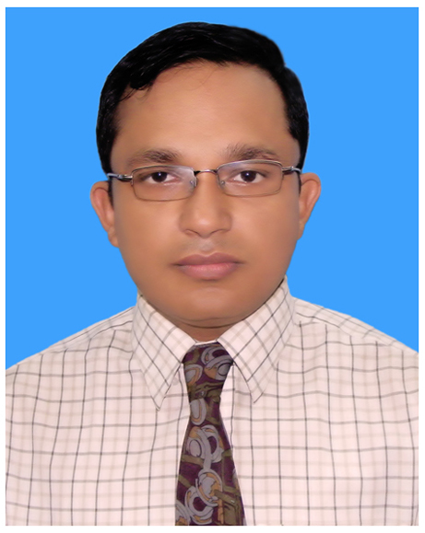
Md. Nahid Yousuf
Assistant General Manager
Partex Beverage Limited
Cell: 017-66667797
E-mail: nahid@partex.net

Objective: Following work experience and skill have make me to prefer working in Marketing Department of any reputed company, where I will be able to share and utilize my experiences to formulate effective strategies and game plans for the development of the business.

EMPLOYMENT RECORDS

⇦
Partex Beverage Ltd
Since September 2004 to date; working as an Assistant Manager then promoted as Brand Manager and now working as Assistant General Manager of Partex Beverage Ltd., franchisee of Royal Crown Cola International, USA, renowned in Bangladesh for its popular brands, namely RC Cola, RC Lemon, MUM etc.
I also look after operation activities as Operation and Sales admin Head of Partex Plastics in additional responsibilities.

Key Responsibilities
- Keep close coordination with sales & distribution department to ensure effective marketing support, utilization of POSM, wide distribution & display of products. Frequent market visit to see the availability & visibility of all products and POSMs.
- Development & introduction of new products and pack sizes and execution of relevant activities namely, packaging materials development according to size of pack, marketing communication development, fixing launching quantity, budget preparation, rate negotiation, lead time calculation and so on.
- Attend monthly supply chain meeting with all department- to learn and exchange all issues related to procurement, finance, production, distribution, sales as well as marketing, and to make adjustments and plans to cope up with entire supply chain operation,
- Regular communication and co-operation with ad agency in regard to idea generation for marketing campaign & communications and close involvement in subsequent activities such as film shooting, editing TV commercials to ensure the quality of films, suggestions for POSMs design etc. to make the communication effective,
- Track competitors’ business in regard to product, price, promotion, distribution, and analyze different areas of their strengths and weaknesses,
- Provide analytical support for Managing Director in portfolio analysis, trending and forecasting
- Maintain a very good & amicable PR with the people of all electronic, print and outdoor media, which not only helps faster execution of the job of marketing communication but also helps attaining good negotiated rate,
- Played an active role on behalf of Partex Beverage Ltd as a sponsored company in different events such as sports, fairs and cultural programs
- Export of RC product range Nepal, Papua New Guinea and UAE

Previous Employment History
⇦
Transcom Beverage Ltd. (Pepsi)
Worked as a Customer Executive of Transcom Beverage Limited from December, 2003 to August, 2004

Key Responsibilities:
- Monitoring sales operation and dealing with dealers for smooth operation and distribution of product.
- Assist the route agent in selling and executing all authorized product, packages and promotions.
- Ensure maintenance of displays and equipment of Pepsi-Cola Company standards.
- Maintain a physical presence in the territory to ensure understands of customer’s need and resolve complain in conjunction with the TDM.

Abdul Monem Ltd. (Igloo)
⇦
Worked as an Area In-Charge of Igloo Ice cream and milk unit of Abdul Monem Ltd from June, 2003 to November, 2003

Key Responsibilities:
- To promote, monitor and evaluate sales.
- Contribute towards marketing development programs.
- Formulate strategies pertaining to operational network planning.
- Assign responsibilities for covering the outlets/markets.
- Expansion of distribution system by planning distributor’s arrangements and rural sales operations.
- Providing Customer Service and maintaining Trade Relationship.
- Ensure that company policies and procedures such as merchandising, and utilization D/F.

Training
⇦
Tabani Beverage Ltd. (Coca – Cola)
I have got two-month training from Tabani Beverage Ltd. (Coca–Cola) on Beverage Marketing.

Internship
⇦
Partex Beverage Ltd (RC Cola)

I have completed Internship at “Partex Beverage Ltd, a unit of Partex Group” under Deputy General Manager on Beverage Market in Bangladesh.

Responsibilities:
- Prepared a feasibility report on Introduction of Post mix and Pre mix fountain machine for Partex Beverage Ltd.

Education
Year-2003 : Master of Business Administration (MBA)
Asian University of Bangladesh (AUB)
Score - CGPA-3.50 (Out of 4 scale)
Year of passing: 2003
Major: Marketing.
Year-1999-2002 : Bachelor of Business Administration (BBA)
Asian University of Bangladesh (AUB)
CGPA-3.59 (Out of 4 scales)
Year of passing: 2002
Year-1997 : Higher Secondary School Certificate (HSC)
College-Govt Azizul Hoque College
Group- Science, Result- Second Division
Board-Rajshahi
Year of passing: 1997
Year-1995 : Secondary School Certificate (SSC)
School- Bogra Zilla School
Group-Science, Result- First Division
Board-Rajshahi
Year of passing: 1995

Personal Information
- Father’s name : Md. Yousuf Ali Mia.
- Mother’s Name : Late Mrs. Nargis Begum
- Date of birth : 2nd August, 1980.
- Nationality : Bangladeshi.
- Permanent address : Prof Md Yousuf Ali Mia Gulshan Housing, Seujgari. Bogra.
- Present address : Flat 6/A Building 3 Govt. Officers Apartment, Joynagor, Kafrul Mirpur 15
- Marital Status : Married
- Spouse name : Fahmida Nasrin
- Daughter (1) : Nameera Nargis
- Email : nahid@partex.net
- Telephone number : (051)-65948 (Residence), 9842888 (Office), 01766667797- (Cell)
- Citizen : Bangladeshi.
- Visiting Place : Nepal, India , Thailand , China, Bhutan
- Member : Dhaka Boat Cub

Referee
Name of referees will be furnished on request.

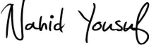
Md. Nahid Yousuf

