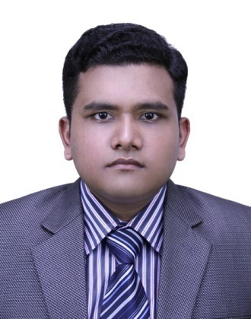**Curriculum Vitae Of**

**Md. Mesbahur Rahman**

**CAREER OBJECTIVES**

I would like to explore my potentials for the betterment of the organization where I shall work. I will also share my knowledge and expertise with other professionals to build up my career.

**EDUCATIONAL Background**

**B.Sc. in Textile Technology:**

Ahsanullah University of Science and Technology, Dhaka

Department of Textile Engineering

Result : CGPA 3.11

Total credit completed : 169

Year of passing : 2014

**H.S.C. in Science:**

Comilla Victoria Govt. College

Board : Comilla

Result : GPA 5.00

Year of passing : 2008

**S.S.C. in Science:**

Comilla Zilla School

Board : Comilla

Result : GPA 5.00

Year of passing : 2006

**MAJOR AREA OF STUDIES**

Fabric Manufacturing Technology, Wet Processing Technology, Apparel Manufacturing Technology, Textile Testing, Quality Control, Elements of Mechanical Engineering, Technical Textiles, Textile Physics.

**Specialization in Yarn Manufacturing Technology**

**INDUSTRIAL TRAINING**

Received industrial training from **Yasmin Spinning Mills Limited**, an enterprise of **Noman Group of Industries**.

Location : Beraiderchala, Mawna, Sreepur, Gazipur.

Duration : 8-week (from 6th November 2014 to 31st December 2014)

**ACADEMIC RESEARCH WORK**

Title : Comparative Studies among Polyester/Cotton Blend Yarns with

Varying Polyester Percentage.

Supervisor : Prof. Dr. Ahmed Jalal Uddin, Dept. of Textile Engineering

Ahsanullah University of Science & technology

**Language Proficiency**

English- Very Good

Bangla- Excellent

**INFORMATION LITERACY & ICT SKILL**

Operating system : Microsoft Windows OS and Ubuntu Linux.

Applications package : Microsoft Office, MS PowerPoint, MS Excel

Adobe Photoshop, Google SketchUp.

**PROFESSIONAL SKILL**

I possess analyzing and problem solving skill, critical thinking, inter-personal skill and commercial awareness. So I want to be professional in my attitude to work.

**TEAM WORK SPIRIT**

While doing industrial training I worked as team leader of our group. At that time I showed amazing team spirit and as such, I was highly appreciated by the supervisor, the trainees and the organization concerned.

**Other Areas of Interest**

Social work

Motivate others

Resolving conflicts

Group projects

Operating equipment

**PERSONAL DETAILS**

Name : Md. Mesbahur Rahman

Father’s name & address : Md. Matiur Rahman

Professor of English &

Dean, School of Arts and Social Science

Britannia University, Comilla.

Mother’s name : Late Iffat Ara

Date of birth : 1st January 1992

Religion : Islam

Gender : Male

Nationality : Bangladeshi

Marital status : Unmarried

Blood group : A+ (ve)

**ADDRESS for Communication**

SERENITY, Plot-22 Section-3 Block-B, Housing Estate, Comilla 3500

Cell : +88 01672 59 88 91

E-mail : [jeeshan17@gmail.com](mailto:jeeshan17@gmail.com)

**REFERENCES**

Prof. Dr. Md. Abdus Sattar

Vice Chancellor

Britannia University, Comilla

Former Vice Chancellor

North South University

Cell : +88 01755 502059

E-mail : asattarnsu@yahoo.com

Dr. Ahmed Jalal Uddin

Professor, Dept. of Textile Engineering

Ahsanullah University of Science & Technology

Cell : +88 01716 451225

E-mail : [jalaluddin2003@yahoo.com](mailto:jalaluddin2003@yahoo.com)

**Affirmation**

I affirm that the information provided here are quite true to the best of my knowledge and can be supported by relevant documents when need arises.

(Md. Mesbahur Rahman)