**Resume of Sagar Kumar Singh**

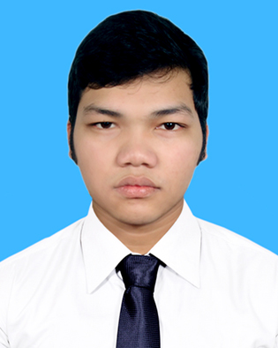

**Sagar Kumar Singh**

**Kha-55/G, Nikhunja-2, Khilkhet, Dhaka**

**Cell: +8801985172039**

**E-mail**: [**saagarsingha@gmail.com**](mailto:saagarsingha@gmail.com)

|  |
| --- |
| **Career Objective** |

**\*** In line with my continued interest and performance in engineering field I have decided to build up my career in the professional field. So, I would like to show my immense aspiration in professional field and proved myself as a sincere and energetic.

**\***To contribute my strong knowledge in textile and well development textile skill to a dynamic position within the textile sector.

|  |
| --- |
| **Educational Qualification** |

* **Bachelor of Science in Textile Engineering (B.Sc.)**

Name of Institution : City University, Dhaka

Major Subject : **Yarn Manufacturing Technology**

Passing Year : 2015

Obtained Result : **3.67**(Out of 4.00)

* **Higher Secondary Certificate (H.S.C)**

Name of Institution : Chunarughat govt collage

Board : Sylhet

Group : Science

Passing year : 2011

Obtained Result : **3.30** (Out of 5.00)

* **Secondary School Certificate (S.S.C)**

Name of Institution : Rajar bazar govt high school

Board : Sylhet

Group : Science

Passing year : 2009

Obtained Result : **3.63** (Out of 5.00)

|  |
| --- |
| **Practical Experience** |

* Lab experience in (Yarn, Wet processing, Fabrics & Garments manufacturing)

* Mill visit in the Different Textile Factory

* Two months practical experience at Keya knit composite

Limited. (Internship) jarun, Konabari, Gazipur, Bangladesh

*

|  |
| --- |
| **Computer Proficiency** |

* Operating System : Windows XP, , Windows 7,8 (all version)
* MS Office : MS Word, Excel, Power Point
* Typing : typing in Bengali and English
* Software knowledge : AutoCAD, Photoshop

|  |
| --- |
| **Communication Skills** |

* Bengali : First language, proficient in speaking, reading & writing.
* English : Second language, proficient in speaking, reading & writing.
* Hindi : Only speaking.

|  |
| --- |
| **Extra Curriculum Activities** |

* **Member** of **City University Textile Club**.
* Participated in a seminar about “**How to be a Good Merchandiser**” which arranged by department of Textile Engineering, City University.
* Participated in a workshop about “**New Age Fashion**” arranged by world class brand YELLOW at City University auditorium.

|  |
| --- |
| **Personal Statement** |

Name : Sagar Kumar Singh

Father’s Name : Kunjeshor Singh

Mother’s Name : Suti Singha

Present Address : 55/G Tanpara, Nikhunja-2, Dhaka

Permanent Address : Vill: Shoysree, P.O: Guchapara, P.S: Chunarughat

District: Habigonj

Date of Birth : 21 August, 1992

Sex : Male

Marital Status : Single

Nationality : Bangladeshi

Religion : Hindu

Blood Group : B (+)

|  |
| --- |
| **References** |

**Dr. Engr. Md. Saiful Islam Name: A.K.M Mazed**

Department Head of Textile Eng. Organization: R.K group

City University, Dhaka Designation: D.G.M (Technical), R.K Spinning Mill

Mobile: +8801558478469 Mobile: +8801713141081

|  |
| --- |
| **Declaration** |

I do solemnly affirm you that the statement with the information contained here in are absolutely correct to the best of my knowledge and belief.

|  |
| --- |
| **Signature** |

   
(Sagar Kumar Singh)