**Md. Mir Salekin**

Ka 17/4 South Kuril (West Face of Jamuna Future Park, Dhaka-1229)

Cell: **01710-588 502**

E-mail: [Salekinca@yahoo.com](mailto:Salekinca@yahoo.com)

**Dated: August 24, 2015**

To

Human Resources Department

**Reedisha Knitex Ltd**

36, Shahid Tajuddin Ahmed Sarani,

Tejgaon Industrial Area, Dhaka-1208, Bangladesh

**Apply for the position of “Executive-Accounts & Finance”**

**Dear Sir,**

In response to your announcement in **BDjobs.Com dated 24.8.2015** for the purposes of above vacancy, I would like to inform you that. . I am looking for Entry/Mid-level job for full time.

**During 3 years of the article ship period, I have conceded out Audit & Accounts, Income Tax & Vat matters in a number of to make me an effective candidate for aforesaid position. I have completed CA-CC (Enrollment no 18946/11) by December 2013 beside qualify PS (K) L partly from S.K.Barua & Co. Chartered Accountants associated with EMPACTA registered in Berlin Germany.**

**I currently working as a Senior Accounts Officer – F&A at NAZ Bangladesh Ltd. A sister Concern of NZ Group which is 100% Export Oriented Knit Composite Concern located in Dhaka**

I believe working in a reputed organization like your one will provide me admirable opportunity for my career growth in the area of Finance & Accounts. I am confident that if provided the opportunity to serve your organization, I will prove myself to be an important asset for your company through my dedication, sincerity and highest level of professionalism.

For any query you can reach me at abovementioned contact and email address.

Thank you for your time and I look forward to hearing from you,

Yours Truly,



..............................

(**Md.Mir Salekin**)



**Enclosed:**

1. Resume And Current Photograph
2. PS (K)L partly qualified outcome sheet (Internet copy published by ICAB)
3. CA-cc Certificate and Provisional Certificate of BBA
4. Internship Completion Certificate

**Md. Mir Salekin**

Address : Ka 17/4 South Kuril, (West face of Jamuna Future Park)

Bashundhara R/A, Dhaka-1229.   
Contact no: **+88 01710-588 502**  
E-mail : Salekinca@yahoo.com

**Career Objective:**

To trace a career in a reputed organization where I can best utilize my skills and ability by participating in its growth through contributing in the functional areas like Finance, Accounts, Cost Control, Internal Audit, Budget and General laws.

**Career Summary:**

During 3 years of the article ship period, I have conceded out Audit & Accounts, Income Tax and Vat matters. Number of Audit & Accounts related profile stated below:

**Limited Company:**

**1)** INCEPTA pharmaceuticals ltd.**2)** BNS Group of Companies, **3)** Ahmed Amin Group of companies, **4)** Waste Concern Fertilizers ltd, **5)** Sally Ann Bangladesh Ltd, Link 3 Technologies Ltd.

**Research Organization:** ICDDRB **(**Employees Income Tax consultancy)

**Micro Credit Regularity Authority**: Polli Progoti Shohayok Shongostha (Faridpur)

Coast Trust-Shamoly Mirpur

**International /Local (NGO’s): 1)** BRAC-Project **2)** The Leprosy Mission International **3)** RIC (Resource Integration Source) **4)** World Vision Bangladesh **5)** OXFAM -GB (Donor Project) **6)** Seventh Day Adventist Church of Bangladesh **7)** Summer Institute of Linguistic Bangladesh (SIL Bangladesh) etc.

**Income Tax & Vat related responsibilities stated below:**

* + - Prepare Individual & Corporate Income Tax return.
    - Prepare documentary evidence submission for Income Tax Assessment.
    - Withholding tax calculation & return Submission within prescribed date.
    - Challan Prepare against TDS or any appearance & deposit to Govt. treasury.
    - Correspondence with Income Tax & VAT circle’s authority.
    - Prepare Mushok-19 & submission to Vat circle office.
    - Facing Assessment, Appeal, Tribunal procedures & issues.
    - To adopt Income Tax & VAT policies in line with Govt. budget & Circulation.
    - Compliance with Income Tax & VAT Act & Rule and keep liaison with Government regulatory bodies

**Employment History:**

* + 1. **Senior Accounts Officer (** 02/05/2015 to Ongoing)

**NAZ Bangladesh Ltd.**

**100% Export Oriented Knit Composite Concern.**

Company Location : 4th flr, Annona Shopping Complex, Lane # 13, DOHS, Baridhara, Dhaka.

Department : **Finance & Accounts**

**Job Responsibilities:**

**Export Related Duties**

Ensure Revenue Recognition in respect Export Document and posting journal (Foreign and Local Sales)

Collect FBP/QIB (Voucher & Realization Sheet) from concerning bank and posting journal

Prepare and Preserve aforesaid documents Monhwise for future reference

Check Bill, Voucher (JV, Payment Voucher, Receipt Voucher, Contra Voucher), and Maintain Ledger

**Import Related Duties**

Ensure Payable against in respect Import Document and posting journal (Foreign and Local Purchase)

Preserve Bill of Exchange database daily basis and refer to concern department for Ensuring Acceptance

Received Local Supplier Bill, and Communicate for settlement

Supplier Payment reconciliation (if necessary)

Check Bill, Voucher (JV, Payment Voucher, Receipt Voucher, Contra Voucher), and Maintain Ledger

**Income Tax Related work**

Assist to Prepare Withholdings Tax Quarterly for the purposes of submission within prescribed time

Assist to Prepare VAT Return monthly for the purposes of submission within prescribed time (if required)

**Other Duties**

Movement of Impress fund Handle Impress fund (if required)

Responsible for Factory Fund flow movement through various Concern (if required)

Prepare Departments Meeting Minutes

Dong team work

Ensure Safety & Keeping documents for future references. Maintain Confidentiality

* + 1. **OFFICER –AUDIT** (From 01/09/2014 to 30/04/2015)

**ACS TEXTILES (BD) LIMITED.**

**A British Investment.100% Export Oriented Manufacturing Concern.**

Company Location : Tetlabo, Parabo, Ward no 03, Borpa, Rupgonj, Narayangonj.

Department : **Finance & Accounts**

**Duties/Responsibilities**

* Check and verify all sorts of Cash fund Approval, Petty cash (Received & Disbursement, on regular basis), Store requisition, L/C costing, Maternity benefit payment, Final Settlement, Local Transport bills, Leave application etc.
* Ensure Provision of AIT in respect of ITO 1984, Withholding Tax return quarterly basis, and VAT return monthly basis, physical Cash counting (monthly) and reporting to superior.
* Ensure and verify all sorts of requisition, Delivery challan & Bill with GRN in respect approved work order and justify all procurement related bills, vouchers that the best prices have been set.
* Check & Participate in Salary/OT/Extra OT/Bonus/Profit Bonus disbursement. Checking Bank payment & receipt vouchers after posting in book of a/c, Bank advice for Salary/OT/Bonus/Party Payment etc.
* Make sure Import L/C acceptance, Export proceed proof copy, verify export realization charges with bank agreement and approved rates and report about any other excess charges by the bank.

* Auditing and Internal control review of various records at different departments (Like- Packing Store, General Store, Accounts, Weaving, and Dyeing, Printing, and Garments Accessories division).
* Prepare audit findings report with necessary analysis and comparison to Head of Audit Personnel, Respond to audit queries raised by external auditors, Govt. audit team and internal auditors.
* Preserve proper documentation system for future reference
* Ensure physical verification Stock monthly basis and required basis.
* Accomplish market survey as and when required
* Assist in developing / modifying audit policy of the company time to time
* Perform Inventory counting and account true view to management as per verification of records(receiving, Issuing, and Confirm closing balance) of various department
* Perform other works as assigned by the Head of Department time to time.
  + 1. **Business Executive** ( Liability & Non funded Business) ( From 3/5/2010 to 9/12/2010)

**BRAC Bank Limited**

Company Location : Corporate Head Office, Gulshan Circle-1, Dhaka.

Department : **Retail Banking Division**

**Duties/Responsibilities*:***

* Accumulate salary accounts from organization and ensure disbursement through banking channel.
* Ensure compliance of various services like statement, balance confirmation, internet banking etc.
* Ensure compliance of various information beyond the services also like Personal loan issuing Process.
* Respond to audit queries raised by external auditors, Govt. audit team and internal auditors.
* Assist team for problem solution when it is deemed to be necessary.
  + 1. **Internship** (From 13/1/2010 to 21/4/ 2010)

**Prime Bank Ltd (Islamic Banking Branch)**

Company Location : 19 Dilkusha, Dhaka

Department : **GB, Loan, Clearing, Foreign Exchange**

**Duties:**

* Prepare Pay Order, Issuing Debit Card, and Sending E -statement, dealing PLACID money transfer.
* Opening Individual (Savings, Fixed, Current A/C & DPS) & Mother Accounts.
* Assist clearing officer to accumulate cheque and informed customer those have cheque return
* Handling Documentary Credit & Advise from Customers

**Academic Qualification:**

|  |  |  |  |  |  |
| --- | --- | --- | --- | --- | --- |
| **Exam Title** | **Concentration/Major** | **Institute** | **CGPA** | **Pass. Year/ Duration** | **Achievement** |
| BBA | Finance /Marketing | Presidency University. | 3.06  B - | 2010 (April.) | Academic. |
| H.S.C. | Business Studies | Adamjee Cantonment College, Dhaka. | 4.40  A | 2005 | Academic. |
| S.S.C. | Business Studies | Banani Bidya Niketon School & College, Dhaka | 4.13  A | 2003 | Academic. |

**Professional Qualification**:

|  |  |  |  |  |
| --- | --- | --- | --- | --- |
| **Certification** | **Institute** | **Location** | **Tenure & Enrollment no** | **Firm Name** |
| **CA - CC with PS (K) L 400 marks succeed 300 appear.** | **ICAB** | **Karwan Bazar Dhaka.** | **Commencing Dec 20, 2010.**  **CC date Dec 19, 2013.**  **Enrollment no. 18946/11** | **S.K.Barua & Co. Chartered Accountants.** Associated with  **EMPACTA** registered in **Berlin Germany** |

**Compliance Knowledge**

Acquired Knowledge about IAS, ISA, The Companies Act -1994, ITO 1984, BSEC Rules 1987, VAT Act 1991 and Labour Law 2006 in respect IFRS Compliance.

**Career and Application Information:**

|  |  |  |
| --- | --- | --- |
| **Looking For** | : | Entry /MID Level Job |
| **Available For** | : | Full Time **(Notice period 15 days)** |
| **Present Salary** | : | Taka 23,050 |
| **Expected Salary** | : | Taka 30,000 |
| **Preferred Job Category** | : | **Finance & Accounts, Audit & Accounts**, Treasury, Bank/Insurance/Leasing institutions. |
| **Preferred District** | : | Dhaka, Gazipur, Rupgonj, Norshingdi, Narayangonj, Valuka |
| **Preferred Organization Types** | : | **Textiles,** **Group of Companies**, Pharmaceutical, MNC’s, Ceramic/Glass Industry, Telecommunications, Electronic Media, Joint ventures, Paper industry, Printing Packaging, Buying House. |

**Extra-Curricular Activities:**

Sound Knowledge in Accounting Software/Operating System: 1. SAP (partial), Tally, Kandaree (Accounting & Inventory Soft.), Kormee (HRM Soft.) ERP owned, Ms Office Packages (MS word, Excel, PowerPoint, Outlook Express)

**Language Proficiency:**

|  |  |  |  |
| --- | --- | --- | --- |
| **Language** | **Reading** | **Writing** | **Speaking** |
| English. | High. | High. | Medium. |
| Bangla. | High. | High. | High. |

**Personal Details:**

|  |  |  |
| --- | --- | --- |
| Father's Name | : | Late Mir Sirajul Alam (Former Revenue Officer – DHAKA WASA) |
| Mother's Name | : | Anwara Begum (Home Maker) |
| Date of Birth | : | January 20, 1988 |
| Gender | : | Male |
| Nationality | : | Muslim |
| Religion | : | Islam |
| Marital Status | : | Married |
| Permanent Address | : | **Vil**l**age**: Naruchi, **Post**: Hemnogor**, P/S**: Gopalpur, **District**: Tangail, |
| Current Location | : | Bashundhara R/A. . |

**Reference (s):**

|  |  |  |  |
| --- | --- | --- | --- |
| Name | : | **Md. Eftekhar Ali FCA** | **Suhrid Kumar Barua FCA** |
| Organization | : | S.K.Barua & Co. Chartered Accountants | S.K.Barua & Co. Chartered Accountants |
| Designation | : | **Partner & Former AGM of Audit & Accounts of PKSF. Enrollment: 910** | **Principal & Senior Partner.**  **Enrollment: 232** |
| Address | : | House # 432/2nd flr, Road # 30, DOHS Mohakhali, Dhaka-1206. . | House # 432/2nd flr, Road # 30,  DOHS Mohakhali, Dhaka-1206. . |
| Phone (Off.) | : | 01824-56 79 96, 9884390 | 01824-56 79 96, 9884390 |
| Mobile | : | **01713- 415 898 (Self)** | 01819-13 70 95 (Self) |
| Web Address | : | **Skbarua.Org** | **Skbarua.Org** |
|  |  |  |  |

**Professional Stage (Knowledge) Level partly qualify result sheet published by ICAB at WWW.ICAB.ORG**

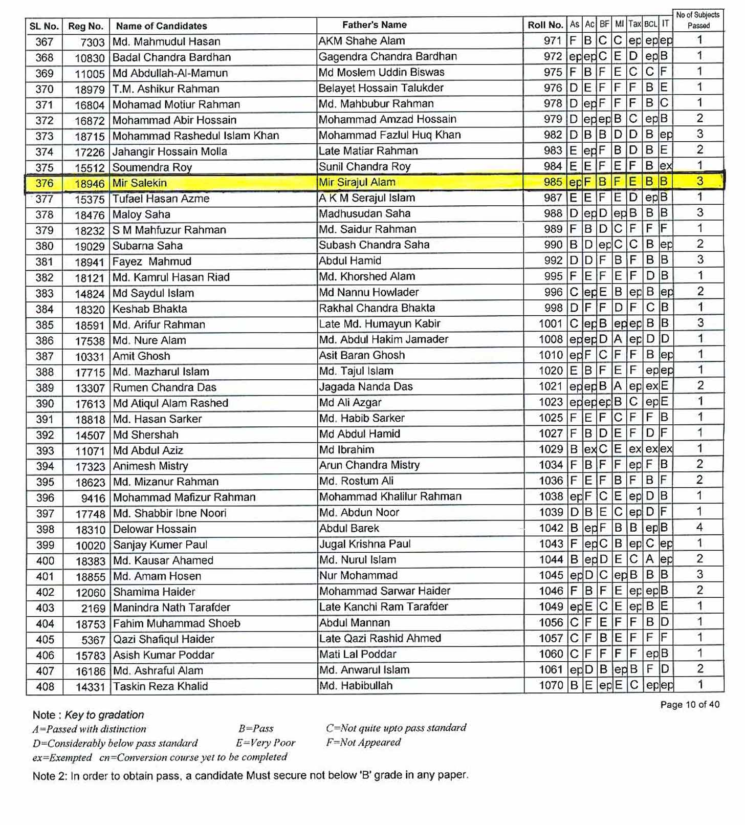

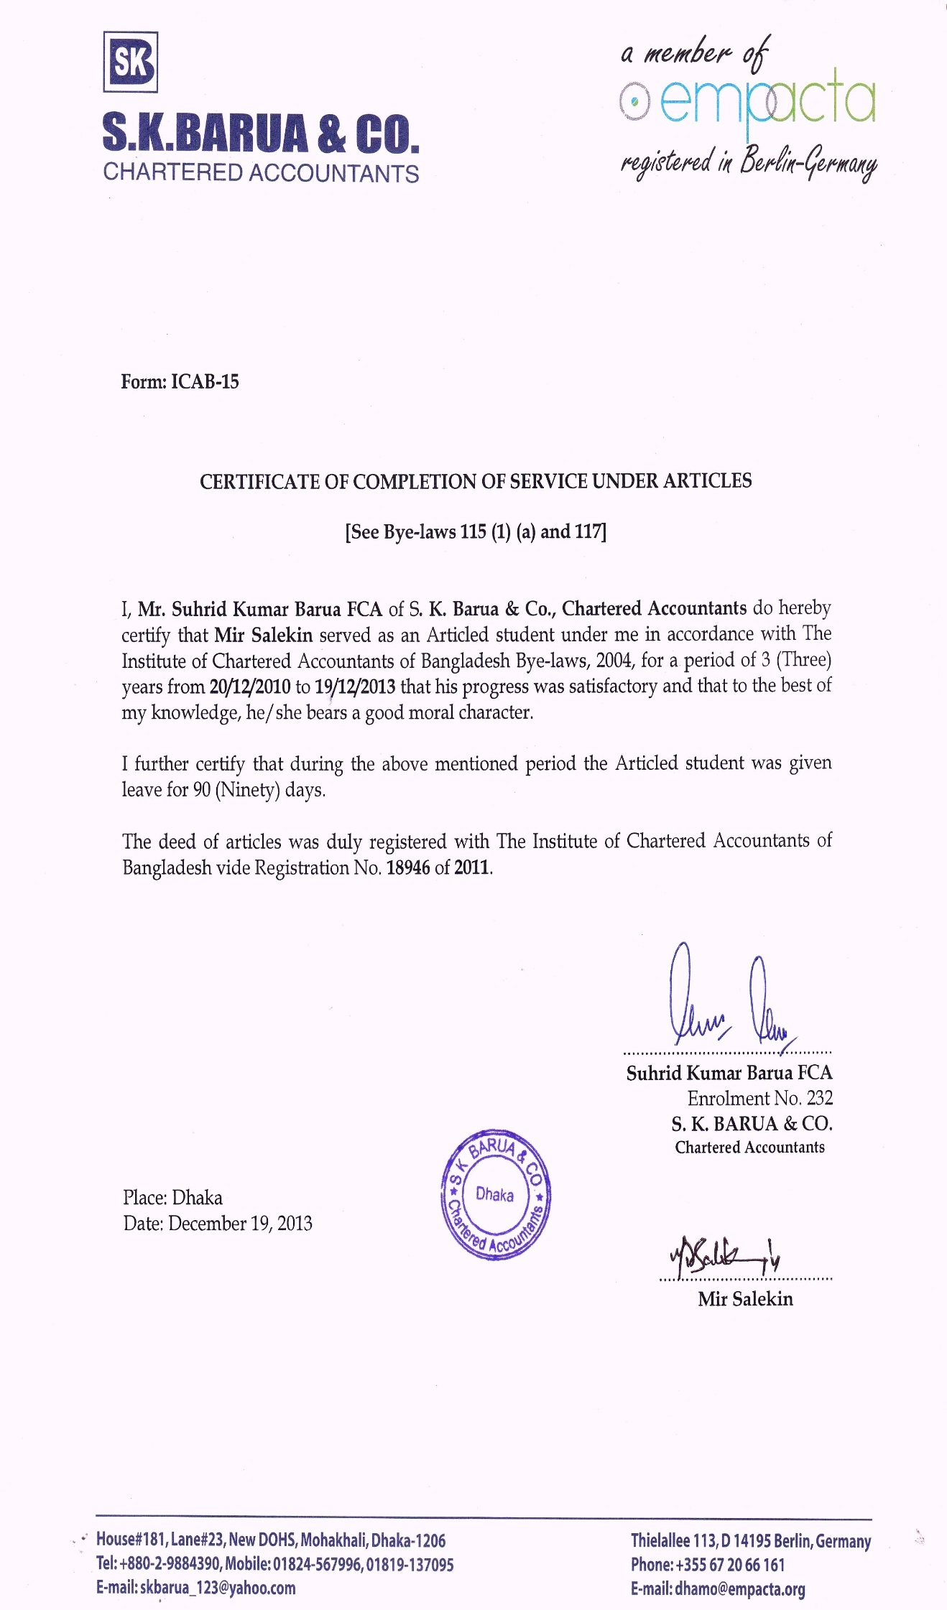**Course Completion Certificate of CA**

**Provisional Certificate of BBA**



**Internship Certificate**

