**Resume Of**

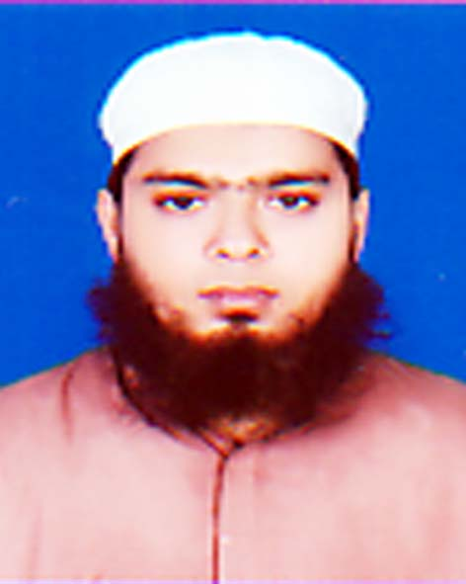

**Md. Sajadul Islam Sarker**

Mohammadpur Housing Limited

Road -2, House -153, Dhaka-1207

Cell: +8801725-356173

E-mail: [sajadul.comilla@gmail.com](mailto:sajadul.comilla@gmail.com)

**Career Objective**

To obtain an entry level position in the field of finance or accounting that would best utilize my potentials as well as to apply my theoretical knowledge into an innovative and challenging corporate environment.

**Academic Qualification**

|  |  |  |  |  |  |
| --- | --- | --- | --- | --- | --- |
| **Name of Examination** | **Board/University** | **Group/**  **subject** | **Passing Year** | **GPA/CGPA**  **As applicable** | **Achievement** |
| MBA | Pabna University of science & Technology | Finance & Banking | 2013 | **3.95**  (out of 4.00) | **Second Position** |
| BBA | Pabna University of science & Technology | Finance & Banking | 2012 | **3.95**  (out of 4.00) | **First Position** |
| H.S.C | Comilla | Business studies | 2008 | **4.70** |  |
| S.S.C | Comilla | Business studies | 2006 | **4.63** |  |

**Research Experience**

**Research at Hindrances in receiving loan for SME in Bangladesh with special reference to Pabna districts.**

Supervised By: Dr. Md. Mushfiqur Rahman

Professor, Department of Business Administration

Pabna University of Science & Technology

Mobile No: +8801718842497

**Seminar and Workshop**

* Seminar on “Structure and Performance of Rural Economy of Bangladesh” organized by Economics Department of Pabna University of Science & Technology.
* Workshop on “How to be a good public speaker”, organized by Pabna University of Science & Technology.

**Experience (Internship)**

**Internship Program at Department of Deposit & Loan Management (DLM) in Janata bank Ltd, Pabna corporate Branch.**

**Computer and Language Skills**

* **Computer Skills:** MS word, MS Excel, SPSS

(Advance Training on Microsoft Word & Excel organizes by Pabna University of Science & Technology)

* **Language Proficiency:** Full working knowledge in English and Bengali

**Extra Curricular Activities**

* Worked as sub-committee member of Rota act club Pabna University of Science & Technology (PUST)
* Participated “winter cloth distribution program” organized by PUST.
* Worked as a volunteer member at “ Voluntary Blood Donation Campaign” organized by Rota act Club of Pabna University of Science &Technology (PUST)

**Key Skills**

* Effective Communication in different situation.
* Self- Motivated to Meet Challenge.
* Hardworking & Innovative in Nature.
* Cooperative, Dedicated and Energetic.

**Personal Details**

Name : Md. Sajadul Islam Sarker

Father’s Name : Md. Abdul Hakim Sarker

Mother’s Name : Sakhina Begum

Date of birth : 04 July 1990

Nationality : Bangladeshi

Marital Status : Single

Religion : Islam

|  |  |
| --- | --- |
| **Permanent Address :**  C/O : Md. Abdul Hakim Sarker  Vill : Panty  P/O : Panty Bazar  Thana : Muradnagar  Dist. : Comilla | **Present/Mailing Adress :**  Md. Sajadul Islam Sarker  Mohammadpur Housing Limited  Road -2, House -153, Dhaka-1207  Cell: +8801725-356173  E-mail: [sajadul.comilla@gmail.com](mailto:sajadul.comilla@gmail.com) |

**References**

**Md. Kamruzzaman Dr. Md. Mushfiqur Rahman,**

Dean & Chairperson Associate Professor, Department of Business

Department of Business Administration Administration

Pabna University of Science & Technology Pabna University of Science & Technology

Mobile: +8801716183432 Mobile No: +88/01718842497

E-mail:kamrul_mba@yahoo.com E-mail:drmushfiqur@gmai.com

**Declaration**

I do hereby declare that the above information is true and correct to the best of my knowledge.

Yours truly,

**Md. Sajadul Islam Sarker**