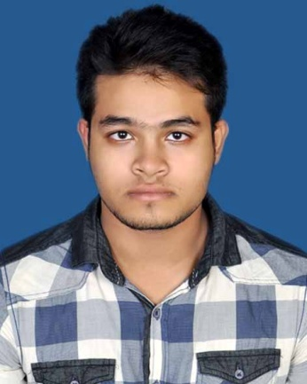**Resume**

**of**

**Md. Shoreful Islam (Adip)**

**Contact: 01621855697**

**Career Objective**

To show my aspiration to become a quick learner and to prove myself as sincere and energetic person through extensive hard work, integrity, honesty and incessant creativity to a well renowned institution for having a respective and challenging career.

**Academic Certification**

**Secondary School Certificate (S.S.C)**

Name of Institution : Dighulia Shahid Mizanur Rahman High School

Name of Board : Dhaka

Name of Group : Business Studies

Passing Year : 2011

Result : GPA- 4.13

**Higher School Certificate (H.S.C)**

Name of Institution : Shaheed Ramiz Uddin Cantonment College

Name of Board : Dhaka

Name of Group : Business Studies

Passing Year : 2013

Result : GPA-4.00

**SELF-ASSESSMENT:**

I am sincere, honest, hard working, pragmatically challenging and self- motivated person having, positive attitude towards working with good interpersonal relations with different national & religions.

**LANGUAGE:**

* Bengali: Mother Tongue
* English: Good both in written and verbal.

**INTEREST AND ACTIVITIES:**

Creative thinking, Reading books, Photography, Scientific research, Performing social activities.

**Computer Skill:**

Operating system XP, 7, 8,10

MS. Power Point, MS. Excel, MS. Word Pad,

Internet Browsing

About Know Computer Hardware

**Personal details**

Name : Md. Shoreful Islam (Adip)

Father’s Name : Md. Aynal haque

Mother’s Name : Sahenur Begum

Permanent Address : Village-Luhuria, P.O- Nagarbari

P.S.-Kalihati, Dist- Tangail

Present Address : Solmaid Khandokar Bari More, Gulshan,

Vatara, Dhaka-1212

Date of Birth : 20-12-1996

Nationality : Bangladeshi (By birth)

Religion : Islam

Marital Status : Unmarried

Sex : Male

Contract No. : 01621855694

Height : 5'-5"

Weight : 71 Kg

Blood Group : O-

...........................

Signature

Date: