.

**Dewan Aynul Haque**

H# 1152, R# 08, Ward#33, Board bazaar, National University

Gazipur Sadar, Gazipur.

Phone: +8801746544893

+8801682093916

E-m@il: [aynuldewan@gmail.com](mailto:aynuldewan@gmail.com)

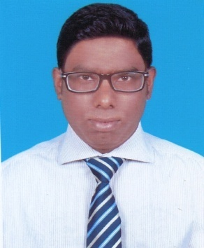

**CAREER OBJECTIVE:**

Pursue for a high responsibility and challenging position in a dynamic organization where I will get the opportunity to utilize my knowledge, experience and also to prove my proficiency for further career development.

**EDUCATIONAL QUALIFICATION:**

* **(B.B.A): Bachelor of Business Administration**

Institute : East West University.

Major : Accounting

Duration : 4 years

Passing Year : 2016

Result : 2.80(out of 4.00)

* **(H.S.C): Higher Secondary Certificate**

Institute : B.A.F Shaheen College, Dhaka.

Passing Year : 2010

Department : Business Studies.

Result : 5.00 (out of 5.00)

Board : Dhaka.

* **(S.S.C) : Secondary School Certificate**

School : Safiuddin Sarker Academy and College, Tongi,Gazipur.

Passing Year : 2008

Group : Business Studies.

Result : 4.88 (out of 5.00)

Board : Dhaka.

**SKILL & PROFICIENCY:**

**Language:**

* Bangali : Mother tongue.
* English : Proficiency of reading, writing, speaking and listening.

**Computer:**

Ms- Word, Ms- Excel, Ms- Power point, Multimedia & Internet Browsing.

**Interested:**

Creative thinking, Travelling, Web Browsing, Playing, Social activities etc.

**SPECIALITY:**

* Hard working Cool minded and able to take decision under any stress situation.
* Communicative band friendly.
* Ability to manage and work with group.
* Readiness to work stress and worth environment.
* Energetic and good Interpersonal skill.
* Adoptive to new technology and quick learners.

**PERSONAL INFORMATION**:

Name : Dewan Aynul Haque.

Father’s Name : Dewan Moazmmel Haque.

Mother`s Name : Dewan Masuda Begum

Date of Birth : 8th November, 1993

Sex : Male

Nationality : Bangladeshi (By birth)

Religion : Islam

Marital Status : Unmarried

Height : 5’2’’

Blood Group : B (+) ve.

Home District : Naogaon.

National Id No : 19933313031000700.

Permanent Address : H# 1152, R# 08, Ward#33, Board bazaar, National University,

Gazipur Sadar, Gazipur.

**REFERENCE:**

1. **Dewan Mynul Haque (Brother)**

Senior Merchandiser

El Corte Ingles, S.A. Liaison Office Bangladesh

Gulshan-2, Dhaka 1212

Gmail: [mynul1978@yahoo.com](mailto:mynul1978@yahoo.com).

Mobile: +8801712191983.

1. **Dewan Anamul Haque (Brother)**

Asst. Manager (Planning & Coordination)

M.M Knitwar Ltd.

Konabari,Gazipur.

Mobile: +8801730023213.

**CERTIFICATION:**

I undersigned certify that to the best of my knowledge and belief this bio-data correct describes qualification of me.

**Date: 220**/09/2014 Signature

**(Dewan Aynul Haque)**