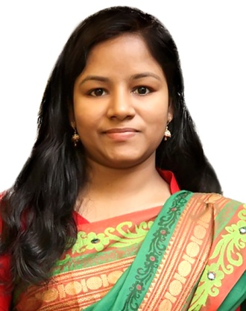**Nadira Rahman**

**House #22, Road 02, Block - C, Mirpur-12,**

**Dhaka-1216, Bangladesh**

**Mobile: +88 01713591371**

**E-Mail:** [**nrahman878@gmail.com**](mailto:nrahman878@gmail.com)

I want to build a long term career with opportunities for career growth. I am more than interested in the amount of new skills that the job will offer to me as learning new technologies will be beneficial for me as well the company. As a fresh graduate, I am looking to join a stable company that would give me a chance to learn more and therefore enhance my job profile greatly and also the chance to solve problem in an effective manner in a challenging position.

**Educational qualification**

**Masters of Business Administration (MBA)**

Name of University : Bangladesh University of Professionals (BUP)

Major : Supply Chain Management

Result : CGPA: 3.49(in scale of4)

Trimester Completed : 6 out of 6

Year of passing : 2015

**Bachelor of Business Studies (BBS)**

Name of Institution : Dhaka City College (DCC)

Major : Finance & Banking

Result : First Class

Year of Passing : 2009

**Computer Knowledge**

* Microsoft Office Application
* Internet browsing
* E- mail

**Work Experience**

**Thesis Report on (B.Sc)**

**Apprentice**, Grameenphone Ltd, Customer Service, 2013-2016

* Provided one-stop quality customer service over phone
* Proactively warned/informed customers regarding our products/service
* Captured customers insights and escalating critical issues/complaints and providing timely feedback
* Maintained targeted KPI on a regular basis
* Served customers with helping attitude and thus played a significant roll in customer satisfaction, retention and acquisition.

**Reference**

**Muhammad Suhel Miah**

Manager, Customer Experience & Service

Grameenphone Ltd

Mobile # 8801711504260

E-Mail # [suhel_miah@grameenphone.com](mailto:suhel_miah@grameenphone.com)

|  |  |
| --- | --- |
| **Imrose Sohel**  Advisor, Asian Dredgers Ltd.  Sharif Mansion, Level-02  56-57, Motijheel C/A, Dhaka-1000  Mobile # 8801713453507  E-Mail # sohelimrose@gmail.com |  |