**Curriculum Vitae**

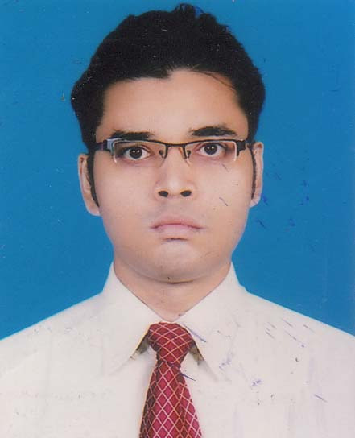

**PERSONAL PROFILE:**

Name : **Syed Ahsanul Hoque**

Father’s Name : Syed Aminul Hoque

Mother’s Name: Ferdous Begum

Date of Birth : 30th march 1983

Status : Unmarried.

present Address : “AMANAT CHASMA VIEW”

Flat no F2,Road No 3,

Chasma Hil R/A (Mayor Goli)

Chittagong 4209

Permanent Address : 198,199 sholosahar R/A,East Nasirabad

PS :-Panchlish, Po:- Polythechnical

Chittagong 4209

Contact Address : DO

Phone No. : 01813-240-745/01724-422-140

E-mail : tsyedahsanulhoque@yahoo.com

Nationality : Bangladeshi.

**Career Objective:**

Obtain a Challenging Job in a dynamic and progressive company where my creative talent and innovative capabilities would be efficiently utilized to benefit.

## **Employment History:**

**1. Company** : **Regency Garments Ltd.**

Nature of organization : Garments.

Address : Road No.: 07 CEPZ, Ctg.

Position : Planning officer (20th March 2009to 31st December-2012)

Division : Woven

Method : Full time

Buyer :TOMMY HILLFIGER

**2. Company** : **Smart jacket (BD) Ltd.**

Nature of organization : Garments.

Address : Plot No.: 11-12, Road No.: 05 CEPZ, Ctg.

Position : Senior Planning officer (1st January 2013 To 31st May 2015)

Division : Woven.

Buyer :H & M,CARTERS,VF ASIA

**3. Company** : **Fergasam BD Ltd.**

Nature of organization : Garments.

Address : Plot No.: 11-12, Road No.: 05 CEPZ, Ctg.

Position : Deputy Planning Manager (1st June 2015 To Till Now)

Division : Woven.

Buyer :TOMMY,

**Duties and Responsibilities :**

1. Conduct with buyer.
2. Sample follow up.
3. Order Book Follow up.
4. Co-ordinate with SR Merchant & Other relevant.
5. Time to time order collect
6. Strong Monitoring of Production to Shipment
7. Keep Updated To Relevant department & Management
8. To maintain and monitor the interdepartmental co-operation such as production department quality control department.
9. Shipping mark follow-up and review the buyers comments and rectify that by mail.

**ABILITIES:**

1. Goal oriented and self motivated.
2. Focused and hard working.

3 Outstanding communication and interpersonal skills.

**Academic Qualification;**

**Masters in Business Studies 2010**

Result : 2nd Class

Group : Commerce.

Name of the collage : Govt. Hazee Mohammed Mohshin College

Name of the University : National University

**Bachelor in Business Studies 2008**

Result : 2nd Class

Name of the collage : Govt. Hazee Mohammed Mohshin College

Name of the University : National University

**Higher Secondary School Certificate 2004**

Result : GPA-(3.20)

Group : Commerce.

Name of the collage : Govt. Hazee Mohammed Mohshin College

Name of the Board : Educational Board of Chittagong.

**Secondary School Certificate -2002**

Result : 1st Division

Group : Commerce.

Name of the School : Motijheel Model High School.

Name of the Board : Educational Board of Dhaka.

**Language proficiency:**

Quite efficient enough in M/S word, M/S Excel and adequate knowledge on windows operating system, internet-web browsing and e-mail.

**Bengali:**

Speaking : Excellent

Reading : Excellent

Writing : Excellent

**English:**

Speaking : Excellent

Reading : Excellent

Writing : Excellent

**Hindi:**

Speaking : Excellent

Reading : No

Writing : No

**Hobbies** : Computer, music, reading book, watching and playing football, cricket, shopping.

**Syed Ahsanul Hoque**