20th March 2017

Senior Vice President

Head of Human Resource

Reedisha Food & Beverage Ltd.

Reedisha Group

**Dhaka**

Re. **For senior post (Sales and Distribution)**

Dear Sir,

I am enclosing herewith my CV with a photograph for the above post. Please note that I have worked more than 25 years in Sales and Distribution division like as **Nestle, Garnier, Frito- Lay (Lays) etc**. and presently working with **FMCG** products in Proyash Distribution Co. Ltd. a concern of **Ahmed Group**. If you are looking a professional person, I am very much interested to work in your organization.

Thanking you.

Md. Mamunur Rashid Chy.

Cell : 01733751882

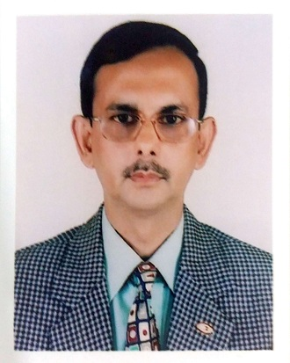

Resume Of

**MAMUNUR RASHID CHOUDHURY**

Apartment – 6/c, Eastern Housing Apartment

26/B Tupkhana Road, Shegunbagicha, Dhaka – 1000

Cell number: 8801733751882

E-mail: [mrc2009@yahoo.com](mailto:mrc2009@yahoo.com)

**Objective** To obtain a position commensurate of professional experience.

**Experience**

Started career as Sales Officer in **Transom Group** on 10th January 1984 in **Nestle Department** to appoint Distributor and to sales and marketing in one part of grater Dhaka and North Bengal Territory.

On 1988 Promoted as a **Departmental Head of Distribution (Nestle)** to attend and monitor National wide operation and activities.

In the year 1992 Transom management given to handle the **Pharma division and FMCG (Nestle**, **Garnier, Frito-Lay) products** to increase the sale in greater Sylhet area and **ensure smooth delivery with law cost.**

In the year 1995 Transom management **given the responsibilities of 112 officers, Executives, Managers activities and controlling and evaluate their performance time to time.**

In the year 2009 Transom management evaluated the performance and promoted as a **Deputy General Manager (**Sales and Admin**)**, thus left from position on 2nd June 2009.

Worked in Euro Pharma Ltd. as a **Head of Distribution and Administration** from January 2010 to February 2013.

Currently engaged in Proyash Distribution Co. Ltd. a concern of Ahmed Group as a **Chief Executive Officer** from May, 2013.

**Job Responsibilities**

Creating, Communicating and implementing the company’s vision, mission and overall direction.

Leading, Guiding, Directing and evaluating the work of all Executives.

Attend National wide monthly Sales target by setting goals and objective by proper

Allocation of manpower and logistic according to the market coverage plan.

To provide all MIS (Management Information System) reports available with automation system

Including all statement, analytical information of sales to review periodical sales achievement and performance to all respective concern as and when required.

Plan, organize and accelerate company’s resources (Man power & Logistic support) for optimum use and proper maintenance to ensure cost effective business growth of the organization.

Monitor all credit sales and arrange to realize/recover according to the due date of entire outstanding.

Resume of **Mamunur Rashid Choudhury** **Page no. 01**

**Trainings**

Attended a practical training course on banking procedure in all sections in Agrani Bank, University branch, Rajshahi.

Participated in different Sales and Distribution training programs in Bangladesh and India,

Conducted by Nestle India, Frito-Lay India, L’Oreal and Garnier India.

**Personal Details**

Father’s Name : Md. Rais Choudhury

Mother’s Name : Mrs. Lazzatunnesa Choudhury

Permanent Address : 15/ Surma R/A

Shullaghor

PO, PS & Dist. Sunamganj

Academic Fitness : B.Com (Hons) Accounting, 1980

Rajshahi University

M.Com (Accounting) 1981

Rajshahi University

Date of Birth : 30th September 1954

Nationality : Bangladeshi

Religion : Islam

Marital Status : Married

**Reference** **Mr. A. K. M. Shirin Mr. Miftauddin Chowdhury**

Managing Director Justice, Supreme Court

Dutch Bangla Bank Ltd. High Court Division

Shena Kolyan Bhobon Dhaka

Dhaka

__________________________

**Signature** **(Mamunur Rashid Choudhury)**

Resume of **Mamunur Rashid Choudhury** **Page no. 02**