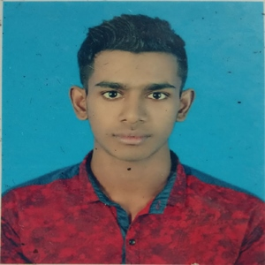

Subject: Application for the post of computer operator.

Sir,

I would like to apply for the post of computer operator in your organization in reply to your advertisement. My necessary are furnished hereunder for your kind perusal and consideration.

Resume Of

MD. Zakariya Hossain

Name: Zakariya Hossain

Father’s name: Santes Ali

Mother’s name: Ayesha khatun

Present address: Village:Islampur.Post: Balshabari.

Upazila: Ullapara. District: Sirajgonj.

Marital status: Unmarried

Religion: Islam

Education:

|  |  |  |  |
| --- | --- | --- | --- |
| Exam | Year | Board | Result |
| SSC | 2015 | Rajshahi | 3.83 |
| HSC | 2017 | Rajshahi | 3.17 |

|  |
| --- |
| I have certificate of computer course from National Institute of Technology |

Experience: Have been working as an Operator at United Surgical Ltd (present)

Interest /Hobbies: Tree Plantation, Movie watching.

About : I simplify my work by establishing good relationships with others I am a high schooler I can speak fluently in Bangla and English and at the same time I can handle computers I have no bad chapter in my previous career I respect my work which my father. - Mother taught me.