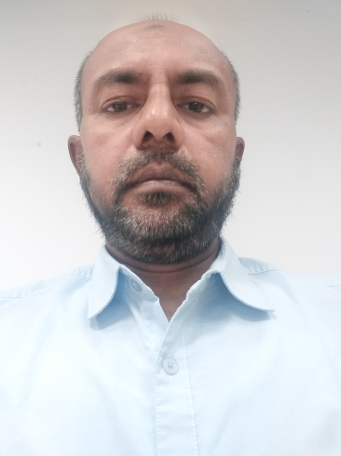

MD. MAHBUBUL ALAM

Address: West Majdayer ,Dalim Bhaban, Narayangonj.

Address2 : Rajendrapur, RP gate.Nayanpur.

Mobile**-** 01678640414, 01736007517

E-mail**: mahbubnipu2@gmail.com**

**CAREER OBJECT**

Looking for a challenging job where I can use my skill for establishments betterment and decent will through my academic knowledge as well as try to do best for occupational to increase companies Business so that would be an asset for the company.

**CURRENT EMPLOYMENT HISTORY**

Asst.General Manager ( Marketing & Merchandising )

Asrotex group ( Fariha Knit tex Ltd, 2017 to Till )

Buyer & Buying : Primark , NEXT , CAMAIEU, NKD, MATALAN, SEARS/KMART, TAILORVINTAGE. FILA , DOLLAR GENERAL USA

PREVIOUS EMPLOYMENT HISTORY

Manager( Marketing & Merchandising) : ( 2016 )

Rupashi Group

Shibu Market, *Enayetnagat, Fatullah, Narayanganj*

Bangladesh.

Buyer Account : Juiki Italy, PEPE&CO,Hagler Fashion, JOYTHAI,SPORTSWEAR,MILTEX USA

Deputy Manager(Merchandising & Marketing) : ( 2012 to 2015 )

Abanti Colur Tex Ltd.

*Polt No.A-646,Shashongaon,Enayetnagat,Fatullah,Narayanganj*

Bangladesh.

*Duties & Responsibility ( Buyer H & M/ PROMOD / EPONA )*

1. Marketing & Merchandising
2. Pricing & New Development

Sr.Merchandiser(Merchandising) : ( 2009 to2011 December )

Fakir Fashion Ltd. (Sister Concern of Fakir Group)

*Duties & Responsibility ( Buyer H&M)*

1. Costing & new development
2. Booking & production Follow up
3. And others Necessary works

Asst.Merchandiser & Sr.Merchandiser (January,2004 to November 2009)

FAKIR APPRELS LTD.

*Duties & Responsibility ( Buyer H&M & Ahlens)*

Address: BSCIC,Panchabati,Fatullah,

Narayangonj - Bangladesh.

**ACADEMIC QUALIFICATION**

|  |  |  |  |  |
| --- | --- | --- | --- | --- |
| **Exam Title** | **Major** | **Institute** | **Result** | **Pass. Year** |
| M.BA | Marketing | Stamford University | GPA 3.00 | 1999-2002 |
| B. Com | Pass | National University | Second Division | 1997 |
| H.S.C | Commerce | Comilla Victoria college | Second Division | 1993 |
| S.S.C | Science | Comilla Ibn Tymia School | 1st Division | 1991 |

SPECIALIZATION

Self-motivated and hard working and energetic can work in any environment. I have good ability to work in a team and social skill. Working on Organic cotton online database update for organic certificate also working by ERP & Fast React.

COMPUTER PROFICIENCY

M S Word, M S Excel, Internet Browsing, E-mail Corresponding and other computer Works. Have a good knowledge on ERP & Fast React Operating System

CAREER AND APPLICATION INFOMATION

1. Looking For : Management
2. Available For : Full Time
3. Present Salary : N/A
4. Expected Salary : Negotiable

PERSONAL DETAILS

1. Fathers Name : LATE MD.ABDUL KALAM AZAD
2. Mothers Name : MRS. RAWSHAN ARA BEGUM
3. Date of Birth : 2ND FEBRUARY ,1976
4. Gender : Male
5. Marital Status : Married
6. Religion : Islam (Sunni)
7. Nationality : Bangladeshi By Birth
8. Permanent Address : Vill: Shibpur, P.O : Uaruq,P \S: Shahrasti

Dist: Chandpur .

Signature