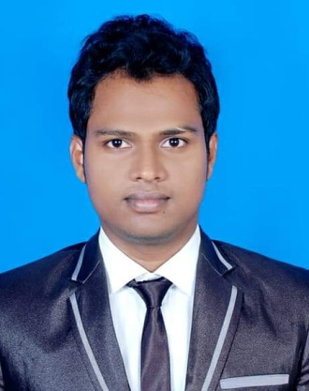

**RESUME OF**

**Md. Sohel Molla**  .

Present Address:

House# 45, Road# Haji Dil Mohammad Avenue (Main Road)

Dhaka Uddan Mohammadpur, Dhaka-1207.

Cell – 01708006506

***Objective***

I am energetic, hardworking, and smart with sound health, aptitude for effective team leadership,

pleasant personality and well-developed communication skill.

***Personal Information***

­­­­­­­­­­­­­­­­

Father’s Name **:** Md. Isaque Molla

Mother’s Name **:** Rahima

Permanent Address **:**  Vill: Sholmari, P.O : Shealdi,

P.S : Alfadanga, Dist: Foridpur.

Date of Birth **:** 05/03/1996

Nationality **:** Bangladeshi (By Birth)

Religion **:** Islam

Gender **:** Male

Marital Status **:** Unmarried

Blood Group : A (+ve)

***Academic Background***

**Program : S.S.C (Dakhil)**

Institution : Sialdi Adarsha Dakhil Madrasah

Subject : Science

Year of Passing : 2012

Board : Madrasah

Performance : 4.88 (out of 5.00)

**Program : H.S.C (Dhaka)**

Institution : Alfadanga Govt. College

Subject : Humanities

Year of Passing : 2014

Board : Dhaka

Performance : 4.10 (out of 5.00)

**Program : B.A Honours (Under University Of Dhaka**)

Institution : Govt. Titumir College

Subject : Philosophy

Year of Passing : 2014-15

Board : University Of Dhaka

Performance : Applied for

***Experiences***

* **Company Name: Monon Khudro Bebshayi Somobay Somiti Ltd**

**Designation: MLSS**

**Working Time: 2 Years**

* **Company Name: Grays chambers,**

**Designation: Office Assistant, Working Time- 03 Years**

* **Company Name: Infinity Marketing Ltd.**

**Designation: Exe. Officer.**

**Working Time: 2 Years.**

***Computer Skills***

* Microsoft Word, Excel, Power point, Net browsing.

***Strength***

* Have the adaption capability with new place and people.
* Sincerity in works, honesty and maintaining commitment.
* Good communication skill.
* Decided to work complete all task promptly and to a higher level of quality.
* Able to work long hours when need arises.

***Language Skills***

* Talking and Writing Bangla and English.
* Hindi only Talking.

***Interests***

* Playing Cricket, Football, Badminton.
* Reading books, listening music, volunteerism, Social services, Traveling.

­­­

***Declaration***

I, the undersigned declare that to the best of my knowledge and belief, the information given in this curriculam vitage is true, complete and accurate; my qualification, my efficiency and language and me.

Sincerely Yours,

………………….

**MD.Sohel Molla**