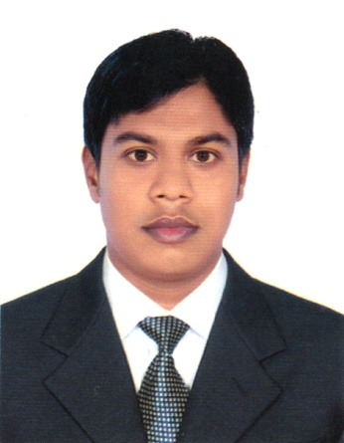**MD.RASHEDUL ISLAM**

Sadu para,Joydevpur Bus stand

Joydevpur ,Gazipur.

**Phone:** +8801751551029

**E-Mail:rashedulislamdu14@gmail.com**

**Career Objective**

Intend to work in challenging and competitive environment where strong sense of responsibility, sincerity, punctuality and commitment is required, where dignity of work provides self-satisfaction and the place of work provides potential avenues for learning experience.

**Educational Qualification**

|  |  |  |  |  |
| --- | --- | --- | --- | --- |
| **Exam Title** | **Concentration/ Major** | **Institute** | **Result** | **Passing Year** |
| MA | Philosophy | University of Dhaka | 3.51 | 2017 |
| BA | Philosophy | University of Dhaka | 3.54 | 2016 |
| HSC | Humanities | Birshrestha Hamidur Rahman College | 5.00 | 2012 |
| SSC | Humanities | Raypur Secondary School | 4.75 | 2010 |

**Professional Qualification**

* **1 year experience as a Area Sales Officer in Abul Khair & Company.**
* **Able to increase sales & develop working manpower.**

**Extra Curricular Activities**

* President of Surjasen Hall Association of Philosophy(SHAP) in 2016
* General Member of Dhaka University Philosophy Club in 2014
* General member of Surja Sen Hall Debating Club in 2014
* General member of Dhaka University Career Club in 2016

**Accomplishments**

* Organizing Iftar Party
* Organizing Fresher Reception
* Organizing Tours
* Organizing Tree Plantation programme

**Technical Skills**

* MS Word, MS Excel, MS PowerPoint &MS Access
* Windows 7 & Windows 10

**Language Proficiency**

* Bengali and English - Fluent in both verbal and written forms of communication.
* Arabic- Only reading

**Areas of Interest**

* Reading articles, newspaper columns
* Travelling, music, social working & watching english movie
* Playing cricket & carom
* Open discussion, leading & motivating

**Soft Skills**

* Flexibility
* Good Interpersonal and communication skills, hardworking, meticulous about details in any task
* Ability to work independently
* Ability to learn from mistakes

**Personal Details**

Full Name : Md. Rashedul Islam

Father’s Name : Md. Moynuddin

Mother’s Name : MST.Shahera Begum

Nationality : Bangladeshi

Date of Birth : 25/04/1994

Religious Views : Islam

Marital Status : Married

Blood Group : O+ (Positive)

Height : 5Feet 8.50 Inches

Permanent Address : Vill: Marufdah; Post: Roypur: Upaz: Jibonnagar; Dist: Chuadanga.

**References**

|  |  |  |
| --- | --- | --- |
| Name  Designation  Address  Organization  Cell Number  E-Mail | Md.Sujon Ali  RSO,MID dept.  Mirpur ,Dhaka.  Abul Khair & Company  01688803305  Alisujon782@gmail.com | Mr.Ahammad Ullah  Assistant Professor  Department of Philosophy  Faculty of Arts  +8801781345500  Ahammad@du.ac.bd |

I hereby certify that all the information provided above is true in best of my knowledge and sense and well supported by legal documents.

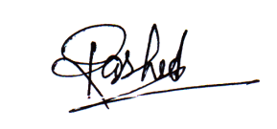

Signature Date: