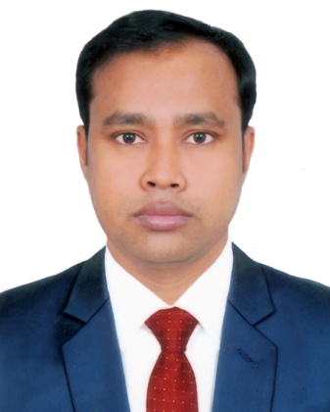

**Md. Mostafa Kamal**

House- 302/5,Nijum vila(4th Floor), Ahmed Nagar,

Paikpara,Mirpur- 1, Dhaka- 1216.

Cell: +880 01724947708

E-mail: mostofa2012bba@yahoo.com

# Career Objectives:

To pursue a challenging career in a leading and well-reputed organization where enthusing, honesty, sincerity, obedience, hard working and motivational factors will help and support me to utilize my knowledge and expertise for professional development.

# Educational Attainments:

**Master of Business Administration (M.B.A)**

Institute : Prime University

Year of passing : 2014

Major : Finance & Banking

Result : CGPA- 3.52 out of 4.00

**Bachelor of Business Administration (B.B.A) Hon’s**

Institute : Prime University

Year of passing : 2012

Major : Finance & Banking

Result : CGPA- 2.95 out of 4.00

**Higher Secondary School Certificate (H.S.C)**

Institute : Kushtia Islamia College

Group : Business Studies

Year of Passing : 2008

Result : GPA- 3.70 out of 5.00

Board : Joshore

**Secondary School Certificate (S.S.C)**

Institute : The Old Kushtia High School

Group : Science

Year of Passing : 2006

Result : GPA- 2.69 out of 5.00

Board : Joshore

# Logo

# Working Experience:

* Working experience as a **Territory Sales Manager** at PRAN- RFL Group from 01 February 2020 to Till Now.
* Working experience as a **Assistant Regional Manager** at Minister Myone Group from 06 July 2019 to 30 January 2020.
* Working experience as a **Sales Representative** at PRAN- RFL Group from November 2014 to 30 June 2019.

# Computer Skills:

Completed 6 Months Course on Basic Computer Knowledge includes MS Word, MS Excel, MS Power Point, Photoshop & Net Browsing.

# Personal Profile:

Name : **Md. Mostafa Kamal**

Father’s Name : Md. Monirul Islam

Mother’s Name : Mst. Parul Khatun

Permanent Address : Vill: Jugia, P.O: Jugia,

P.S: Kushtia, Dist: Kushtia.

Date of Birth : 25th June, 1990

Marital Status : Single

Gender : Male

Religion : Muslim (Sunni)

Nationality : Bangladeshi

Blood Group : B+

National ID No. : 199050717925000170

# Language Ability:

Bengali : Mother Tongue

English : Reading, writing and Speaking.

Interest Hobbies : Deviating/Public Speaking, Travelling, Enjoying

Music, Play game & Reading Book.

# LogoReference:

|  |  |  |
| --- | --- | --- |
| Amitabh Chakraborty  Deputy Director (DBI-2)  Bangladesh Bank  Head Office,  Motijheel C/A, Dhaka- 1000  Cell: 01712166601 |  | Dr. Khurshida Pervin  Assistant Professor (Statistics)  Dept of Business Administration  Prime University  Mirpur, Dhaka  Cell: 01671182834 |

# Declaration:

I’m Md. Mostafa Kamal hereby declared that the above-furnished information is true to the best of my knowledge and believe.



Date: 08/11/2020

Signature