***R E S***

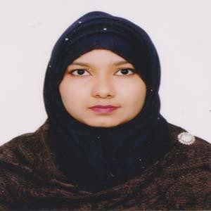

***U*** Resume of

# *M* NASRIN AKTER

***E*** Mobile: **01632-962358**

## Career Objective

To work in a dynamic, intensive environment, where the creativity and interest can be found to develop the skills as well as the career with a strong emphasis on sustained growth and development.

## Academic Records

* **Bachelor of Arts (Hon’s)**
  + Institute Name **: Eden Mohila College**
  + University **:** National University
  + Subject **:** Philosophy
  + Passing Year **:** Ongoing
* **Higher Secondary Certificate (H.S.C)**
  + Institute Name **: Dania College**
  + Board **:** Dhaka
  + Group **:** Arts
  + Passing Year 2015
  + Division **:** 3.67 out of 5.00
* **Secondary School Certificate (S.S.C)**
  + Institute Name **: Jatrabari PDB High School**
  + Board **:** Dhaka
  + Group **:** Arts
  + Passing Year 2013
  + Division **:** 3.88 out of 5.00

## Language Proficiency

* English **:** Fair reading, writing and speaking ability

1

* Bengali **:** Mother tongue



## Computer Literacy

* Package Program **:** Microsoft Office Word, Ms-Excel, PowerPoint.
* Others **:** E-mail and Internet Browsing

## Personal Details

* Father’s Name **:** Md. Nayeb Ali
* Mother’s Name **:** Shahanaz Akter
* Date of Birth **:** 12 June, 1997
* Gender **:** Female
* Marital Status **:** Married
* Religion **:** Islam(Sunni)
* Nationality **:** Bangladeshi
* Blood Group **:** O+
* Present Address **:** 147/14, South Jatrabari, Dhaka- 1204
* Permanent Address **:** Vill- Krishnapur, P.O- Krishnapur, P.S- Manikgonj, Dist- Manikgonj

## Experience

As a Marketing Executive Officer in Asia Tec Ltd, April 2016 to till now.

Karim Group Call Centre Executive ( 2 Years)

## Confidence

I undersigned, hereby declare that I will be responsible for any wrong information provided here.

Signature



# (NASRIN AKTER)

2