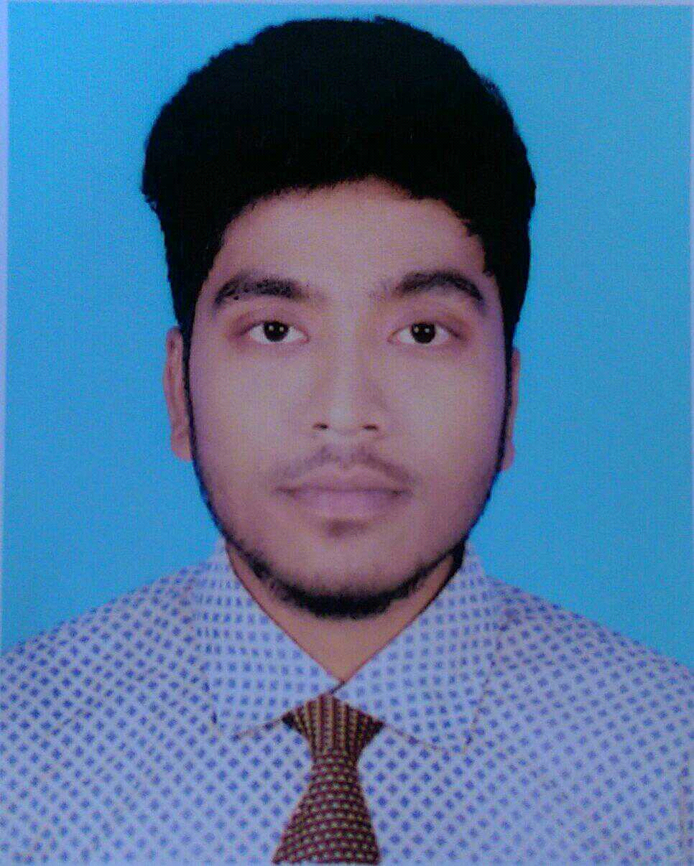

**RESUME**

**OF MD. SHIMUL RANA**

+8801744471783

House# 173, Road# 01

Uttorpara, Khilkhat, Dhaka-1229

**Career Objective:**

Looking for A Dynamic and Challenging Job To Utilize My Background And Willing To Work In A Creative And Technical Environment Where There Are Scope To Utilize Knowledge And Creativity.

**Academic Qualification**

**B.sc in Mechanical Certificate:**

Institution : Sonargaon University, [Mohakhali –Dhaka]

Result : 3.55

Department : Mechanical

Passing Year : 2020

**Diploma-in-Engineering Certificate:**

Institution : Rajshahi Polytechnic Institute , Rajshahi.

Department : Mechanical Technology

Result : 3.28(Out of 4)

Passing Year : 2015

Board : Bangladesh Technical Education Board, Dhaka.

**Secondary School Certificate (S.S.C):**

Institution : Daokandi High School, Rajshahi.

Group : Science

Result : 4.50(Out of 5)

Passing Year : 2011

Board : Rajshahi.

**Language Skill:**

Good in English, Bengali, preparing reports Presentation Etc.

**Computer skill:**

MS-Word, MS-Excel, Power Point, & Extra Ordinary at Internet Sector.

**Training and Industrial Attachment:**

1.Conducting 4 Week Attachment in Bangladesh Railway at Saidpur.

2.Completing 14 Week Digital Marketing at CoderTrust-Bangladesh.

3.Completing 12 Week Industrial Attachment Under the Department of **Thermodynamics** In Technical Division.

**Speciality:**

* Innovative.
* Ready to take challenge to meet the target*.*
* Able to work individually and in group.
* Communicative and friendly.
* Determined and self-motivated.

**Personal Details:**

**Name : Md. Shimul Rana**

Father’s Name : Md. Alauddin

Mother’s Name : Mst. Sima Begum

Date of Birth : 20-12-1995

Gender : Male

Marital Status : Married

Religion : Islam.

Nationality : Bangladeshi.

Blood Group : AB+

Permanent Address : Tekatapara, Paba, Rajshahi,6240.

**Declaration**

I, hereby, declare that each of the information stated above is true and given in a cool brain, any willing mistake will result me in disqualification.

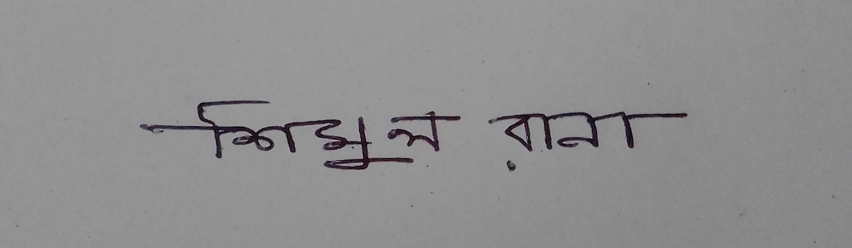

**SHIMUL RANA**

Date:18-3-2020