**Lab Activity 5: JSON and jQuery**

<https://sites.google.com/view/webdevelopmentbic21203habib/home>

# Summary

In this lab, I explored client-side scripting by creating a JSON file to store book information, including titles, authors, publication years, and genres. I developed an HTML file to fetch and display specific book details in the browser console using JavaScript. Additionally, I rewrote JavaScript DOM operations using jQuery to demonstrate its efficiency in manipulating web elements dynamically. The tasks enhanced my understanding of JSON data handling and jQuery’s role in creating interactive web pages.

# Screenshots

* **Screenshot 1: Content of books.json**

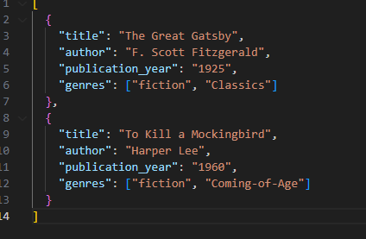

Displays the JSON file containing two book entries with fields for title, author, publication year, and genres, formatted as a structured data array.

* **Screenshot 2: Browser Console Output**

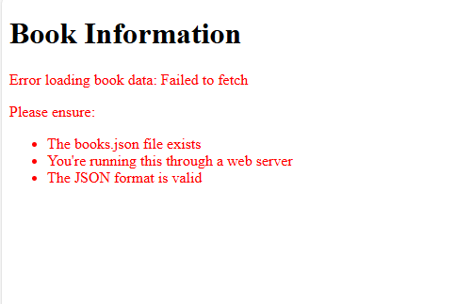

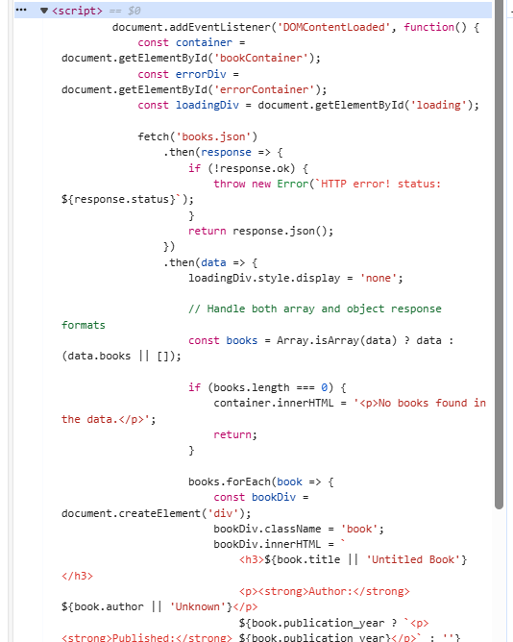

Shows the console output from index.html,

**Screenshot 3: jQuery-Modified HTML Page**

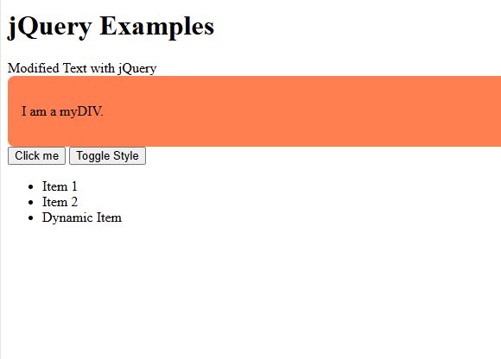

Displays the jquery.html page where the text of an with ID myElement is changed to ”Modified Text,” a div with ID myDIV has a coral background applied via the mystyle class, and clicking a button with ID myButton triggers an alert saying ”Button clicked!”.

# Reflective Journal

This lab introduced me to JSON and jQuery, which are pivotal for modern web development. Initially, structuring the JSON file was challenging due to my unfamiliarity with its syntax, but creating books.json clarified how data can be organized for client-side use. Using the fetch API to retrieve and parse JSON data was a new experience, and seeing the output in the browser console was rewarding. Learning jQuery was particularly exciting, as its concise syntax, such as $("myElement").text("Modified Text"), simplified DOM manipulation compared to vanilla JavaScript. The lab bridged the gap between static and dynamic web content, enhancing my ability to create interactive user experiences. I felt accomplished seeing the jQuery modifications work seamlessly and am eager to apply these skills in more complex projects.

1