**Lab Activity 6: Web Development with PHP**

<https://sites.google.com/view/webdevelopmentbic21203habib/home>

# Summary

This lab focused on using PHP to create dynamic web pages. I developed three PHP scripts: one to display personal details in a table, another to present student data using an associative array and a foreach loop, and a third to calculate the area of a rectangle using a PHP function. These tasks introduced me to embedding PHP within HTML, handling arrays, and defining reusable functions.

# Screenshots

Lab6_q1

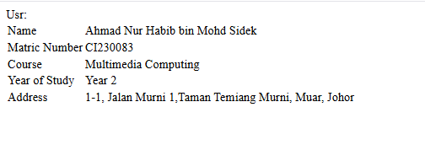

Lab6_q2

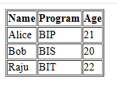

Lan6_q3

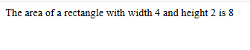

# Reflective Journal

This lab was my first hands-on experience with PHP, and it was a great introduction to server-side scripting. Embedding PHP code within HTML to generate dynamic content was initially confusing, but I quickly grasped how to use PHP variables and echo statements to display data. Working with associative arrays was familiar from other programming languages, but using the foreach loop in PHP to iterate over data was straightforward and effective. Defining a function to calculate the rectangle’s area helped me understand PHP’s function syntax and parameter passing. The main challenge was ensuring proper HTML-PHP integration, but testing on a local server helped me resolve syntax errors. I felt more confident in my PHP skills after this lab and appreciated its power in creating dynamic web content.