**Lab Activity 7: CRUD with PHP**

<https://sites.google.com/view/webdevelopmentbic21203habib/home>

# Summary

In this lab, I developed a user management system using PHP and MySQL. I created a database and a users table, implemented registration and login forms with password hashing, and added CRUD (Create, Read, Update, Delete) functionality to manage user records. Session management was incorporated to restrict access to authenticated users, and CSS was used for styling.

# Screenshots

* **Screenshot 1: Registration Form**

Displays the registration form with fields for matric number, name, password, and role, along with a success message after submission.

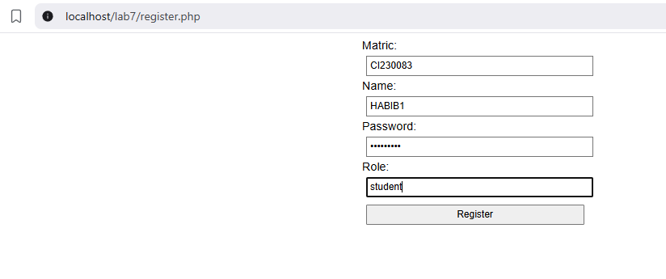



* **Screenshot 2: Login Form**

Shows the login form and the user list page after successful authentication.

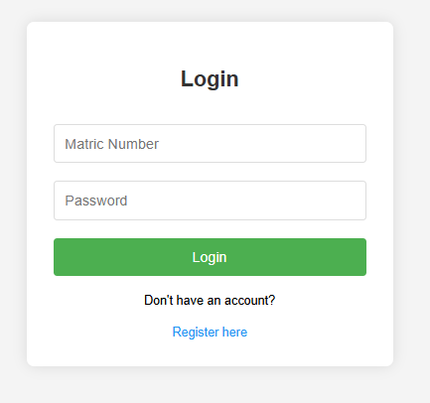

* **Screenshot 3: User List**

Displays a table of all registered users with columns for matric number, name, role, and buttons for editing or deleting records.

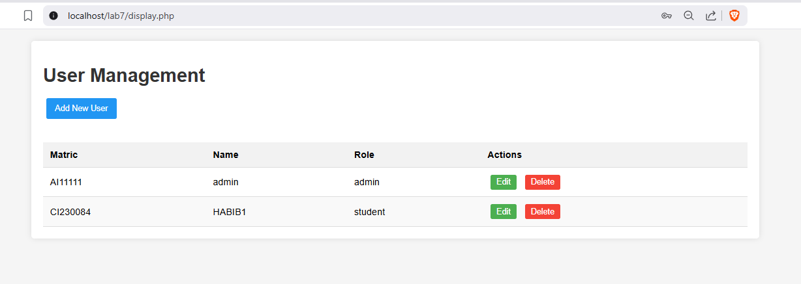

* **Screenshot 4: Edit Form**

Shows the form pre-filled with user data for updating an existing record.

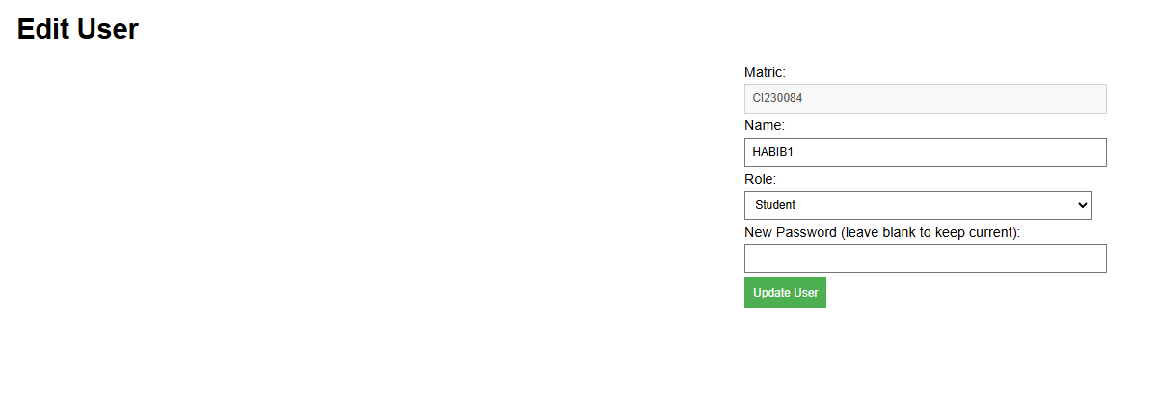

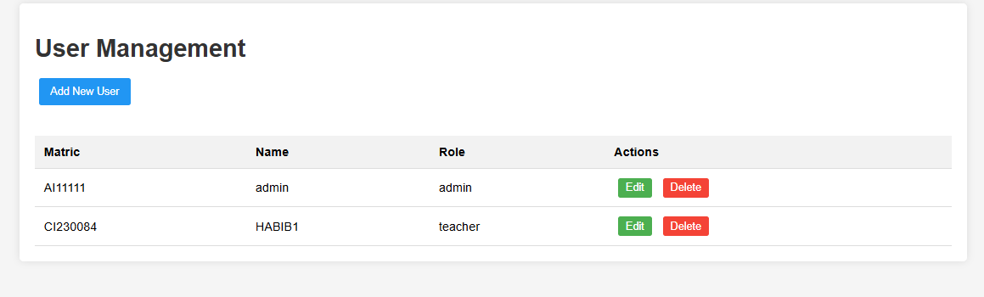

# Reflective Journal

This lab on **CRUD with PHP** deepened my understanding of backend development. I successfully built a **user management system** with secure registration, login, and admin controls. The biggest challenge was ensuring **security**—hashing passwords and preventing SQL injection—but using **PDO and prepared statements** helped. I also learned the importance of **session management** to restrict access. While the system works, I realize I could improve it with **AJAX for smoother updates** and better error handling. Overall, this lab strengthened my PHP skills and showed me how crucial proper **data validation and security** are in web development. Next time, I’d like to experiment with **role-based permissions** for more dynamic access control.