**Lab Activity 8: Client and Server-Side Scripting with Database**

<https://sites.google.com/view/webdevelopmentbic21203habib/home>

# Summary

This lab activity focused on integrating PHP with MySQL to create dynamic web applications, covering essential concepts such as database connectivity, user authentication (registration and login systems), and CRUD (Create, Read, Update, Delete) operations. Through exercises like building a ShoutBox and a user management system, we implemented secure practices such as password hashing, input sanitization, and session management. The lab emphasized the transition from static to dynamic web pages by leveraging server-side scripting to interact with databases, demonstrating how PHP and MySQL work together to handle data persistence, user authentication, and role-based content display.

# Screenshots

* **Screenshot 1: Shoutbox Interface**

Shows the shoutbox form for submitting messages and a list of recent shouts, updated dynamically via AJAX.

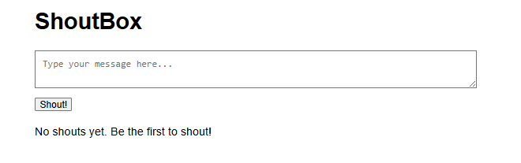

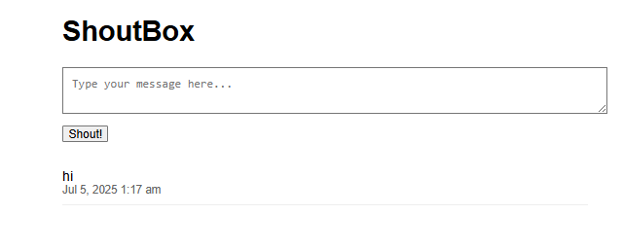

Exercise 4: User Registration & Login Script in PHP and MySQLi

Script in PHP and MySQL.

• Steps to Create Simple User Registration & Login Script in PHP and MySQLi

1. Create a Database

2. Create a Database Table with five fields:

id, username, email, password, trn_date

3. Create a Registration Form

4. Create a Login Form

5. Connect to the Database by using PHP

6. Authenticate Logged in User

7. Create Index Page

8. Create Dashboard Page

9. Create a Log Out

10. Create a CSS File

* **Screenshot 2: Exercise 4**

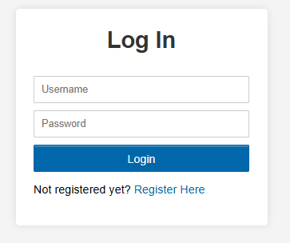

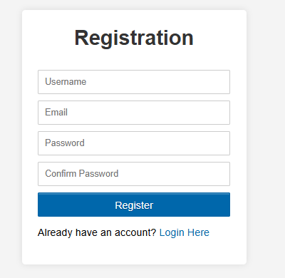

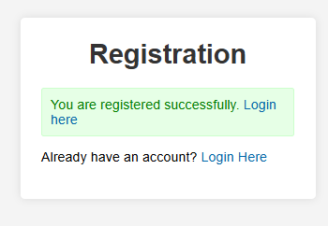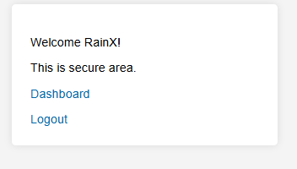

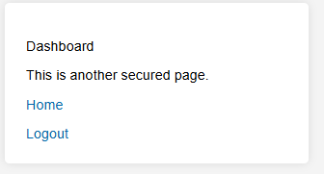

Exercise 5: Insert, View, Edit and Delete Record from Database Using PHP

and MySQLi

• Now you need to create another table to keep records in the table, update dashboard.php file and

add four more new pages which are insert.php, view.php, edit.php, and delete.php, follow the

following steps:

1. Create Another Table for Records

2. Update Dashboard File

3. Create Insert Page

4. Create View Page

5. Create Edit/Update Page

6. Create Delete Page

* **Screenshot 3: Exercise 5**

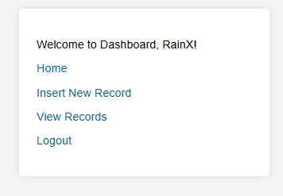

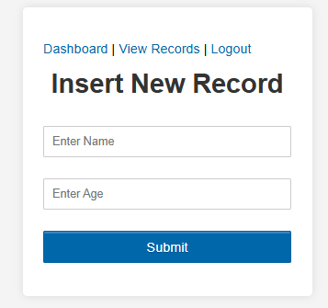



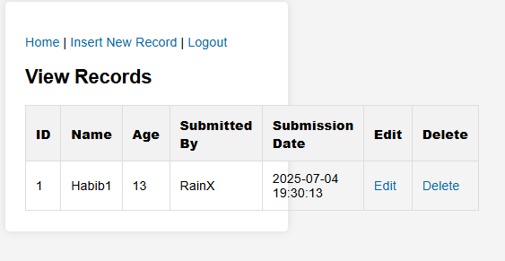

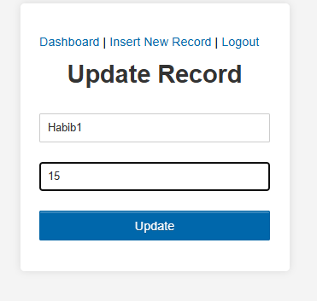

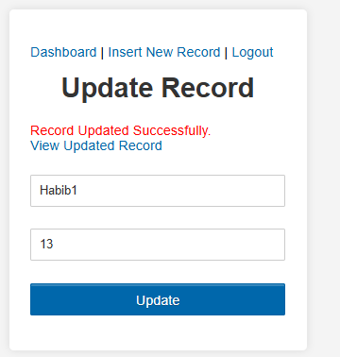

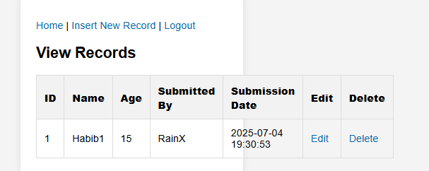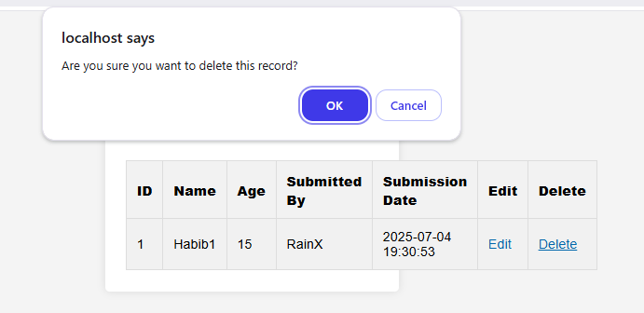

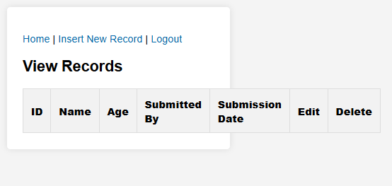

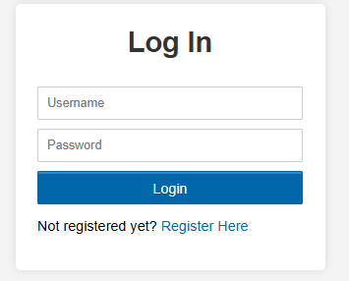

# Reflective Journal

# Completing this lab deepened my understanding of server-side scripting and database interactions, highlighting the importance of security measures like input validation and password hashing in real-world applications. I encountered challenges in debugging SQL queries and session management, which taught me the value of systematic error-checking and testing. The hands-on experience with CRUD operations and user authentication boosted my confidence in building functional web applications. Moving forward, I aim to explore more advanced topics like prepared statements for enhanced security and AJAX for smoother user interactions, recognizing that these foundational skills are critical for developing robust, scalable web solutions.