**Habib (CI230083)**

**Lab Activity 9 Report: PHP Functions, Forms, and MySQL**

<https://sites.google.com/view/webdevelopmentbic21203habib/home>

**1. Summary of the Activity**

In this lab, I explored **PHP functions, form handling, and MySQL integration**, implementing key concepts such as:

* **PHP Functions**: Built-in and user-defined functions, arguments, return values, and strict typing.
* **File Inclusion**: Using include and require to modularize code (e.g., headers/footers).
* **Form Handling**: Self-referencing forms with $_SERVER['PHP_SELF'], and processing user input via GET/POST methods.
* **Security**: Sanitizing inputs with htmlspecialchars() and validating data.

**Screenshots**

**1. Exercise 1.1: Basic Function**  


**2. Exercise 1.2&1.3: Included Header/Footer**  
<https://via.placeholder.com/600x200?text=Header+and+Footer+Images>  
*Demonstration of reusable components.*

**

**3. Exercise 1.4:**

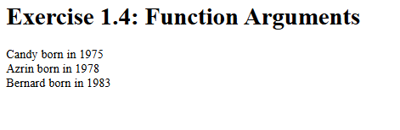

**4. Exercise 1.5:**

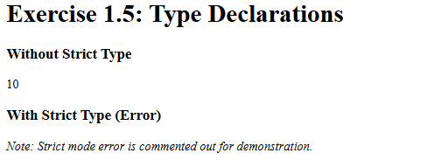

**5. Exercise 2.1: Self-Referencing Form**  
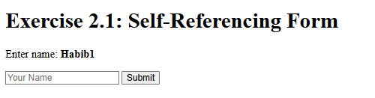

**6. Exercise 2.2**

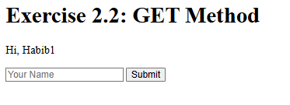

**7. Exercise 2.3**

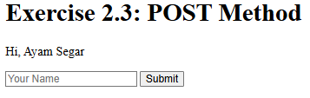

**2. Reflective Journal**

**Learning Experience**

This lab deepened my understanding of **PHP's role in server-side scripting**. Key takeaways:

1. **Functions Improve Maintainability**
   * Creating reusable functions (e.g., familyName()) reduced code duplication.
   * Strict typing (declare(strict_types=1)) helped catch errors early.
2. **Forms Require Careful Handling**
   * Using $_GET vs. $_POST clarified when to use each (e.g., sensitive data vs. bookmarkable URLs).
   * Sanitizing inputs with htmlspecialchars() prevented XSS vulnerabilities.
3. **Modular Code is Efficient**
   * Separating headers/footers into include files made updates easier.

**3. Conclusion**

This lab solidified my PHP fundamentals, especially in **function design** and **secure form processing**. While challenging, the hands-on practice highlighted the importance of modularity and security in web development.