Nikon Azure DevOps Configurations

# 1 Purpose

## This document aims to capture a high-level design for the CI/CD solution for Nikon Mulesoft applications. This design will be used to set up and trigger the pipelines.

## 1.1 Audience

* Mulesoft Architects, Developers and API designers
* DevOps team responsible for deployment and management of MuleSoft applications

# 2 Branches to Mule Environments

|  |  |  |
| --- | --- | --- |
| Branch | Mule Environment | Remarks |
| develop | DEV-OneView | Development |
| release | UAT-OneView | User Acceptance Testing |
| release | Prod-OneView | Production |
| main | Production | Copy of Production Code    After Prod Go-live code needs to merge from release to main |

Note:

The main branch must be created for each application which hold the production equivalent code/configuration.

For Each Feature development : feature/<<TICKET-ID>> or feature/<<TASK-NAME>>

For Development : develop

For UAT, Production : release

Note:

* feature/<<branch-name>> will be merged using PR request only to develop branch.
* develop will be merged with release branch using PR request only. [once develop branch is stable and ready for release]
* Without feature confirmation, feature/<<branch-name>> won’t be merged into develop branch

# 3 Configuration

## 3.1 MuleSoft Application Projects

Project Root Files

Pom.xml - refer doc <https://docs.mulesoft.com/mule-runtime/latest/deploy-to-cloudhub-2>

[ Please refer helloworld-sys-api branch : develop , pom.xml ]

Source Code : [helloworld-sys-app - Repos](https://dev.azure.com/NikonAustraliaMuleSoft/MuleSoft%20Migration/_git/helloworld-sys-app)

Global Properties

* mule.env [ dev, uat, prod ]
* secure.key [ Non-Prod and Prod will have a separate value for this secure key ]

## 3.2 Azure DevOps Variable Groups

The variable groups used for Mulesoft CICD are:

mule.{env}.vars.group

* mule.dev.vars.group (for DEV)
* mule.uat.vars.group (for UAT)
* mule.prod.vars.group (for PROD)

Note: It might be possible that only 3 environments will be there Ex: DEV, UAT and PROD ]

Note:

* Only 3 Envs are available [ Ex: DEV, UAT and PROD ]
* SECURE_KEY will be same for DEV and UAT, PROD will have a separate securekey
* TARGET_NAME will be shared space or private space

|  |  |  |
| --- | --- | --- |
| Variables | Value | Remarks |
| AP_CLIENT_ID | <AP_CLIENT_ID> | Environment Client ID for DEV, UAT or PROD |
| AP_CLIENT_SECRET | <AP_CLIENT_SECRET> | Environment Client Secret for DEV, UAT or PROD |
| BG_ID | <BG_ID> | Business Group ID |
| ENV | XXX | Anypoint Environments:  DEV-OneView  UAT-OneView  Prod-OneView |
| MULE_ENV | xxx | Environment parameter used for the application to decide the property file:  dev  uat  prod |
| MULE_VERSION | 4.6.6 | The runtime version as it appears on the Anypoint platform |
| SECURE_KEY | < SECURE _KEY> | The key value to encrypt and decrypt the secret property values for DEV, UAT and PROD |
| TARGET_NAME | <TARGET_NAME> | The shared space or private space name should be provided.  Ex: Australia Region  Shared space: Cloudhub-AP-Southeast-2  Private space: TBD |

## 3.3 Azure DevOps Secure Files

The secure files used for MuleSoft CICD are:

settings.xml (the permission needs to be granted to all build pipelines)

## 3.4 Azure DevOps Build Pipelines

Prerequisites:

1. Have set-up variable groups for each environment (dev, uat, prod) and secure files(settings.xml) under Pipeline > Library.
2. Create three branches: develop, release, main

|  |  |  |  |
| --- | --- | --- | --- |
| **Branch** | **Type of Pipeline** | **Pipeline Naming** | **Pipeline Name** |
| develop | Build Pipeline | <<app-name>>-<<branch-name>>-package | notification-sys-api-develop-package |
| develop | Release Pipeline | <<app-name>>-<<branch-name>>-deploy | notification-sys-api-develop-deploy |
|  |  |  |  |
| release | Build Pipeline | <<app-name>>-<<branch-name>>-package | notification-sys-api-release-package |
| release | Release Pipeline | <<app-name>>-<<branch-name>>-deploy | notification-sys-api-release-deploy |
|  |  |  |  |
| **Note:** | Build Pipeline | <<app-name>>-<<branch-name>>-package | This build pipeline will be used to generate artifact version, munit, package and deploy an artifact to AP Exchange |
|  | Release Pipeline | <<app-name>>-<<branch-name>>-deploy | This release pipeline will be used to deploy an artifact to respective environments. (Ex: DEV, UAT and PROD ) |
|  | Release Pipeline | The release pipeline will have two stages:   1. UAT (MULE UAT deployment) 2. PROD (MULE PROD deployment) |  |

Set up to **Build pipelines**

1. Click ‘New pipeline’ to create pipeline
2. Select “Use the classic editor to create a pipeline without YAML” > AzureRepos Git > Maven

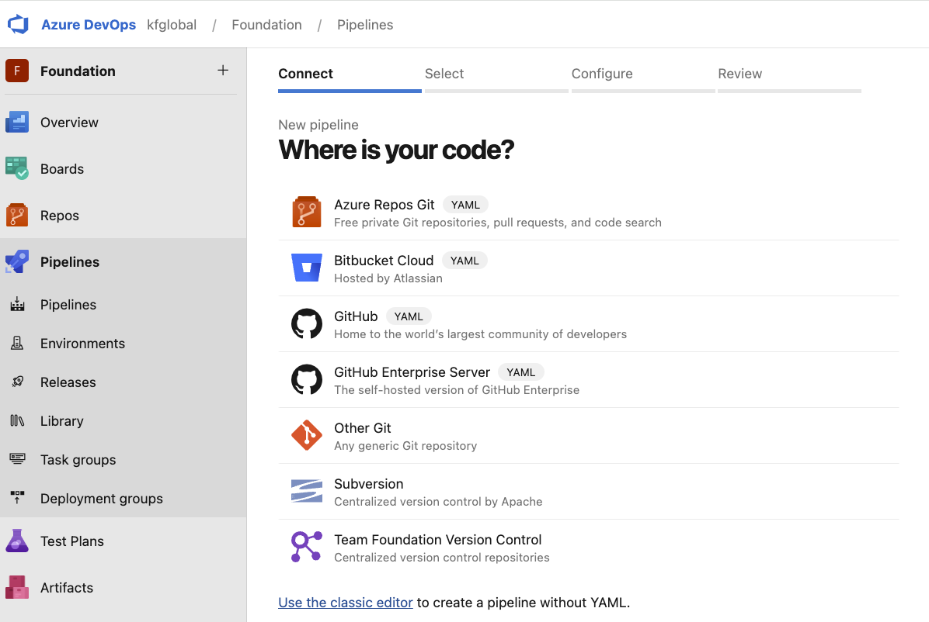

1. Configure - Pipeline to: [ Branch : develop and Action : package ]

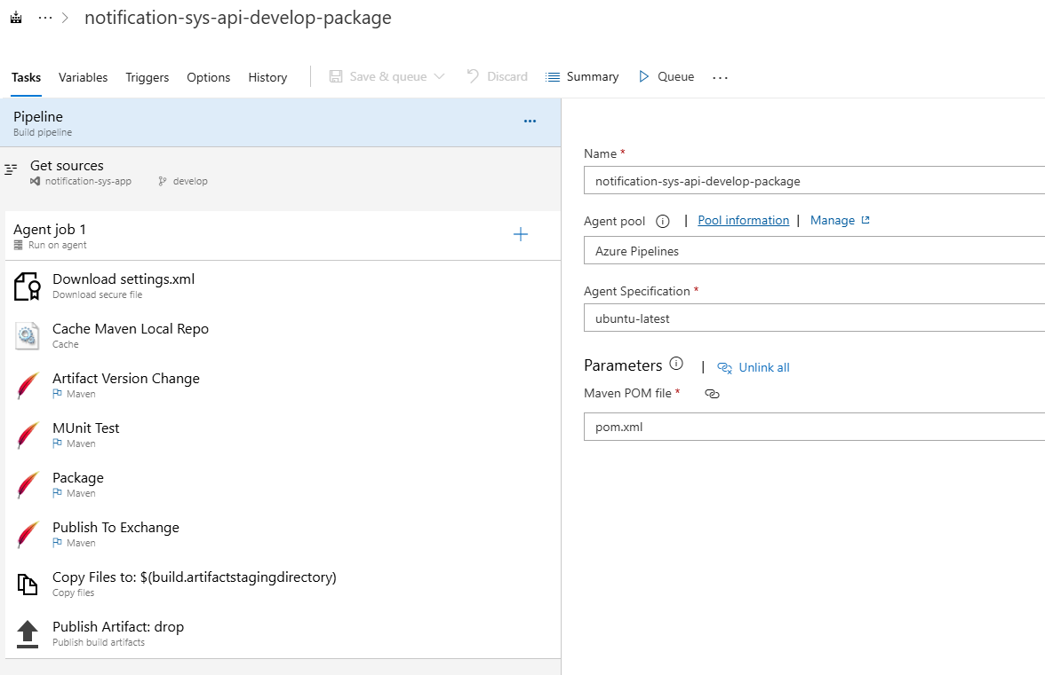

1. Configure - Agent Job 1 > Agent Pool and Specification

1. Add and configure a new task - Download Secure file

1. Add and configure a new task - Cache

Key: maven | "$(Agent.OS)" | $(Build.SourcesDirectory)/pom.xml

Path: $(MAVEN_CACHE_FOLDER)

Additional restore Key prefixes:

maven | "$(Agent.OS)"

maven

1. Configure existing task - Maven
2. Artifact Version Change

Set Goal(s), Option(s) and Remove Junit Test Results

Goal(s)

build-helper:parse-version -DgenerateBackupPoms=false versions:set -DnewVersion=$(NEW_BUILD_VERSION)

Option(s):

-s $(mvnSettings.secureFilePath) $(MAVEN_OPTS)

Note:

* Validate Pipeline variables are configured properly.

* Validate Variable groups are associated with dev groups

1. MUnit Test

Set Goal(s), Option(s) and Junit Test Results

Goal(s)

clean test

Option(s):

-s $(mvnSettings.secureFilePath) $(MAVEN_OPTS) -Dsecure.key=$(SECURE_KEY) -Dmule.env=$(MULE_ENV)

1. Package

Set Goal(s), Option(s) and Remove Junit Test Results

Goal(s)

clean package -DskipTests

Option(s)

-s $(mvnSettings.secureFilePath) $(MAVEN_OPTS)

1. Deploy To Exchange

Set Goal(s), Option(s) and Remove Junit Test Results

Goal(s) : clean deploy -DskipTests

Option(s): -s $(mvnSettings.secureFilePath) $(MAVEN_OPTS)

Note: MAVEN_OPTS and MAVEN_CACHE_FOLDER are pipeline variables

1. Configure existing task - Copy Files to: $(build.artifactstagingdirectory)

Contents: */*.jar

**/pom.xml

1. Under Variables > Variable groups > Link Variable Group > select variable group depending on corresponding environment (In this case develop branch is DEV environment)

1. Enable continuous integration through customizing ‘Triggers’

1. Click Save and leave an appropriate comment regarding your changes
2. Repeat the steps for other branches respectively ( if needed ).

## 3.5 Azure DevOps Release Pipelines

Setup for release pipelines

1. Create a new release pipeline: New > New release Pipeline > Start with an “Empty Job” > Stage name: <environment-name> and change name of release pipeline at the top of page.

1. Add an Artifact  
    2.1 Configure - select matched build pipeline

1. Add **continuous deployment trigger** (For DEV branch ONLY): Click on the lightning icon on the top right of the artifact and enable: “Continuous deployment trigger”.

1. Add ‘Pre-deployment conditions’ for some special environments (like DEV)

Define the trigger that will start deployment for DEV stage

Select the users who can approve or reject deployments to this stage

1. Click on Tasks and start to add the relevant tasks
   1. Configure an existing task - Agent Job:

* 1. Configure an existing task - Download:

* 1. Add and configure a new task - Bash

cd $(Release.PrimaryArtifactSourceAlias)/drop/target/

ls -la

echo "##vso[task.setvariable variable=ARTIFACT]`ls | grep *.jar`"

* 1. Add and configure a new task - Maven

Maven POM file: $(Release.PrimaryArtifactSourceAlias)/drop/pom.xml

Goal(s): mule:deploy

Option(s):

-s $(mvnSettings.secureFilePath) -DmuleDeploy -DskipTests -Dmule.env=$(MULE_ENV) -Dsecure.key=$(SECURE_KEY) -Dapp.runtime=$(MULE_VERSION) -Dap.applicationName=$(APP_NAME) -Dorganization.id=$(BG_ID) -Denvironment=$(ENV) -Danypoint.privatespace.name=$(TARGET_NAME) -Dap.config.analytics.agent.enabled=true -Dvisualizer.layer=$(VISUALIZER_LAYER) -Dmule.deploy.replicas=$(MULE_DEPLOY_REPLICAS) -Dmule.deploy.vcores=$(MULE_DEPLOY_VCORES) -Danypoint.platform.client_id=$(AP_CLIENT_ID) -Danypoint.platform.client_secret=$(AP_CLIENT_SECRET)

Note: Uncheck the JUnit Test Results:

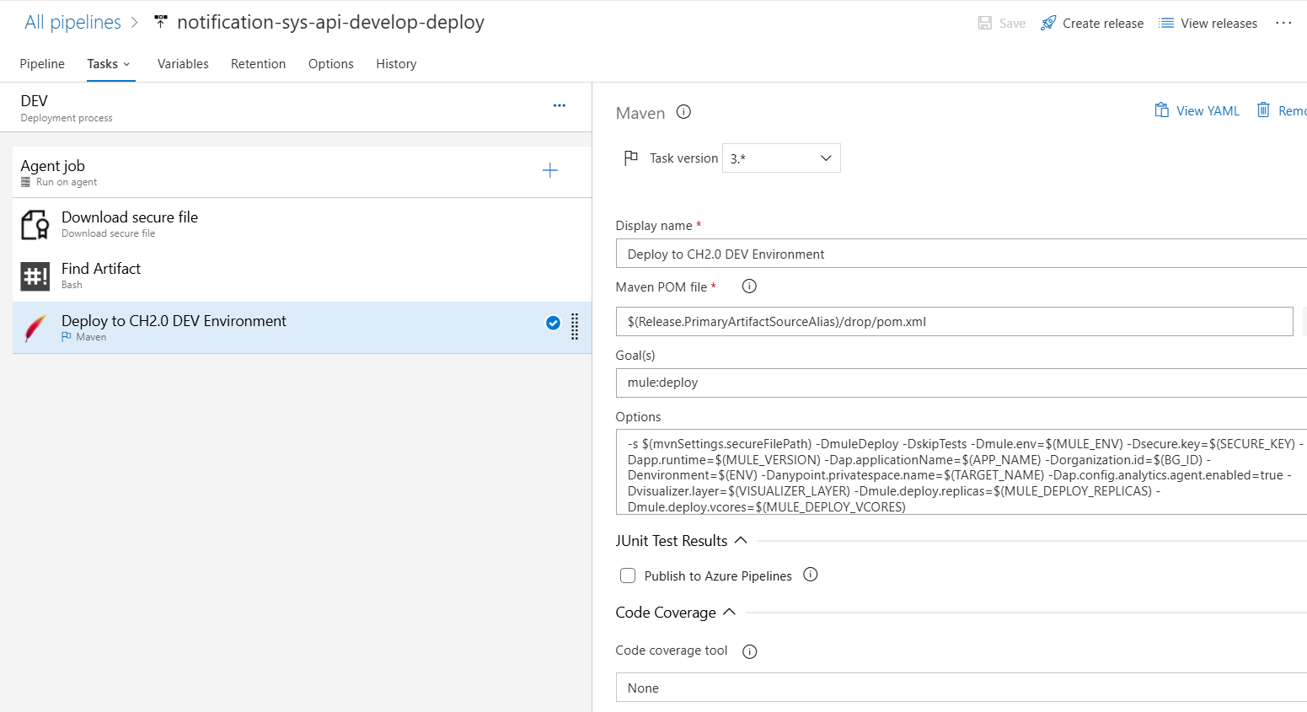

* 1. Add Pipeline variables (APP_NAME)

1. Configure: Pipeline variables for each environment(DEV)

* 1. Add Variable Groups (Select variable groups corresponding to current environment deploying to)

* 1. Click Save and leave an appropriate comment regarding your changes.
  2. Repeat steps for release branch respectively.

# 4. How to use these pipelines

## 4.1 Build pipeline

* Build pipeline will automatically be triggered once code merge into branch
* Or can manually run the pipeline by click ‘Run pipeline’ button

Select branches name to build and click ‘Run’ button

Check pipeline logs by click ‘Agent Job 1

It shows logs as below:

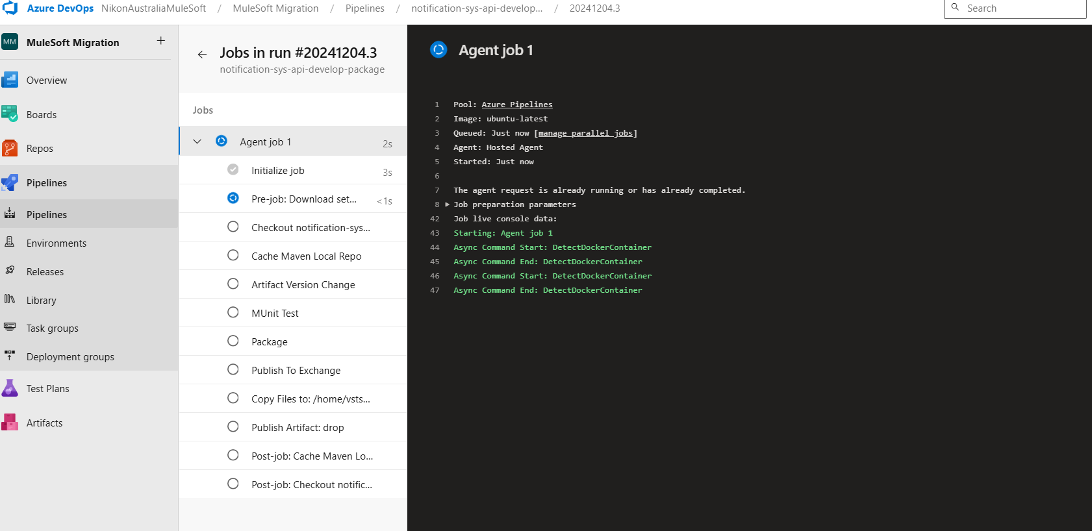

Clone existing build pipeline:

## 4.2 Release Pipeline

* Release pipeline will be automatically triggered and created when a new build is available
* Or you can manually create it by click button ‘Create Release’

* Clone existing release pipeline

* Check logs

Select release pipeline

the release you want to check and Stage, then click ‘Logs’ button

Note: Below are URL details for DEV, UAT and PROD environments.

|  |  |  |
| --- | --- | --- |
| ENV | URL | Comments |
| DEV |  |  |
| UAT |  |  |
| PROD |  |  |