***LAB 3 Assignments***

Task 6: Welcome Message

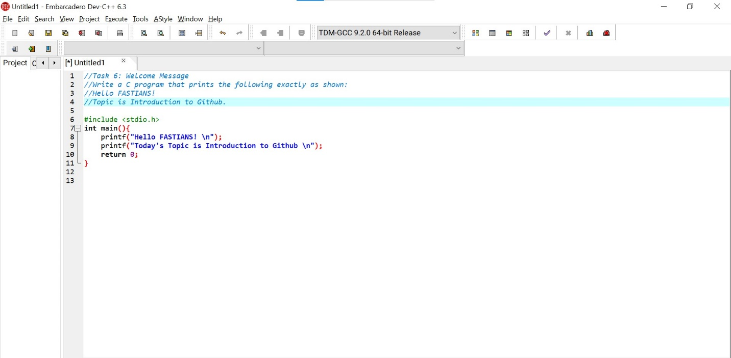

Task 7: Area and Perimeter of a Rectangle

Task 9: Users Information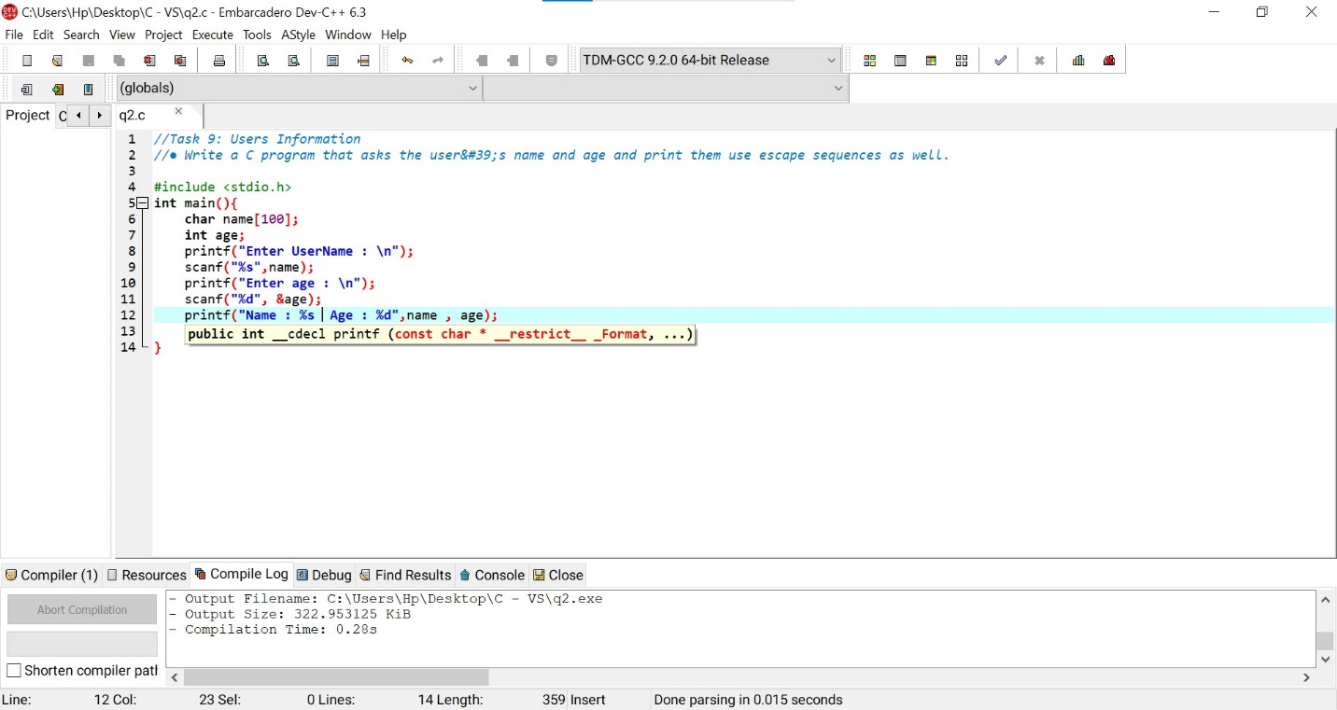

Task 10:Swapping Variables

● Write a program to swap two variables using a third variable.

● Repeat the program again without using a third variable.

