***LAB 4 Assignments***

Q1 . A shopkeeper gives a discount of 10% if the total bill is more than 5000, otherwise

no discount.

Write a program to ask the user for the bill amount and display the final payable

amount..

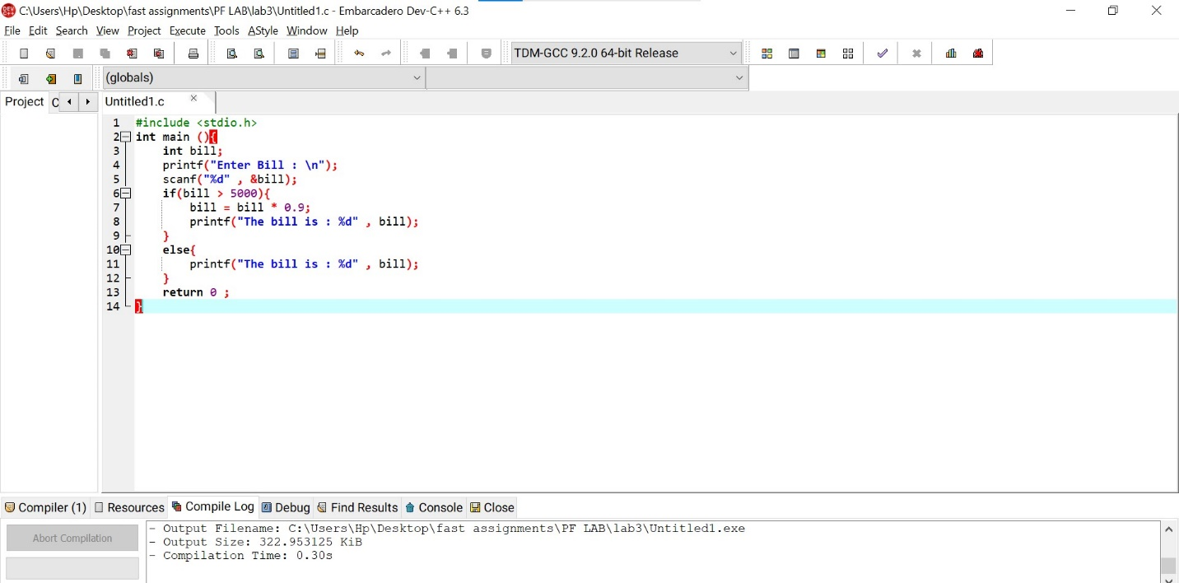

2. A cinema charges ticket prices based on age:

● Age &lt; 12 → 200

● Age between 12 and 18 → 300

● Age 18–60 → 500

● Age &gt; 60 → 250

Write a program to calculate ticket price based on age entered by the user

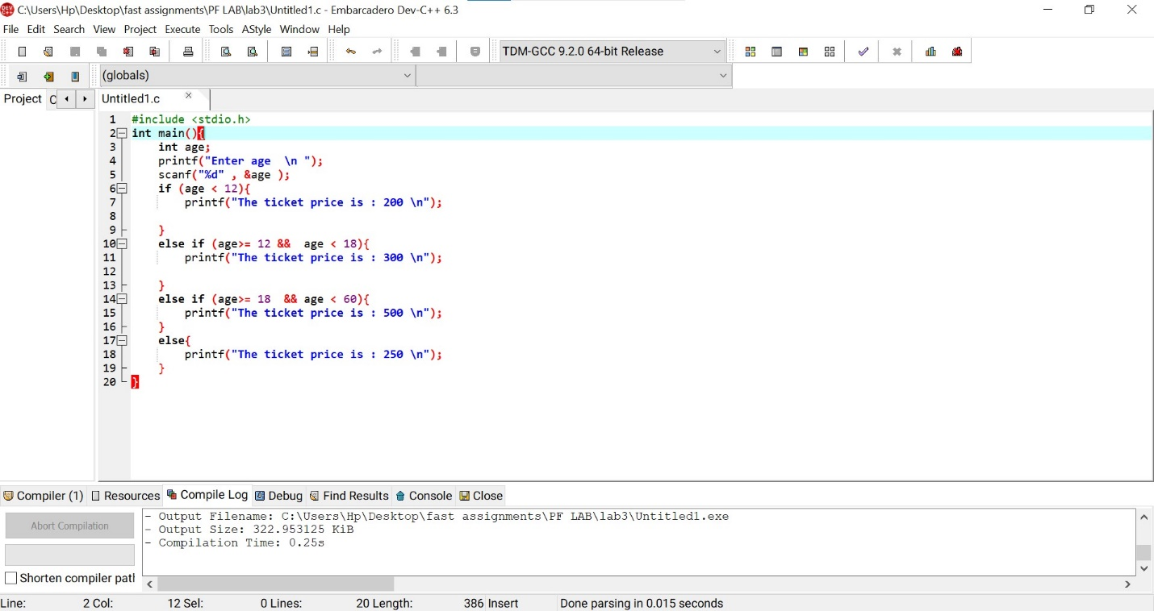

3. Write a program that takes three numbers and finds the largest number using nested

if.

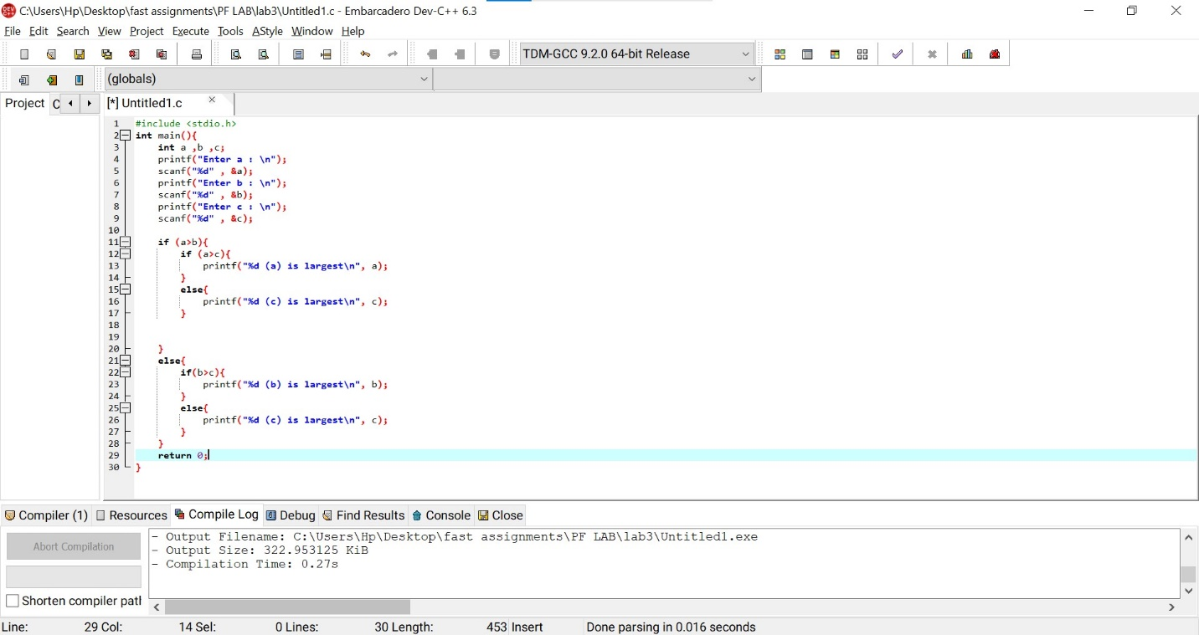

4. A bank approves a loan if:

● Salary ≥ 40,000 AND

● Age ≥ 25.

Otherwise loan is rejected.

Write a program to ask salary and age, then display whether the loan is approved or

Not

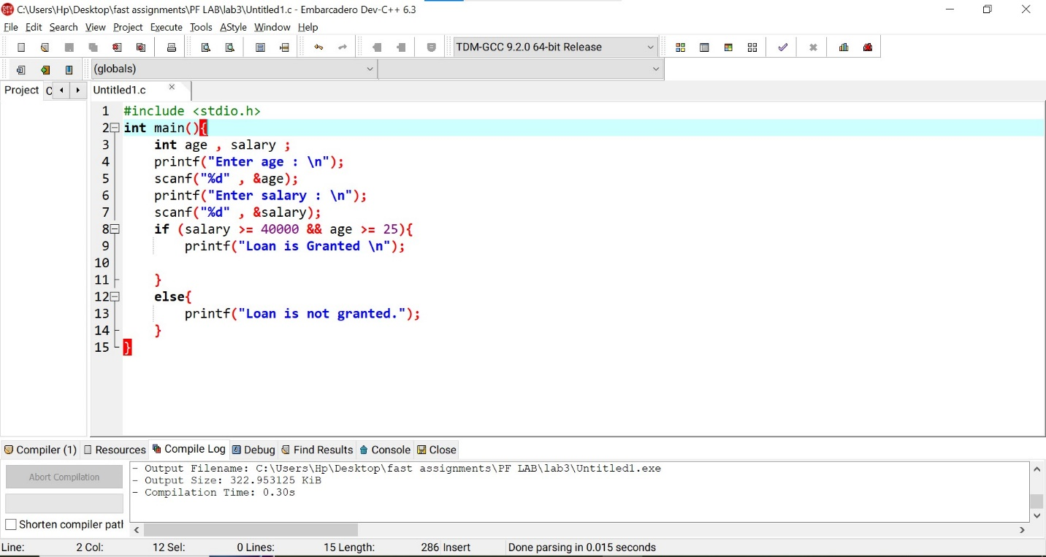

5. A calculator program:

Ask the user to enter two numbers and a choice:

● Addition

● Subtraction

● Multiplication

● Division

Perform the selected operation using switch case

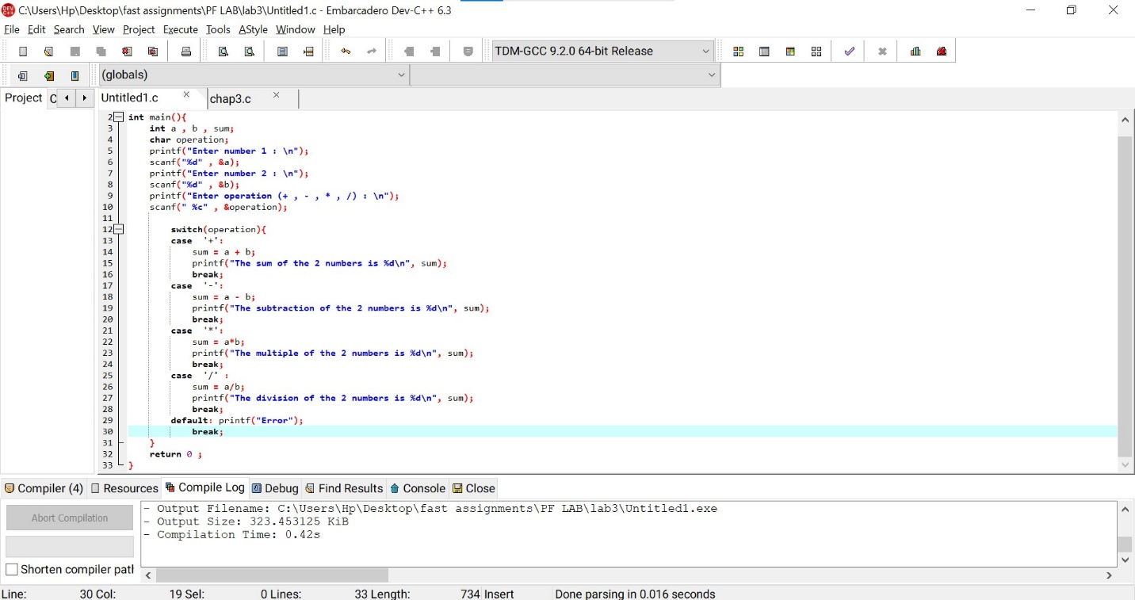

Q6 . A program asks the user for their age. If they are 18 or older, print Eligible to Vote,

otherwise print Not Eligible

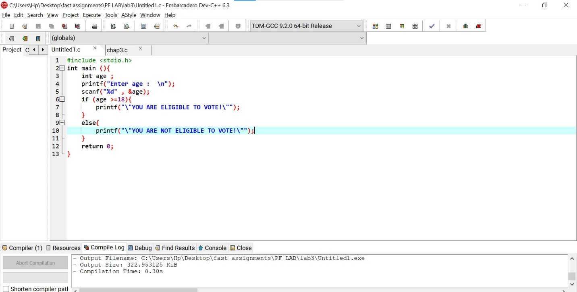

7. A password checking system: If user enters “1234”, print “Access Granted”, else print

“Access Denied”.

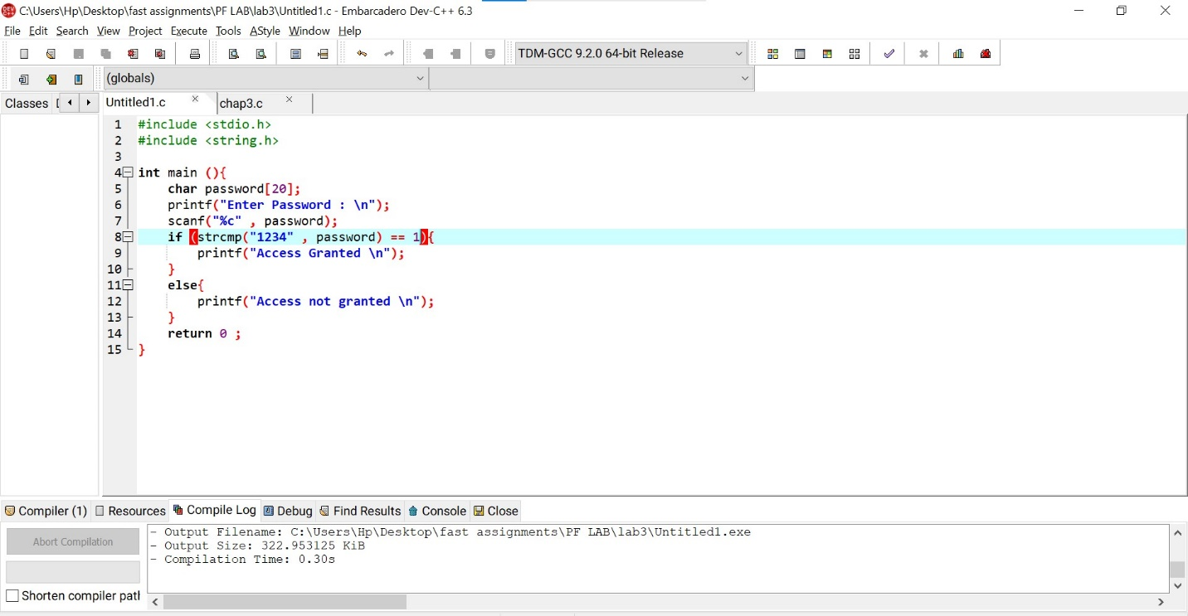

8. If the temperature is greater than 30°C, display “Hot Day”, otherwise “Pleasant Day”.

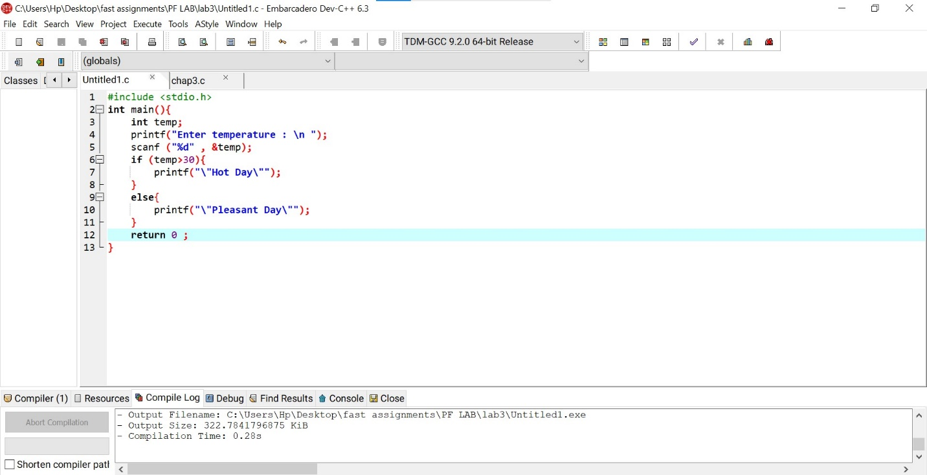

9. A student can only appear in the final exam if:

● Attendance ≥ 75% AND

● Internal marks ≥ 40.

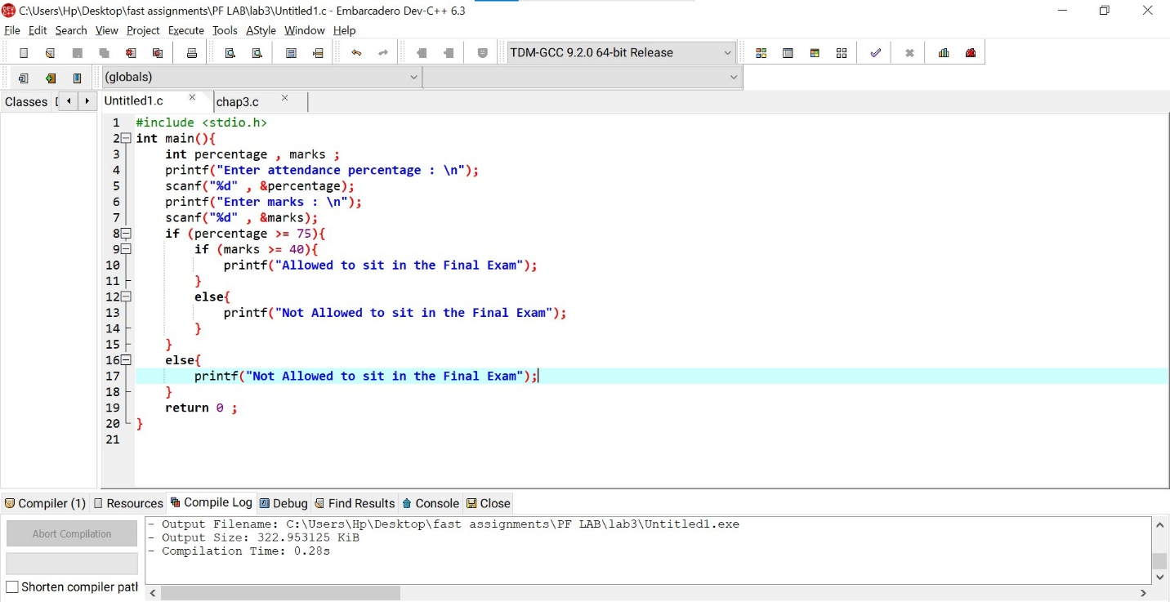

Q10. ATM withdrawal rule:

● Balance must be greater than withdrawal amount

● Withdrawal amount must be a multiple of 500

if both conditions pass, allow withdrawal, else reject.

