

# Course Title: Microprocessor interfacing and embedded system (3 Cr)

**Team project**

**Semester**: Summer 2019

**Group: 2**

**Section:**

**Names, Student IDs and emails:**

**1.MD HABIB ULLAH KHAN-1610961042**

**2.MD MAMUN HOWLADER-1610240042**

**3.HASIN AHMED MALLICK-1522053042**

**4.LIZAN KHAN-1520209642**

Implement the given encryption table using microcontroller. Use single pole, double throw switch to configure the inputs for high and low conditions. Use LEDs to represent the corresponding output statuses

|  |  |  |  |  |  |  |  |
| --- | --- | --- | --- | --- | --- | --- | --- |
| **Input** | | | | **Output** | | | |
| I3 | I2 | I1 | I0 | O3 | O2 | O2 | O1 |
| 0 | 0 | 0 | 0 | 1 | 0 | 1 | 1 |
| 1 | 0 | 0 | 0 | 1 | 0 | 1 | 1 |
| 0 | 1 | 0 | 0 | 1 | 0 | 0 | 0 |
| 1 | 1 | 0 | 0 | 0 | 0 | 0 | 0 |
| 0 | 0 | 1 | 0 | 1 | 1 | 0 | 0 |
| 1 | 0 | 1 | 0 | 0 | 1 | 0 | 0 |
| 0 | 1 | 1 | 0 | 1 | 1 | 1 | 1 |
| 1 | 1 | 1 | 0 | 0 | 1 | 0 | 0 |
| 0 | 0 | 0 | 1 | 1 | 1 | 0 | 1 |
| 1 | 0 | 0 | 1 | 0 | 0 | 0 | 1 |
| 0 | 1 | 0 | 1 | 0 | 1 | 0 | 0 |
| 1 | 1 | 0 | 1 | 1 | 1 | 0 | 0 |
| 0 | 0 | 1 | 1 | 1 | 0 | 0 | 0 |
| 1 | 0 | 1 | 1 | 0 | 1 | 1 | 0 |
| 0 | 1 | 1 | 1 | 1 | 1 | 0 | 0 |
| 1 | 1 | 1 | 1 | 1 | 1 | 0 | 1 |

Hints for deriving the logic expression:

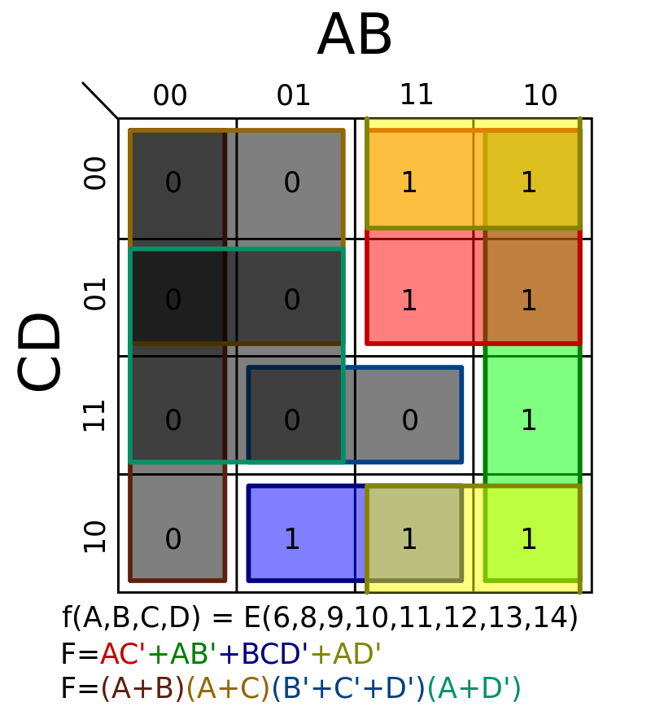

Example microcontroller: (Arduino UNO)

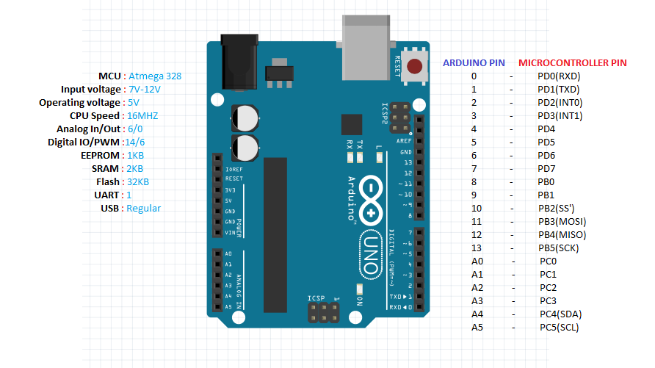

**Supporting materials**

1. Proteus design suite
2. Google

// constants won't change. They're used here to set pin numbers:

const int buttonPin0 = 2; // the number of the pushbutton pin

const int buttonPin1 = 3;

const int buttonPin2 = 4;

const int buttonPin3 = 5;

const int O0 = 10; // the number of the LED pin

const int O1 = 11;

const int O2 = 12;

const int O3 = 13;

// variables will change:

int I0 = 0; // variable for reading the pushbutton status

int I1 = 0;

int I2 = 0;

int I3 = 0;

void setup() {

// initialize the LED pin as an output:

// Serial.begin(9600);

pinMode(O0, OUTPUT);

pinMode(O1, OUTPUT);

pinMode(O2, OUTPUT);

pinMode(O3, OUTPUT);

// initialize the pushbutton pin as an input:

pinMode(I0, INPUT);

pinMode(I1, INPUT);

pinMode(I2, INPUT);

pinMode(I3, INPUT);

}

void loop() {

// read the state of the pushbutton value:

I0 = digitalRead(buttonPin0);

I1 = digitalRead(buttonPin1);

I2 = digitalRead(buttonPin2);

I3 = digitalRead(buttonPin3);

// check the input for output

int x =(not I0 && not I2);

int y =(I0 && not I2);

int z =(I0 && not I1);

int output0 =((not I0 && I2)||(I0 && I1 && I2)||(not I1 && not I2 && not I3 )||(not I0 && not I1)||(not I0 && not I3);

digitalWrite(O0,output0);

int output1 =((x && I3)||(I1 && I3)||(I1 && I2)|| (I0 && I2)||(not I1 && not I3 && I2));

digitalWrite(O1,output1);

int output2 =((not I1 && not I2 && not I3)||(not I0 && I1 && I2 && not I3)||(I0 && not I1 && I2 && I3);

digitalWrite(O2,output2);

int output3 =((not I1 && not I2)||(not I0 && I1 && I2 && not I3)||(I0 && I1 && I3 && I4));

digitalWrite(O3,output3);

/* Serial.println(I0);

Serial.println(I1);

Serial.println(I2);

Serial.println(I3);

delay(1000);*/

}