**Experiment Name:** Packet Through a Router

**Packet:**

A packet is the unit of data that is routed between an origin and a destination on the Internet or any other packet-switched network. Network packets are small (around 1.5 KBS for Ethernet packets and 64 KBS for IP packet payloads) amounts of data passed over TCP/IP networks. As an example, e-mails and web pages will make use of network packets to send information back and forth to the user and recipients. The goal of a network packet is to send information reliably so data does not have to be sent as a single, large file.

**Router:**

Routers are small electronic devices that join multiple computer networks together using either wired or wireless connections. In technical terms, a router is a Layer 3 network gate way device, meaning that it connects two or more networks and that the router operates at the network layer of the OSI model.

**1.One router with pcs:**

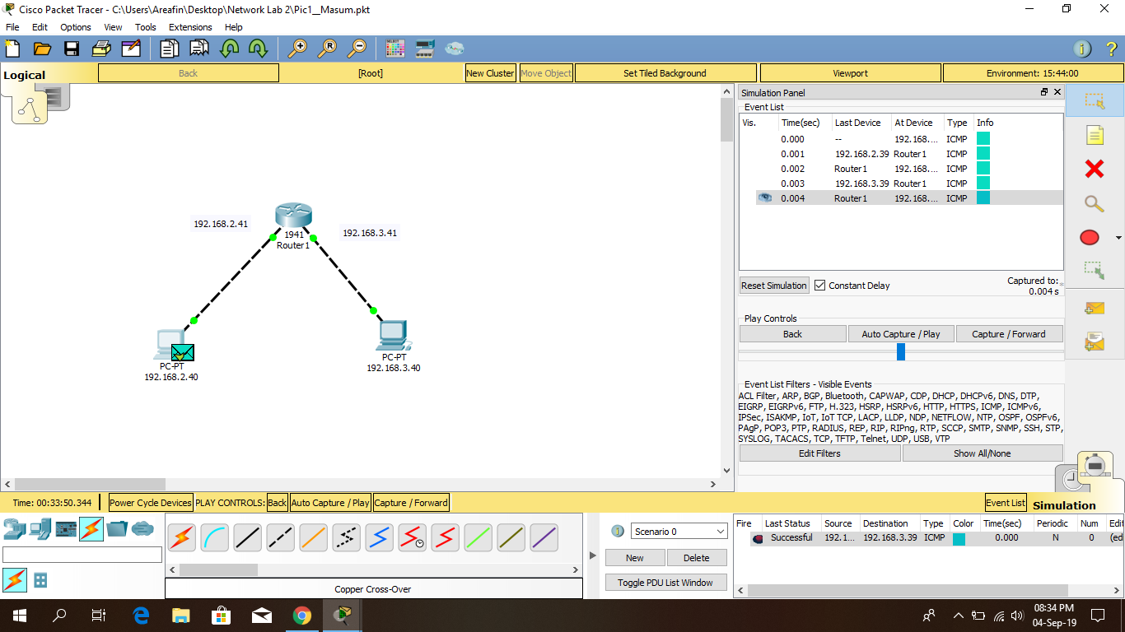

**2.Two routers with pcs:**

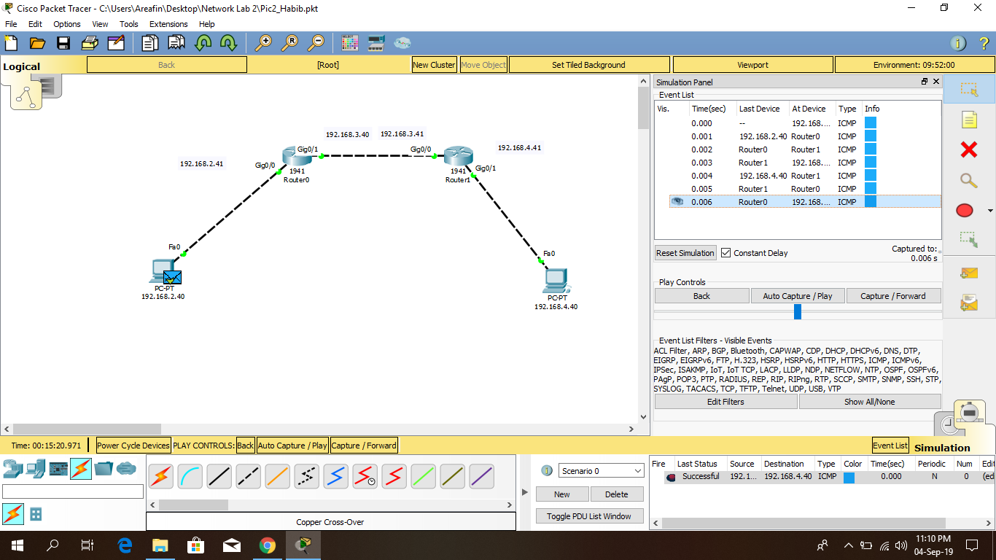

**3.Two routers & hub and pcs:**

**Hub:**

Routers are small electronic devices that join multiple computer networks together using either wired or wireless connections. A hub also called a network hub, is a common connection point for devices in a network. Hubs are devices commonly used to connect segments of a LAN. The hub contains multiple ports. When a packet arrives at one port, it is copied to the other ports so that all segments of the LAN can see all packets.

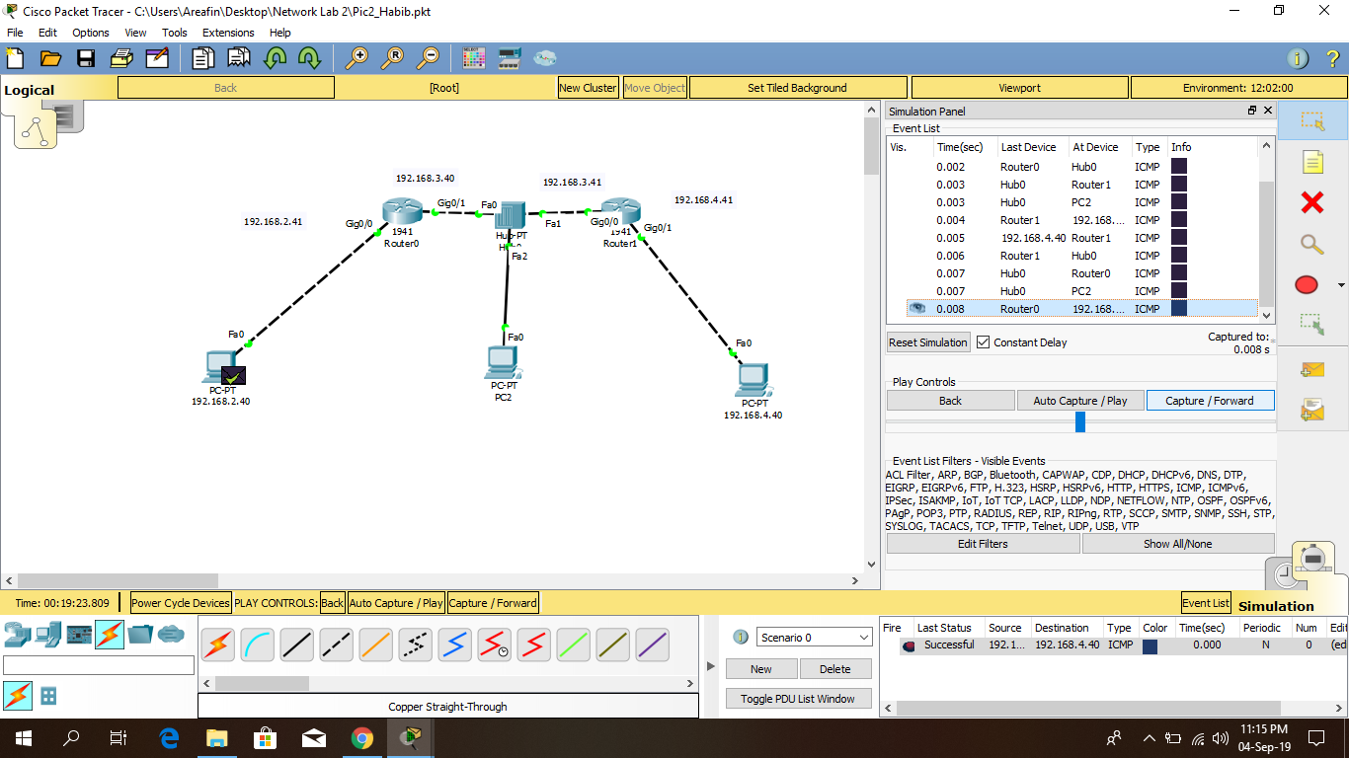

**4.Three routers and pcs:**

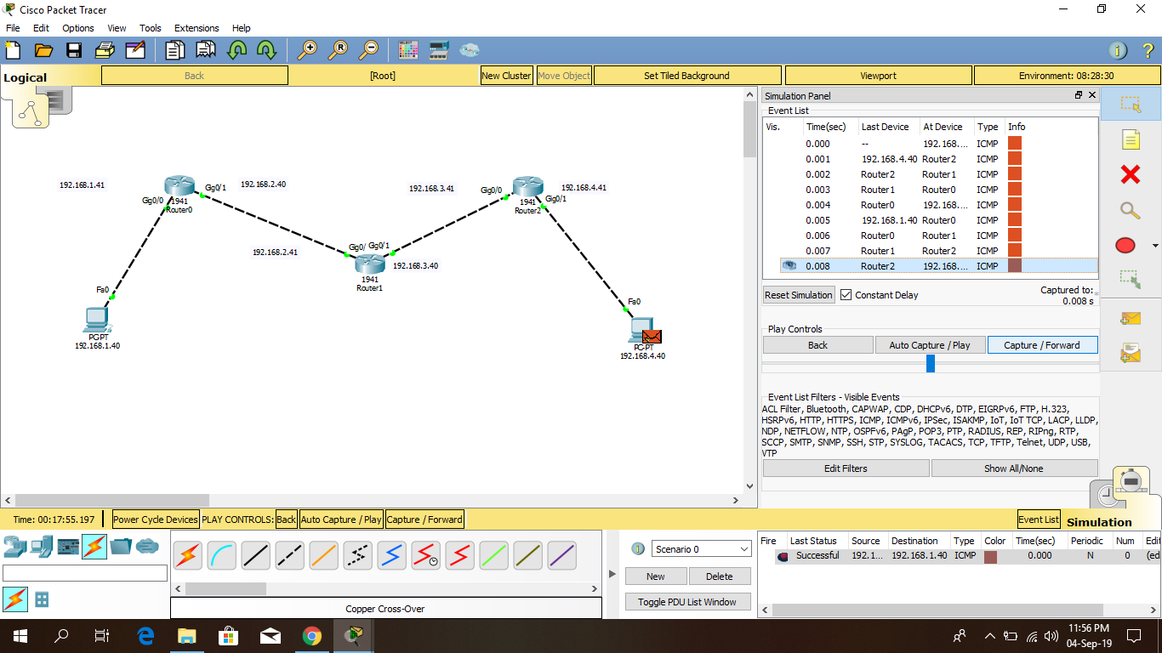

Conclusion:

The system failed to execute the first attempt to pass the message from one pc to another pc but after the first attempt it executes smoothly.