Department of Computer Science and Engineering

Jahangirnagar University

Laboratory Report

**CSE 402:**

Computer Networks Laboratory

**Experiment Name:**

VLAN configuration with layer 3 switch & router

**Submitted by:**

Md.Habibur Rahman

Class Roll: 40

Exam Roll: 160034

4th year 1st semester

**Date of Submission**: September 19, 2019

**Name of the Exp:**

VLANconfiguration with layer 3 switch & router

**Introduction:**

**VLAN :**

A virtual LAN (local area network) is a logical subnetwork that groups a collection of devices from different physical LANs. Large business computer networks often set up VLANs to re-partition a network for improved traffic management. Several kinds of physical networks support virtual LANs, including Ethernet and Wi-Fi.

When set up correctly, virtual LANs improve the performance of busy networks. VLANs group together client devices that communicate with each other frequently. The traffic between devices split across two or more physical networks is usually handled by a network's core routers. With a VLAN, that traffic is handled more efficiently by network switches.

**Dot1q Protocol :**

IEEE 802.1Q (sometimes referred to as 1Q or DOT1Q) is a industry standards based implementation of carring traffic for multiple VLANs on a single trunking interface between two Ethernet switches. 802.1Q is for Ethernet networks only.Unlike ISL, 802.1Q does not encapsulate the original Ethernet frame.For Ethernet V2 frames, 802.1Q inserts a new 4-byte field between the SA and TYPE fields of the original Ethernet frame. Since the addition of this new DOT1Q field changes the original frame, 802.1Q also recomputes and rewrites the original 4-byte FCS at the end of the frame.

802.1Q Header Insertion into Ethernet II frame

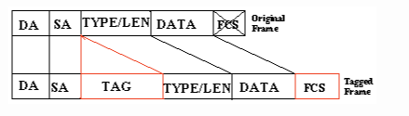

The first 2-bytes of the 801.1Q tag contains the HEX value 0x8100 which signals to the Ethernet receiver the presence of 802.1Q in the frame header.The 802.1Q header also includes 3-bits as a priority field for applying COS markings and 12-bits for a VLAN ID field to mark the VLAN number the frame belongs to.

**VLAN configuration with switch:**

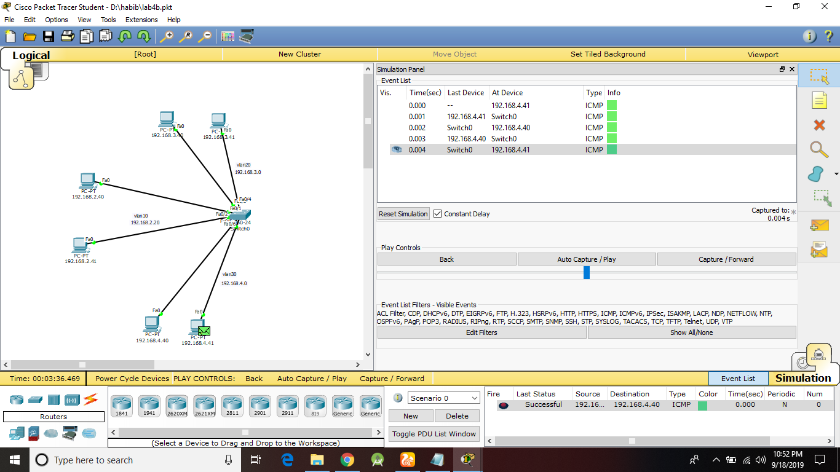

**VLAN configuration with layer 3 switch & router:**

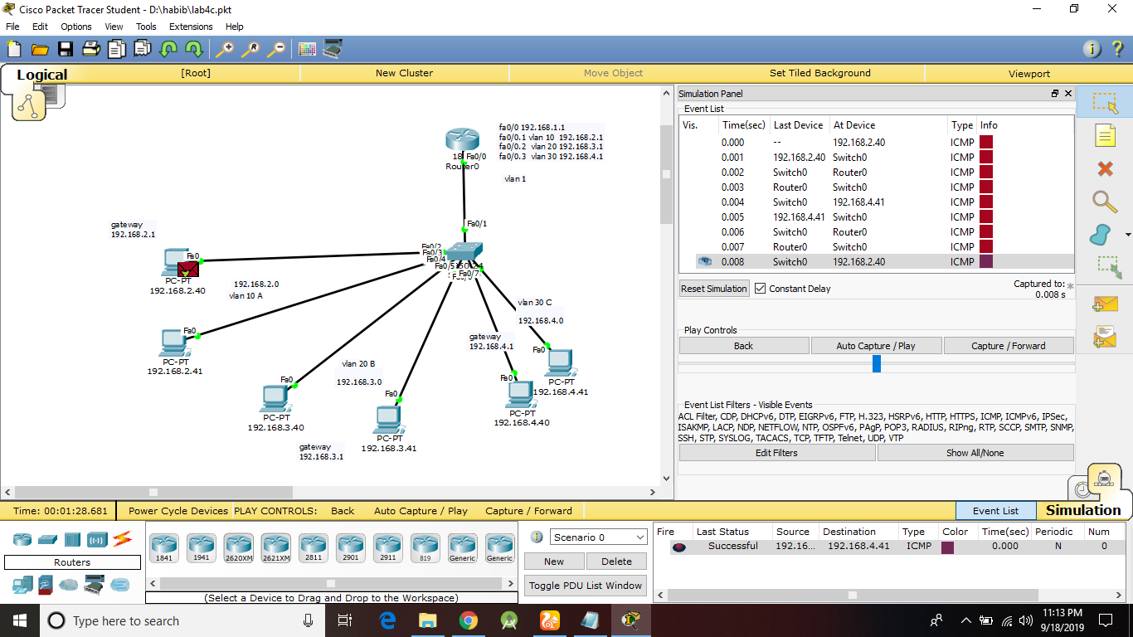

**VLAN configuration with layer 4 switch & router:**

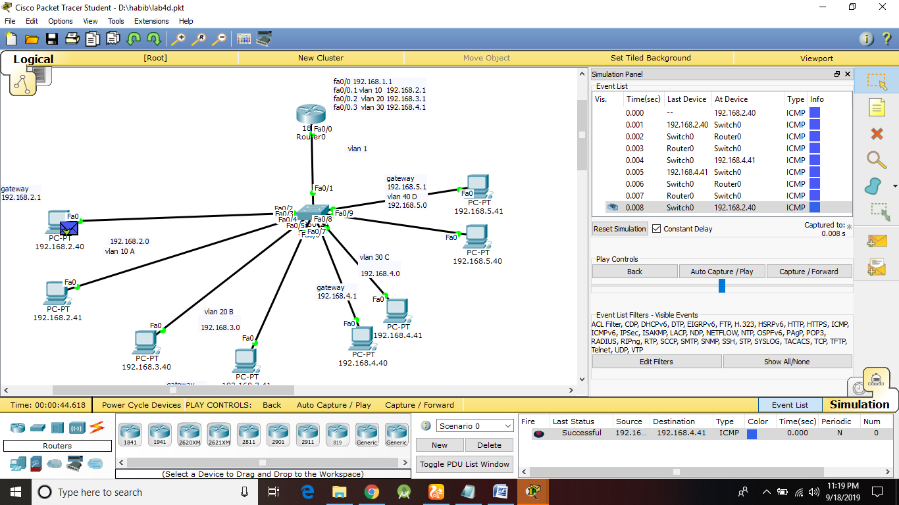

Conclusion:

The transmission may fail for the first time but if everything is connected in the right way it will have a successful simulation.The VLAN trunk command needs to be executed properly.