

Lab Report

Computer Networks Laboratory

CSE-402

Experiment no : 06

Name of the Experiment :

IP Telephony

Submitted by :

Md.Habibur Rahman

Roll :40

**Experiment No: 06**

**Experiment Name:** IP Telephony.

**Objective:** IP telephony (Internet Protocol telephony) is a general term for the technologies that use the Internet Protocol's packet-switched connections to exchange information. The objective of this experiment is to implement IP Telephony connections which improve the performance of telecommunication networks.

**1. Network connection:**

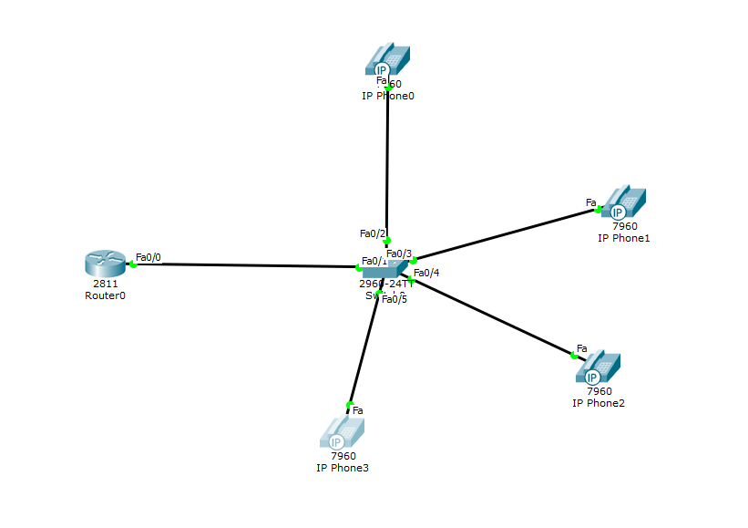

**2.Configure Router:**  
Router>en

Router#conf t

Enter configuration commands, one per line. End with CNTL/Z.

Router(config)#int fa0/0

Router(config-if)#ip add 192.168.10.1 255.255.255.0

Router(config-if)#no shut

Router(config-if)#exit

Router(config)#ip dhcp pool VOICE

Router(dhcp-config)#network 192.168.10.0 255.255.255.0

Router(dhcp-config)#default-router 192.168.10.1

Router(dhcp-config)#option 150 ip 192.168.10.1

Router(dhcp-config)#exit

Router(config)#telephony-service

Router(config-telephony)#max-dn 4

Router(config-telephony)#max-ephone 10

Router(config-telephony)#ip source-address 192.168.10.1 port 2000

Router(config-telephony)#auto assign 1 to 5

Router(config-telephony)#exit

**3.Plug in All the Telephones.**

**4.Configure Switch:**

Switch>

Switch>en

Switch#conf t

Switch(config)#int range fa0/1-10

Switch(config-if-range)#switchport mode access

Switch(config-if-range)#switchport voice vlan 1

**5.Configure Router Again:**

Router(config)#ephone-dn 1

Router(config-ephone-dn)#number 5401

Router(config-ephone-dn)#exit

Router(config)#ephone-dn 2

Router(config-ephone-dn)#number 5402

Router(config-ephone-dn)#exit

Router(config)#ephone-dn 3

Router(config-ephone-dn)#number 5403

Router(config-ephone-dn)#exit

Router(config)#ephone-dn 4

Router(config-ephone-dn)#number 5404

Router(config-ephone-dn)#exit

**Successful Simulation:**

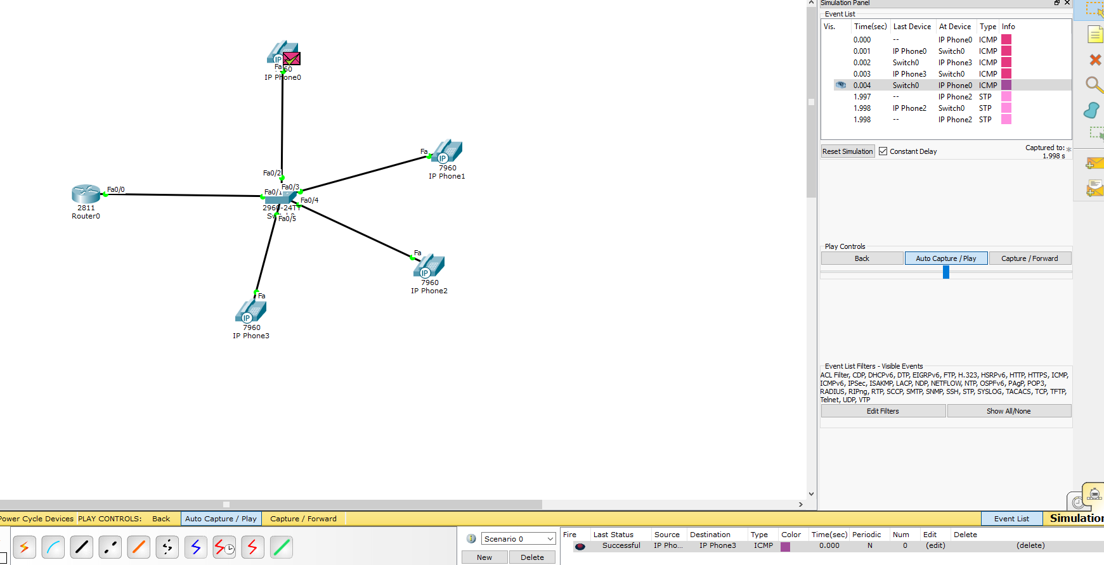

**Verify the circuit with dialing (Calling,Connected,Busy):**

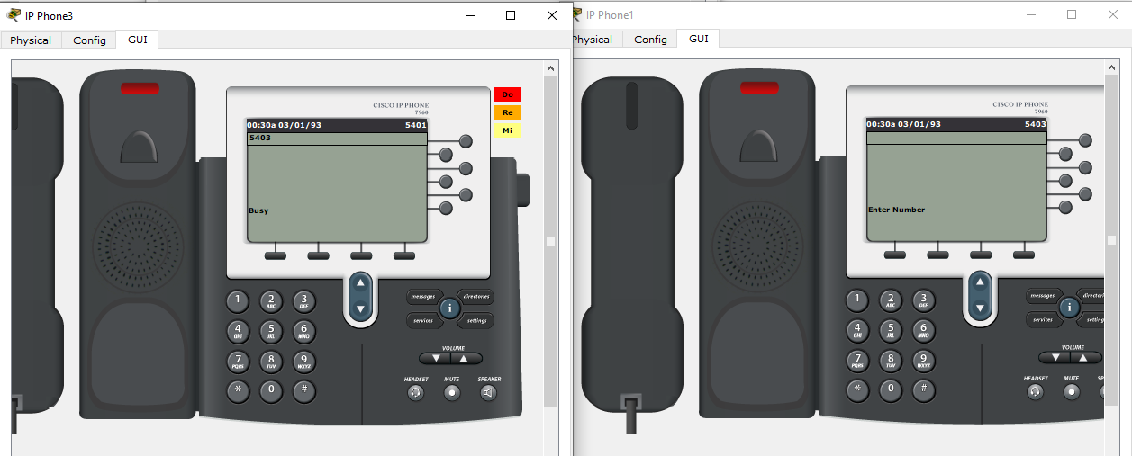

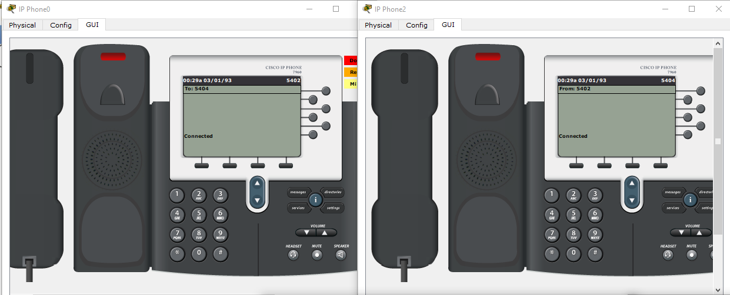

***Home Task:***

**IP Telephony(max-dn 8,max-ephone 12)**

**1. Network connection:**

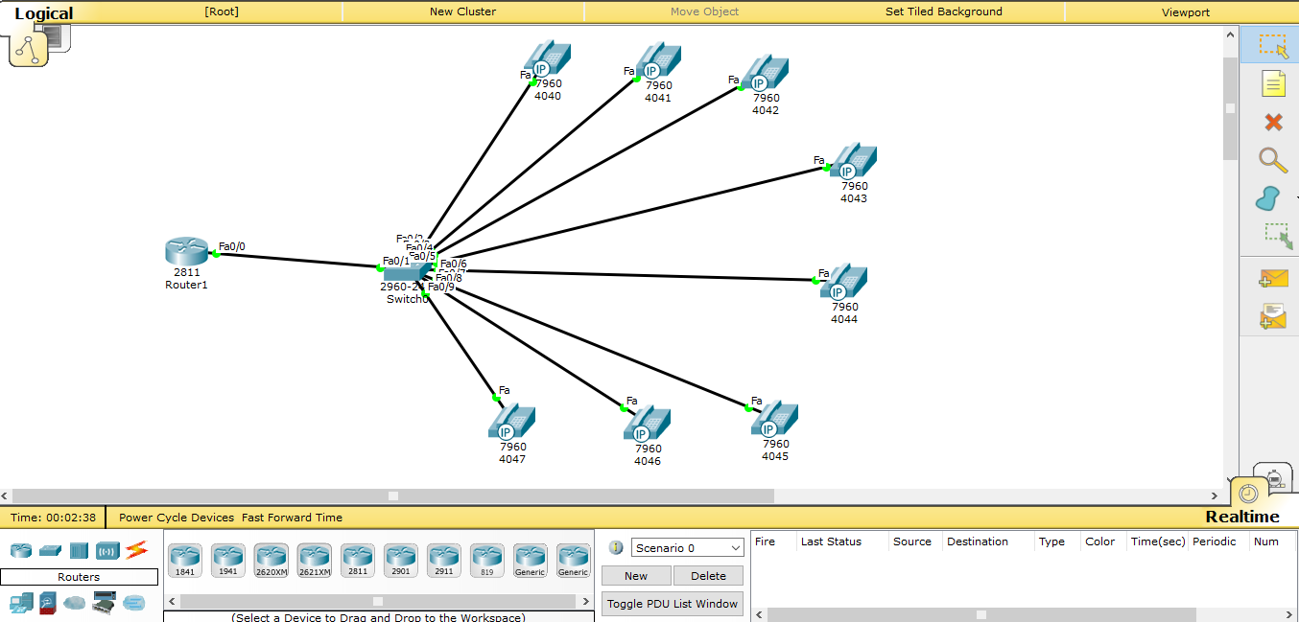

**2.Configure Router:**

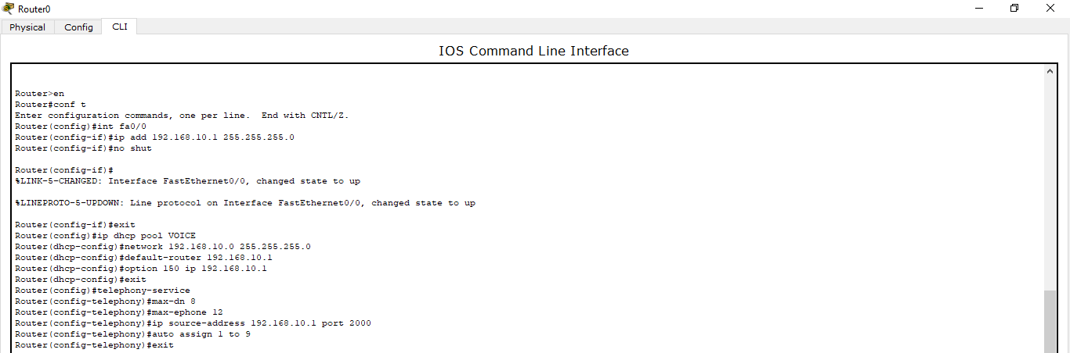

**3.Plug in All the Telephones.**

**4.Configure Switch:**

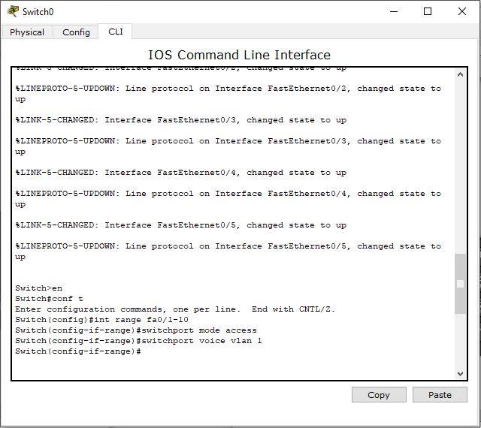

**5.Configure Router Again:**

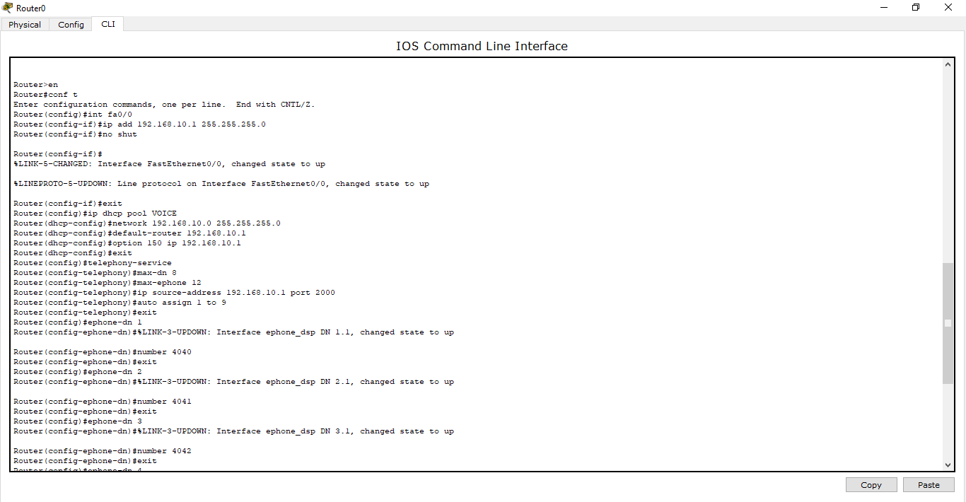

**Simulation:**

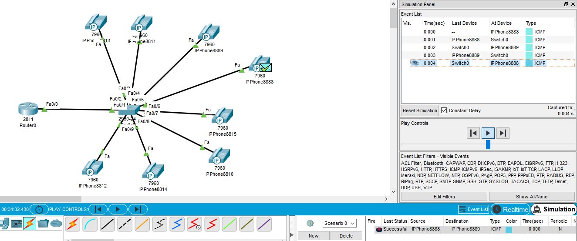

**Verify the circuit with dialing (Calling,Connected,Busy):**

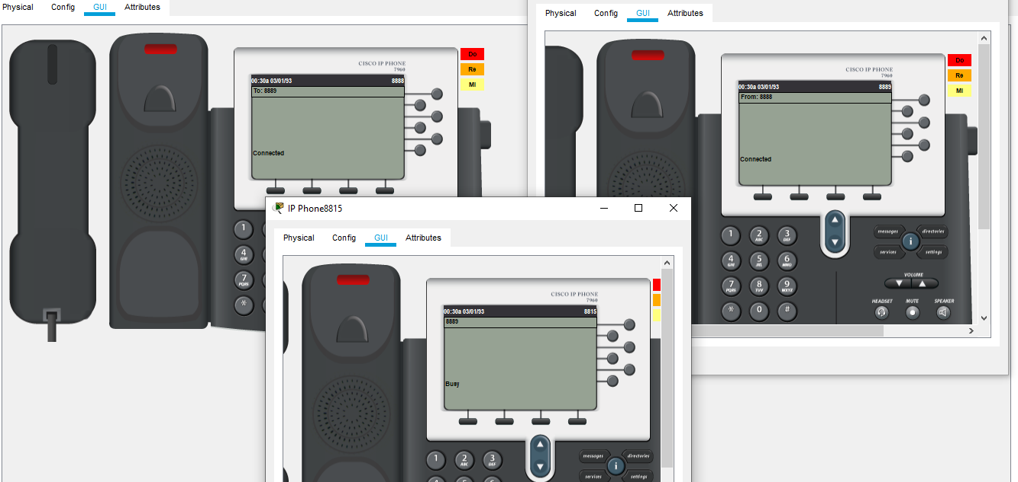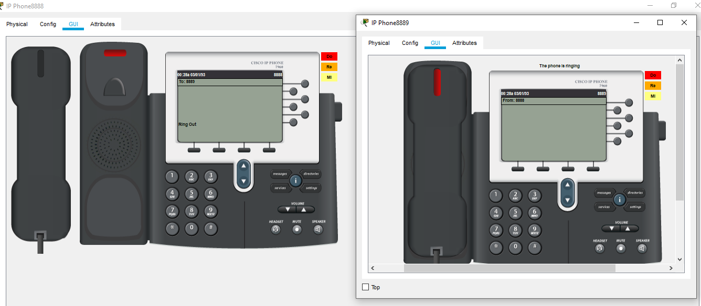

**Conclusion:**

The connections must be established carefully.The directory entry for phones should be done swiftly.