

Lab Report

Computer Networks Laboratory

CSE-402

Experiment no : 05

Name of the Experiment :

DNS Server Configurataion.

Submitted by :

Md.Habibur Rahman

Roll :40

**Experiment no** : 05

**Name of the Experiment** :

DNS Server Configuration Using 1 router and Using 2 routers

**Introduction**:

A server is a device or program dedicated to providing services to other programs, referred to as ‘clients’. DNS clients, which are built into most modern desktop and mobile operating systems, enable web browsers to interact with DNS servers.

The Domain Name System (DNS) is the phonebook of the Internet. When users type domain names such as ‘google.com’ or ‘nytimes.com’ into web browsers, DNS is responsible for finding the correct IP address for those sites. Browsers then use those addresses to communicate with origin servers or CDN edge servers to access website information. This all happens thanks to DNS servers: machines dedicated to answering DNS queries.

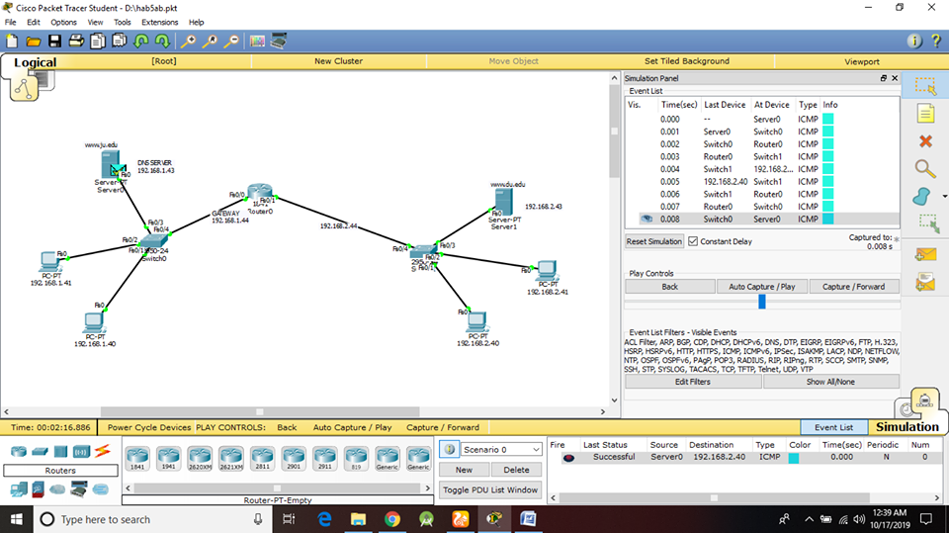

Fig 5.1 : DNS Server Configuration using a router

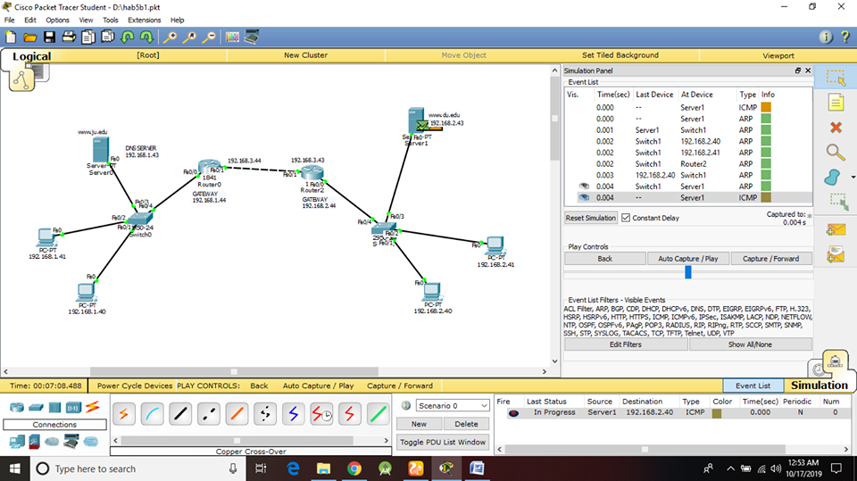

Fig 5.2 : DNS Server Configuration using 2 routers

**Awareness:**

* IP addresses & gateways should be carefully handled.
* Connectors should be chosen carefully.

**Conclusion:**

* Packets of DNS server transmitted successfully through single router.
* Packets of DNS server transmitted successfully through multiple router.