

Lab Report

Computer Networks Laboratory

CSE-402

Experiment no : 07

Name of the Experiment :

Implementation of OSPF algorithm

Submitted by :

Md.Habibur Rahman

Roll :40

**Experiment no** : 07

**Name of the Experiment** :

Implementation of OSPF algorithm

**Introduction**:

**Open Shortest Path First** (**OSPF**) is a link-state routing protocol which is used to find the best path between the source and the destination router using its own Shortest Path First). OSPF is developed by Internet Engineering Task Force (IETF) as one of the Interior Gateway Protocol (IGP.OSPF uses multicast address 224.0.0.5 for normal communication and 224.0.0.6 for update to designated router(DR)/Backup Designated Router (BDR).

In network computing**, DCE (Distributed Computing Environment)** is an industry-standard software technology for setting up and managing computing and data exchange in a system of distributed computers. DCE is typically used in a larger network of computing systems that include different size servers scattered geographically.

**Data Terminal Equipment** is equipment which acts as source or destinations in digital communication and which is capable of converting information to signals and also reconverting received signals.Pieces of data terminal equipment usually do not communicate between each other, which is usually done by data communications equipment

**Connection:**

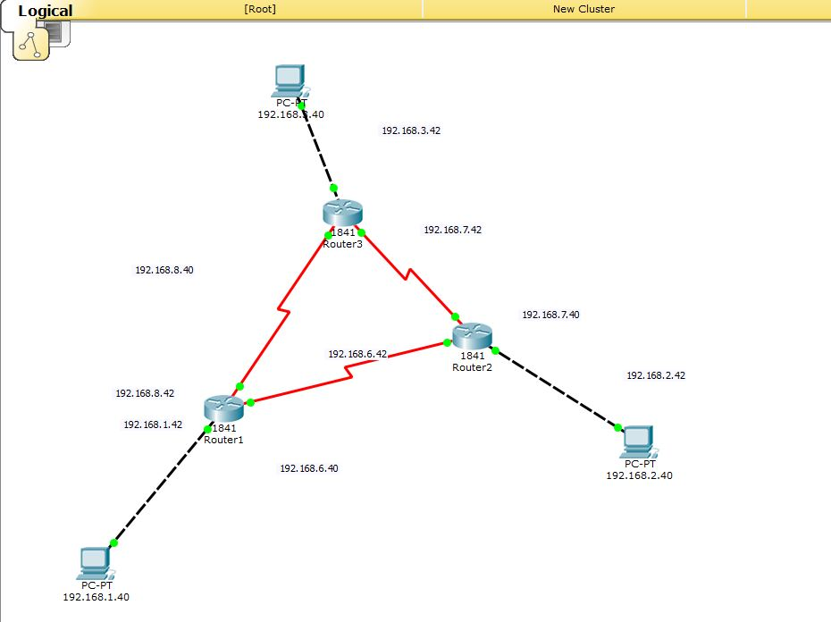

Fig 1.1:Connection of routers and PCs for OSPF algo

**Configuring Router 1:**

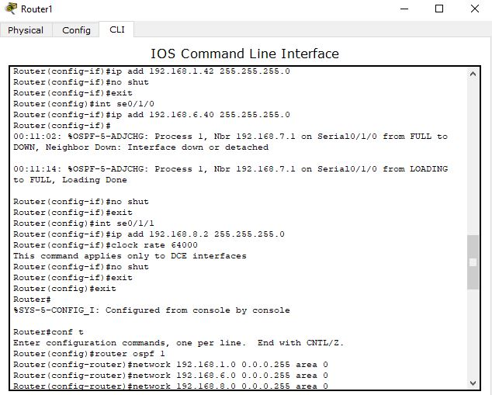

Fig : Configuring Router 1

**Confiuguring Router 2:**

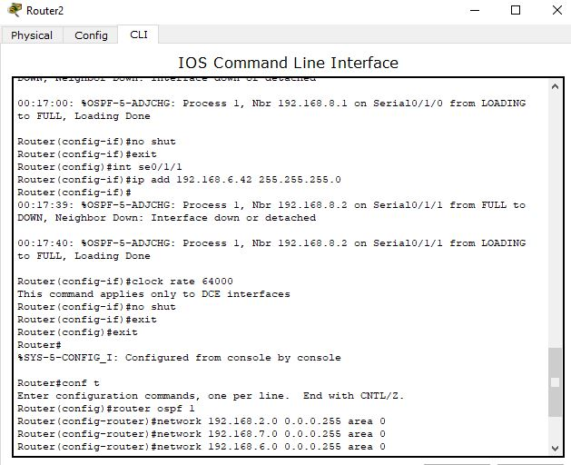

Fig : Configuring Router 2

**Configuring Router 3:**

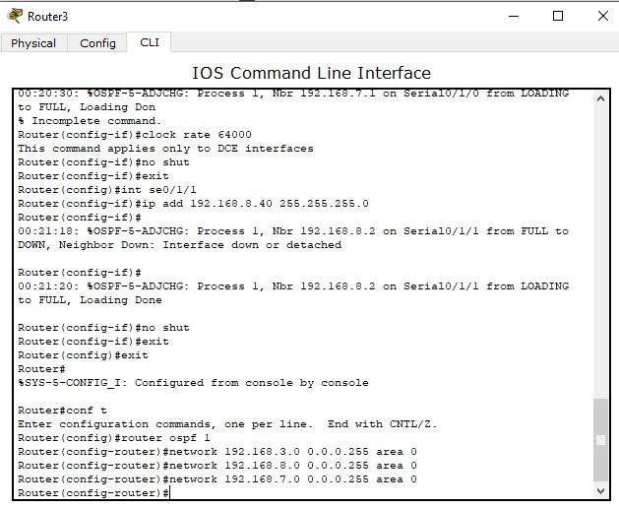

Fig : Configuring Router 3

**Simulation:**

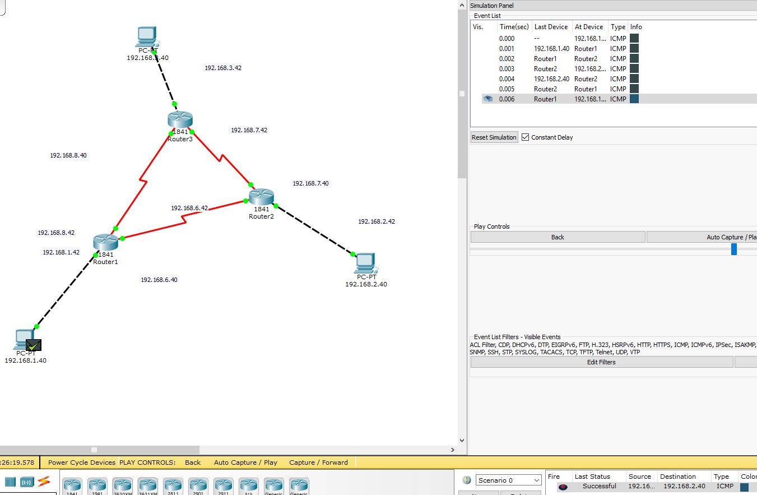

Fig : Real Time Simulation

**Awareness:**

* IP addresses & gateways should be carefully handled.
* Connectors should be chosen carefully.

**Conclusion:**

* Packets of router from one to another transmitted successfully through the network.