**Name of the Exp:** Fundamental of Computer Network

**Tracert Command:**

The tracert command is used to trace the route taken by a network packet from the local host to the destination host on a TCP/IP network. Like the ping command, it can be used with both an IP address and a host name 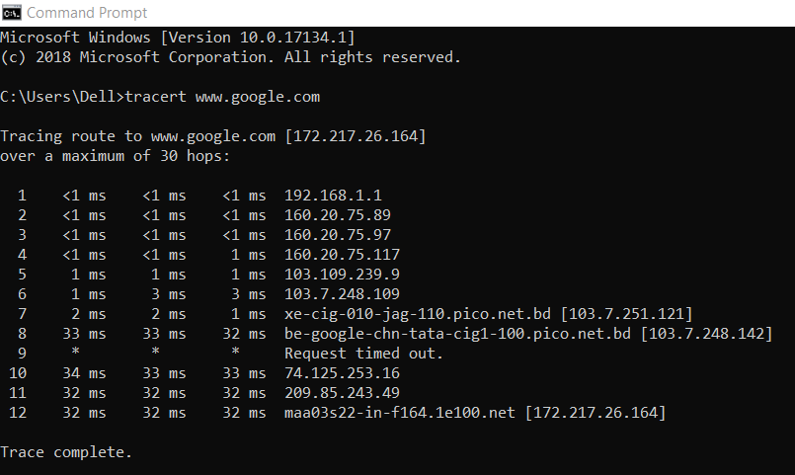

**Ping Command:**

The ping command sends packets of data to a specific IP address on a network, and then let us know how long it took to transmit that data and get a response. It’s a handy tool that we can us to quickly test various points of our network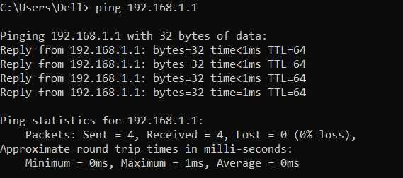

**Ping –t Command:**

When we use ping –t command the process to be continued until you force it to stop by using Ctrl-C.

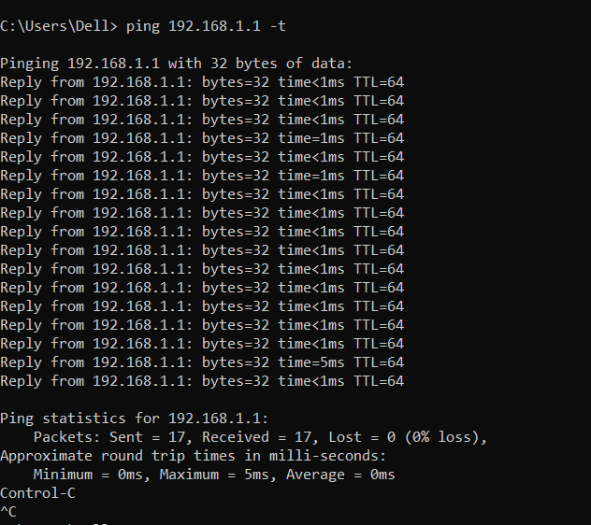

**Ipconfig:**

In Windows, **ipconfig**is a console application designed to run from the Windows command prompt. This utility allows you to get the IP address information of a Windows computer. It also allows some control over active TCP/IP connections. I**pconfig**replaced the older winipcfg utility.

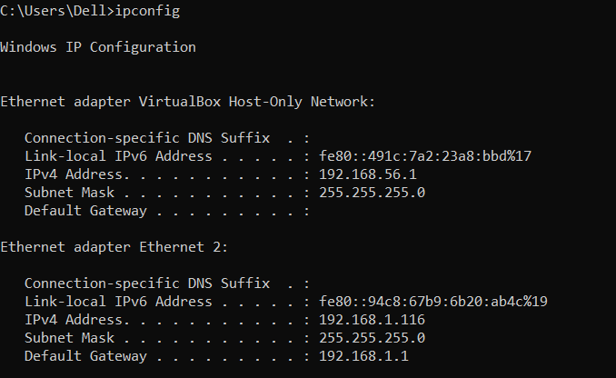

**Hub:**

A hub also called a network hub, is a common connection point for devices in a network. Hubs are devices commonly used to connect segments of a LAN.

Three basic types of hubs exist:

* **Passive hubs**don't amplify the electrical signal of incoming packets before broadcasting them out to the network.
* **Active hubs** perform amplification, much like a [repeater](https://www.lifewire.com/definition-of-repeater-816359).
* **Intelligent hubs** add extra features to an active hub that are of particular importance to businesses.

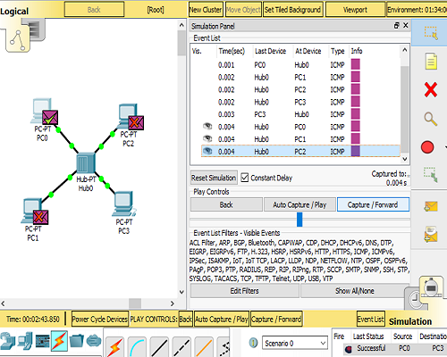

**Hub and Switch connection:**

A switch is used to connect various network segments. A network switch is a small hardware device that joins multiple computers together within one local area network (LAN). A hub connects multiple Ethernet devices together, making them act as a single segment. Switching is the technique by which nodes control or switch data to transmit it between specific points on a network.

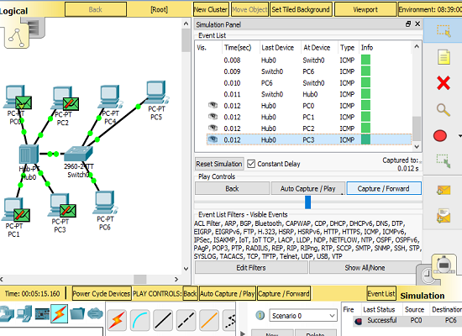

**Hub and Switch and Switch connection:**

Switching is the technique by which nodes control or switch data to transmit it between specific points on a network.

